Intelligent Monitoring (iDS-TCM203)

Installation Guidance

Chapter 1 Installation

1.1 Basic principle and restrictions
For iDS-TCM203, the most important factor for optimal functioning is the installation. As the correction of an existing installation costs considerable expense, in terms of civil engineering and cabling, it is important that the conditions below should be paid attention to at the beginning.

1.2 Installation modes

1.2.1 Middle installation (Recommended)
Based on the principle above, middle installation is able to provide the most ideal condition. The installation guidance is as follow.
I. Install the camera at the middle position of the lanes. Then adjust vertical angle to an appropriate view. The referenced distance of the view is about 80~100 m. Finally, adjust the angel of rotation to make sure all the lanes are vertical in the view.
II. The camera supports vehicle counting no matter it is detecting the head or the tail of vehicle.
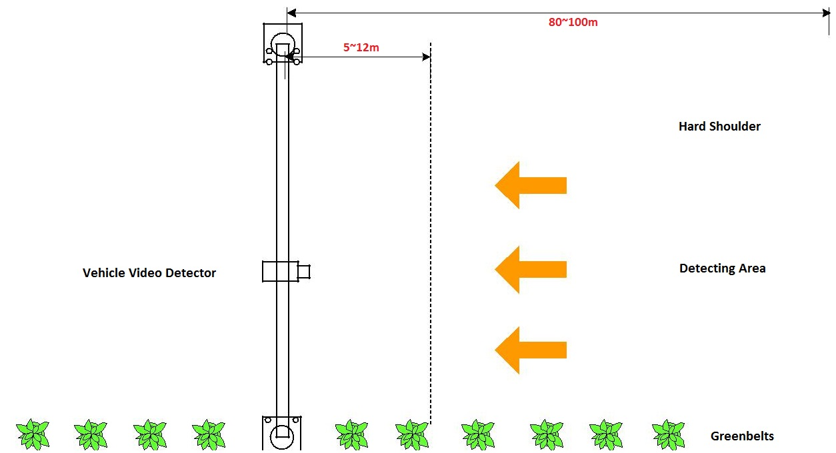
Front Detection
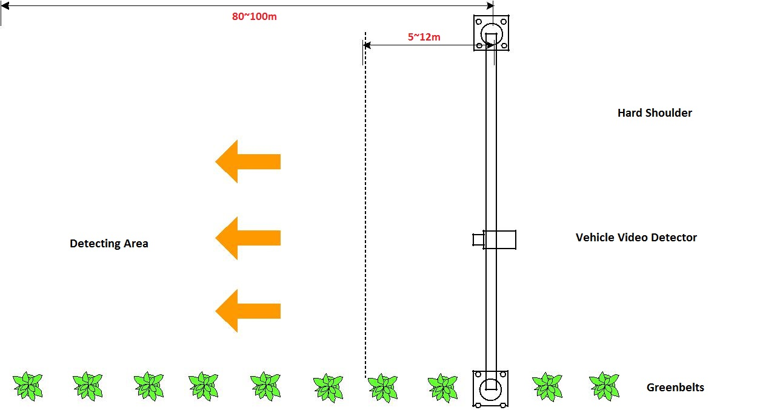
Back Detection

1.2.2 Side installation
Generally, it is not cost-efficient or even allowed to build an infrastructure facility like gantry. The provided installation condition might be unpredictable such as utilizing lamppost or traffic light pole. So we also offer a suggestion of road side installation in compliance with the basic principle.
Firstly, mount the camera on the lamppost or pole beside the road. Then adjust vertical angle to an appropriate view. The referenced distance of the view is about 80~100 m.
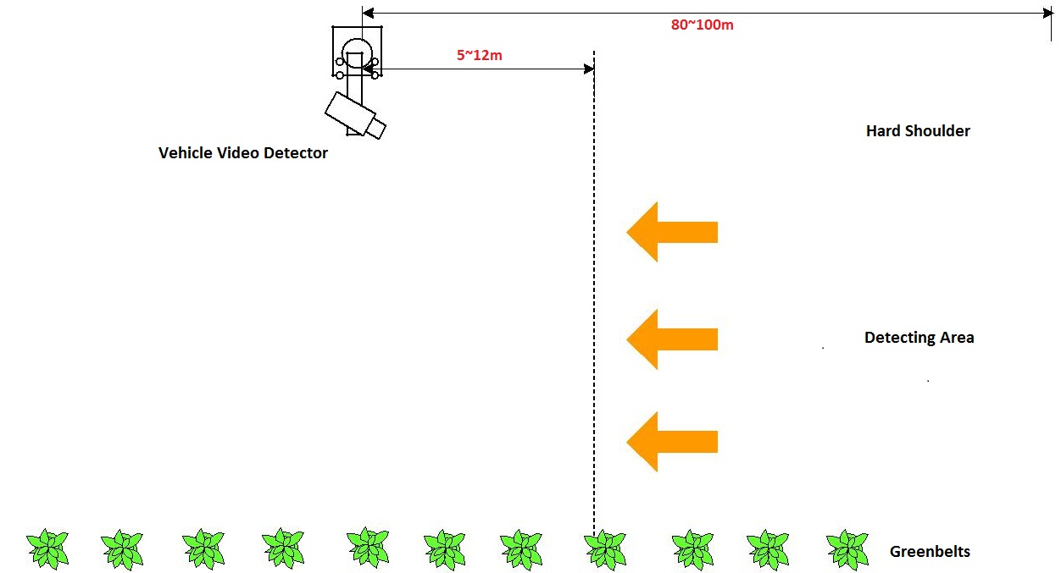
Front Detection
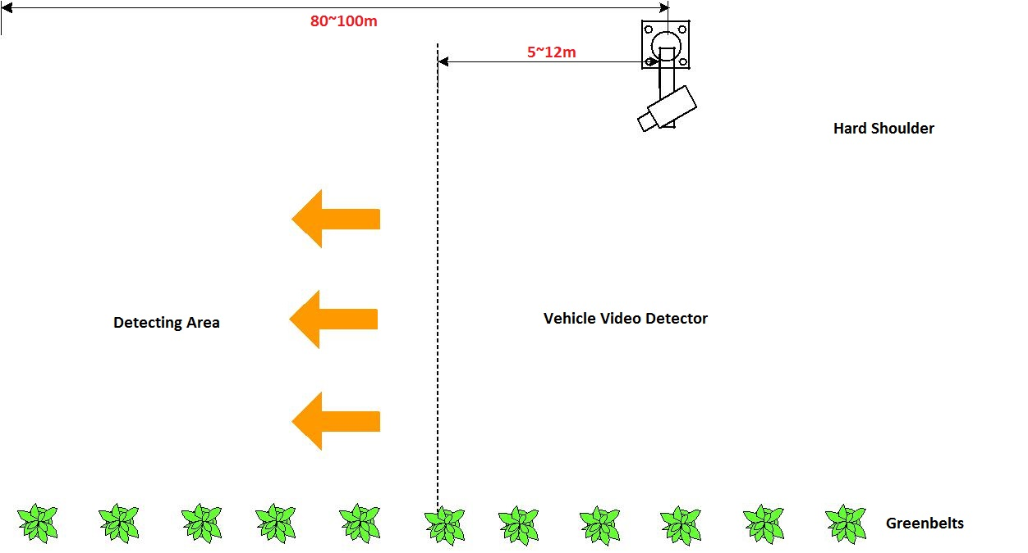
Back Detection

1.3 Device list & Wiring

1.3.1 Device list
No. | Pic | Name | Module
1 | 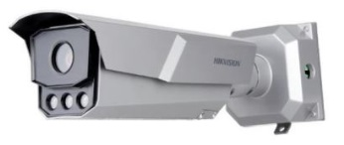 | Vehicle Video Detector | iDS-TCM203
2 | 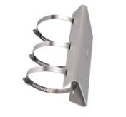 | Hoop & brackets | DS-1275ZJ/HWB

1.3.2 Wiring topology

1.4 Installation with Hoop & brackets

1.4.1 Camera and all accessories are as blow
No. | Pic | Name
1 | 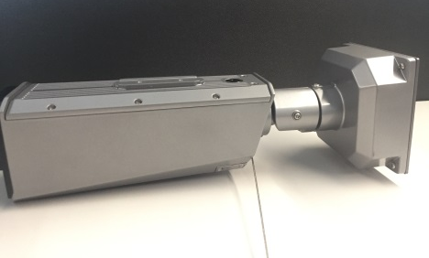 | Camera
2 | 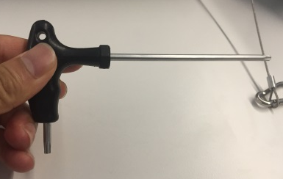 | Screw driver
3 |  | Seal cover
4 | 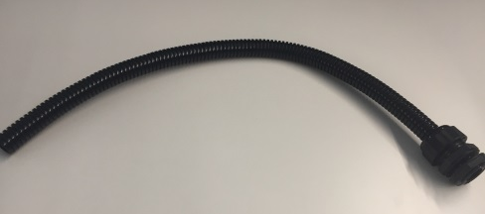 | Waterproof pipe
5 | 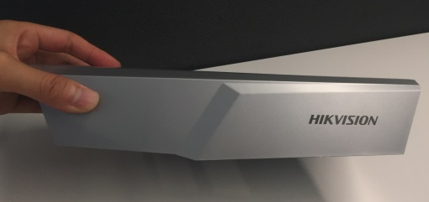 | Sunshade cover
6 |  | Hoop & brackets

1.4.2 Installation t graphical representation
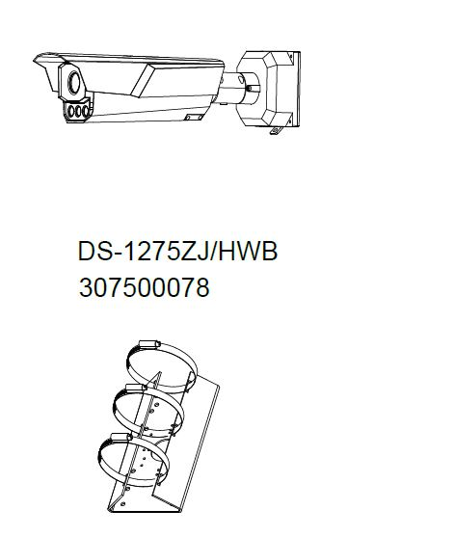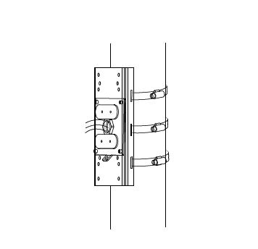
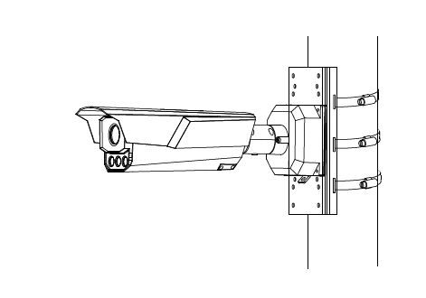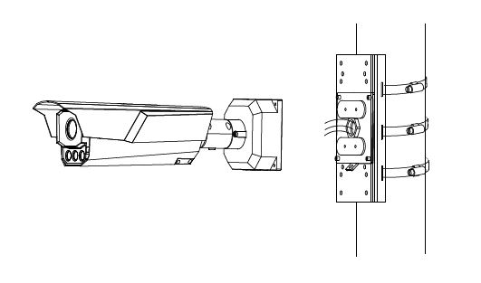
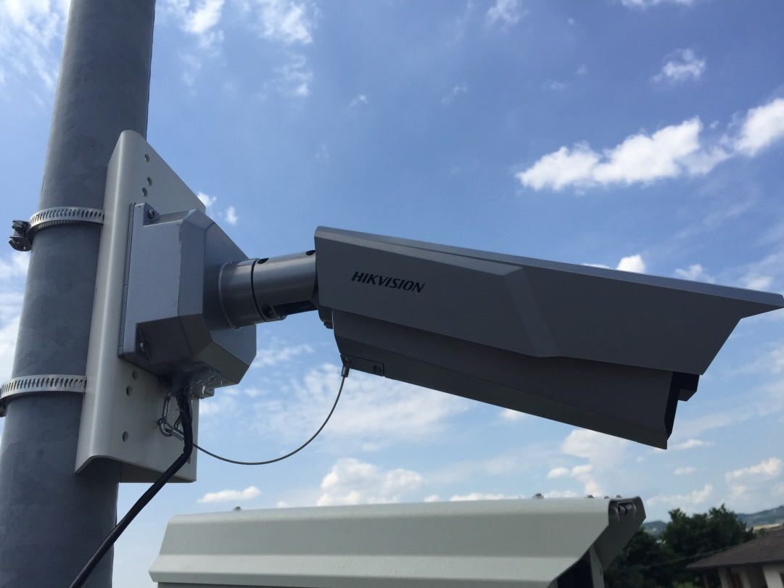

- Adjust rotation angel and vertical angel
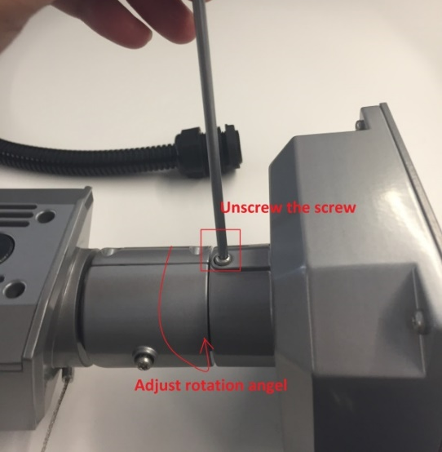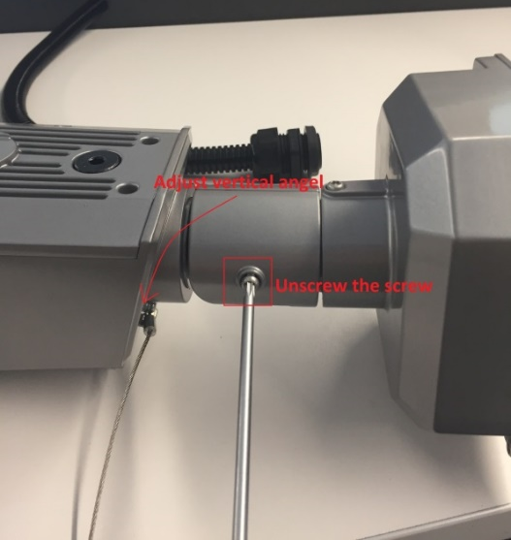

- Adjust camera rotation
Use screw driver to unscrew the screw as below, then you can adjust rotation to make TF at the below side.
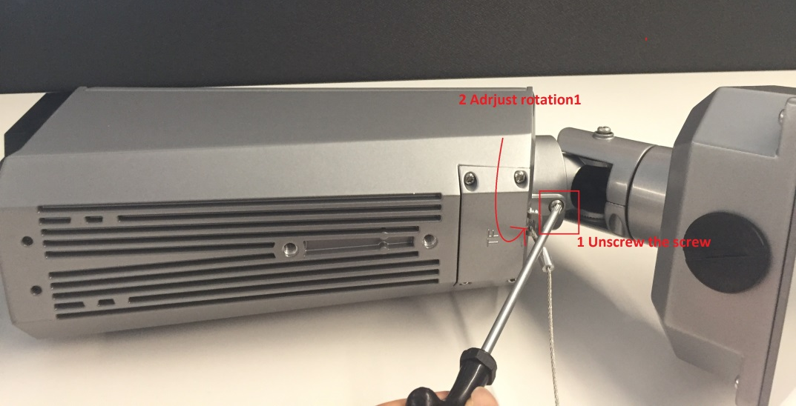
- Install the cover on the bracket
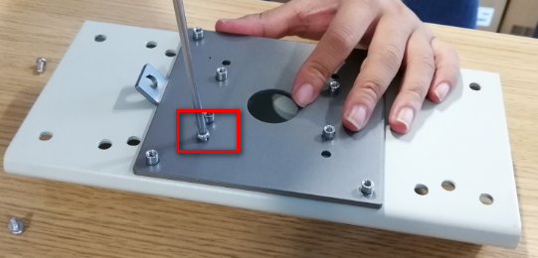
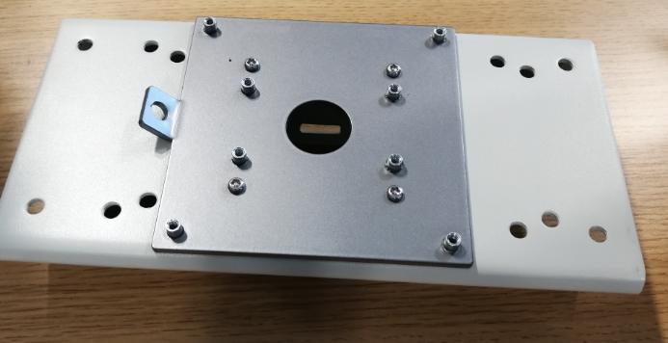
- Screw it to the cover as shown below
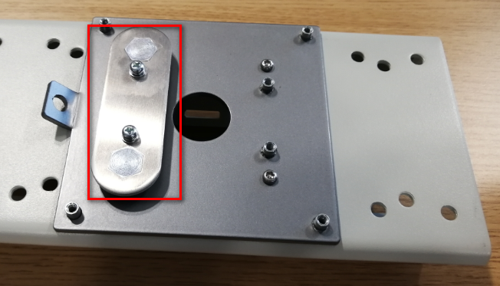
- Install the waterproof tube in the hole in the middle of the cover
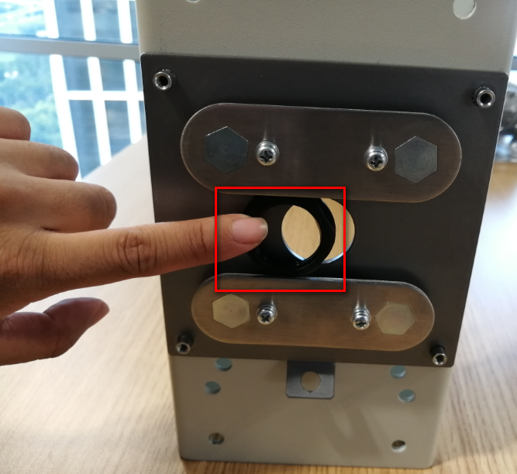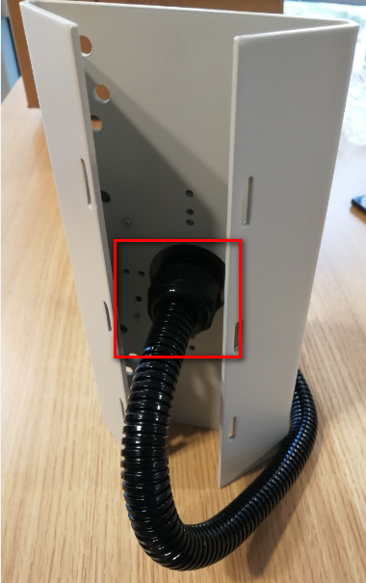

- Tighten the screws
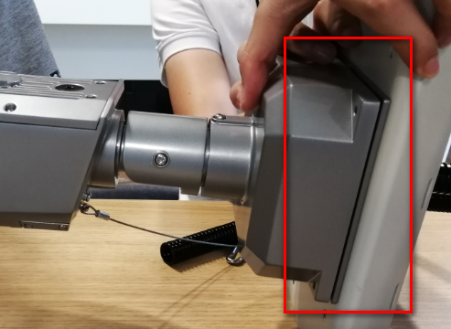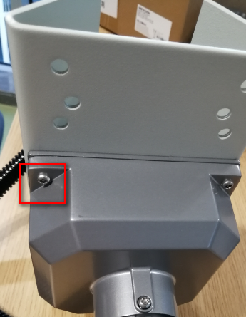

- Screw down waterproof plug
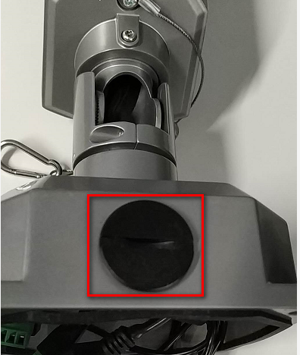
- Install sunshade cover
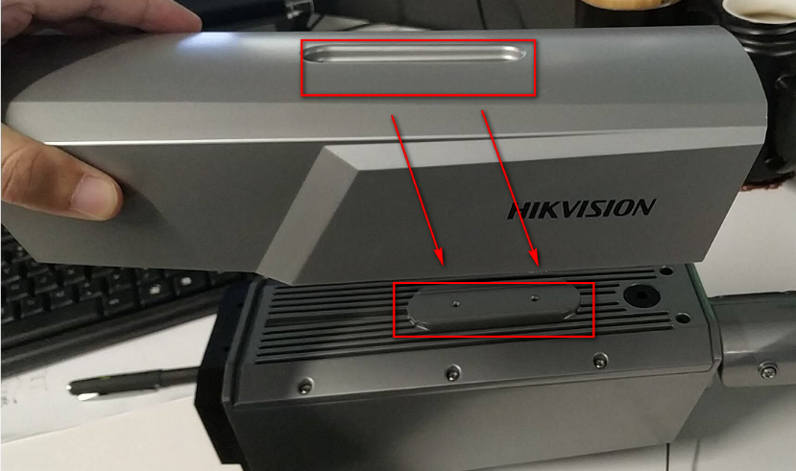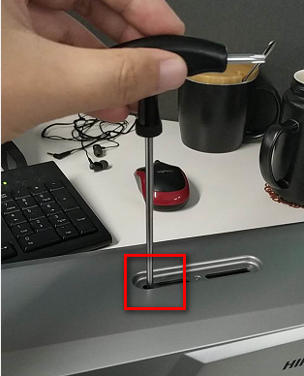
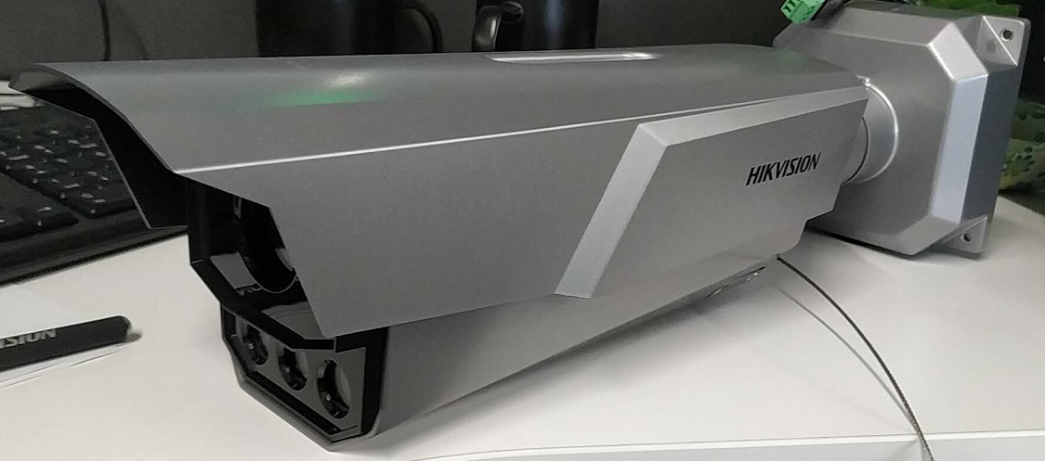

1.5 Installation with Universal bracket

1.5.1 Camera and all accessories are as blow
No. | Pic | Name
1 |  | Camera
2 |  | Screw driver
3 |  | Seal cover
4 |  | Waterproof pipe
5 |  | Sunshade cover
6 | 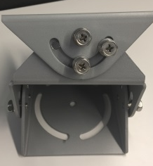 | Universal bracket
7 | 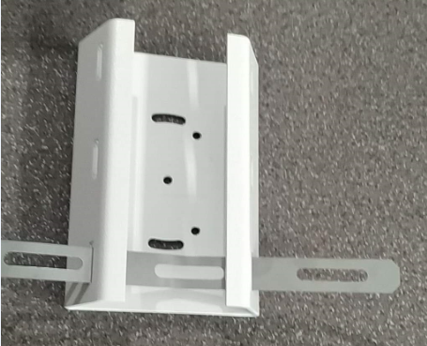 | Hoop & brackets

1.5.2 Adjust rotation angel and vertical angel
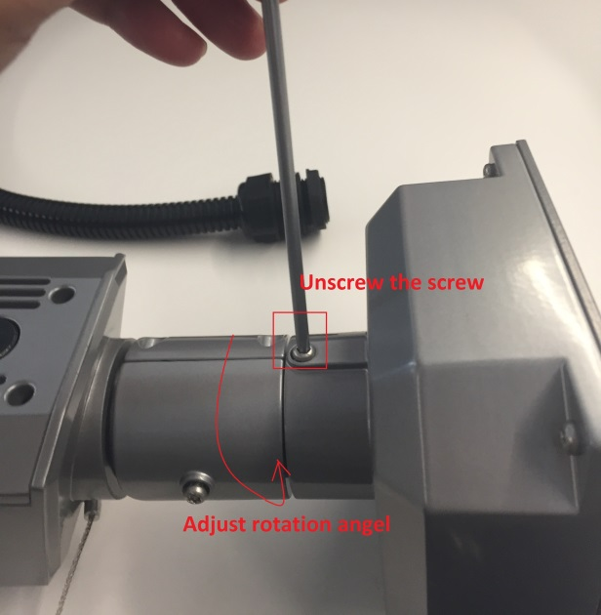
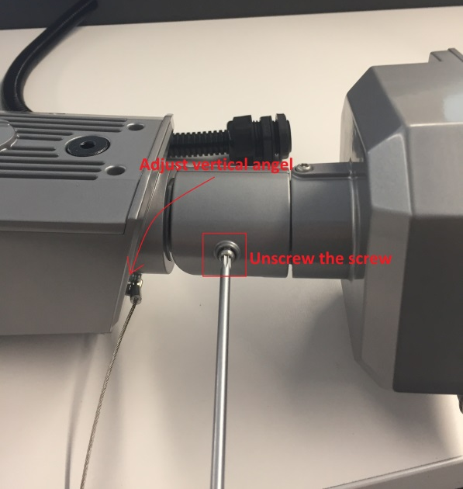

1.5.2 Adjust camera rotation
Use screw driver to unscrew the screw as below, then you can adjust rotation to make TF at the below side.

1.5.3 Install seal cover
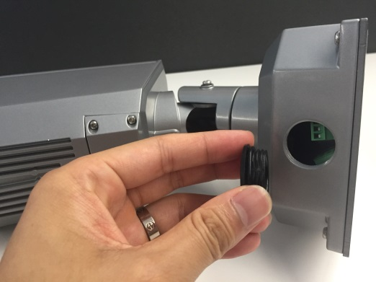
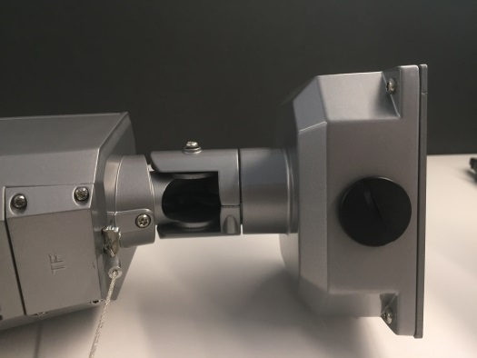

1.5.4 Install sunshade cover
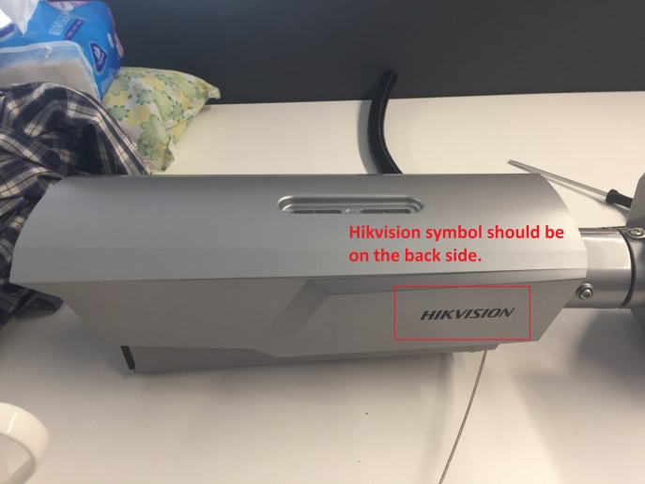
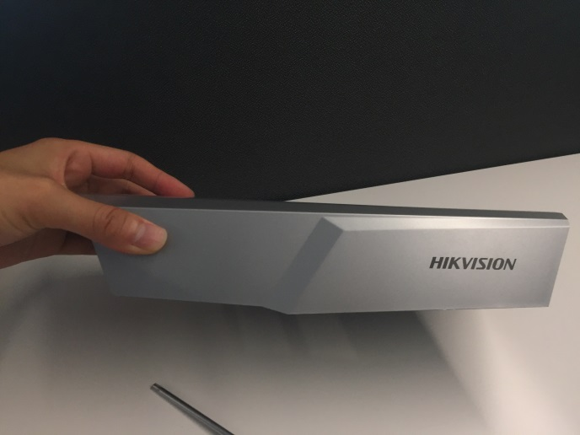

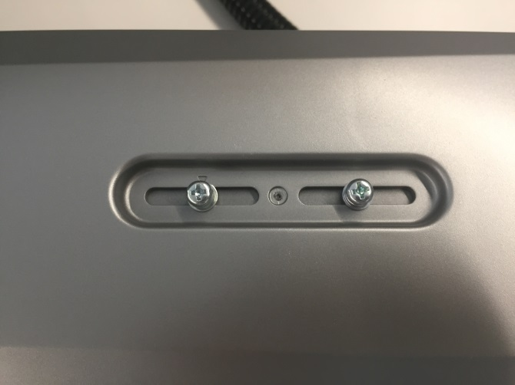
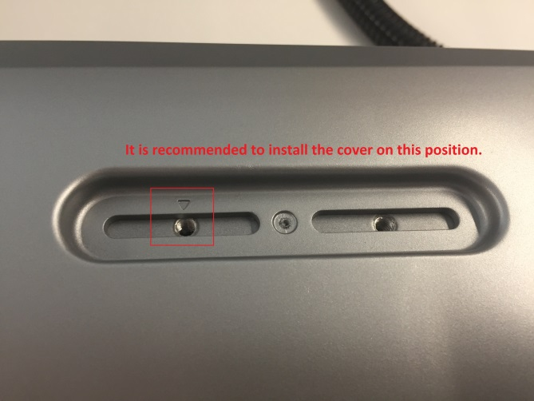

1.5.5 Finish net cable and power supply wiring
Screw off the four screws as in the picture below, then you can find the connection ports for net cable and 24VDC power supply.
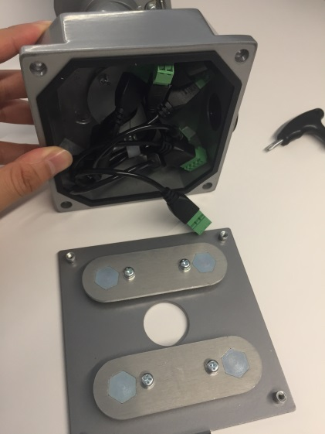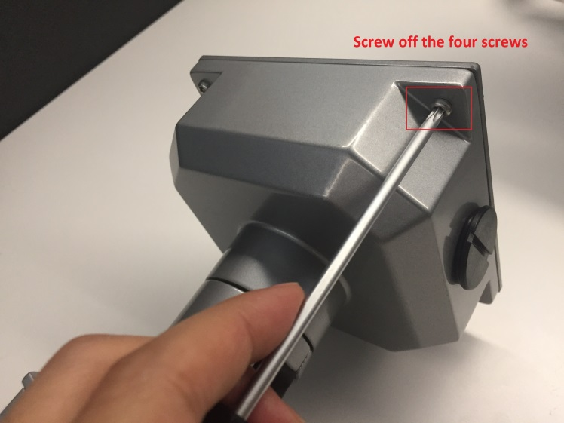
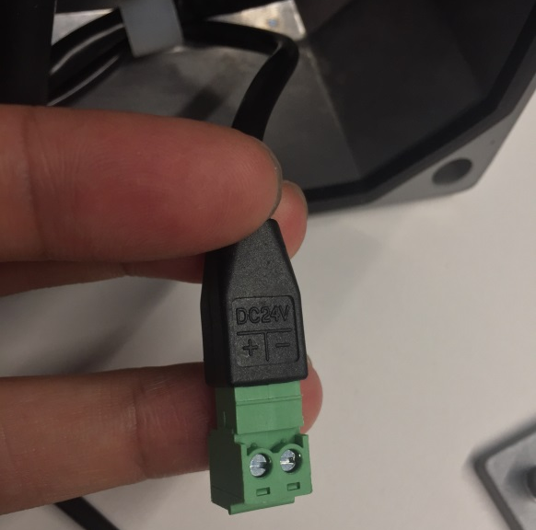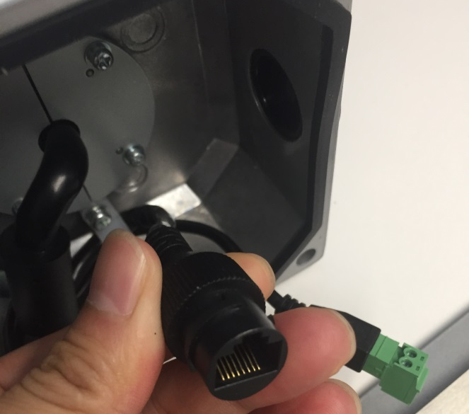

1.5.6 Install waterproof pipe
Disassemble the back plate of camera, fasten the waterproof pipe on the plate, and finally assemble the plate back to camera.
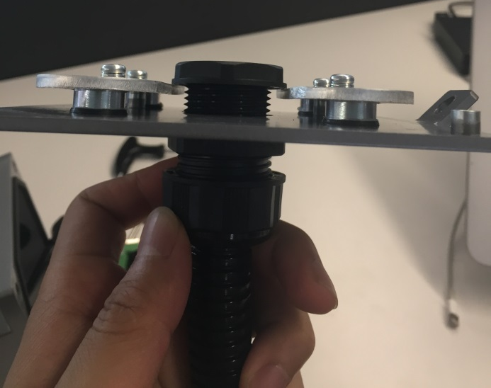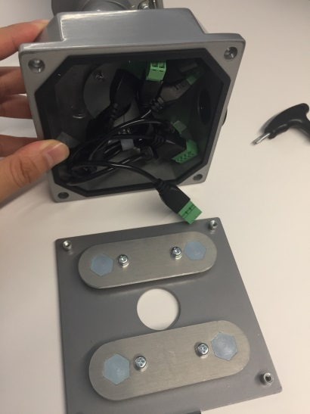

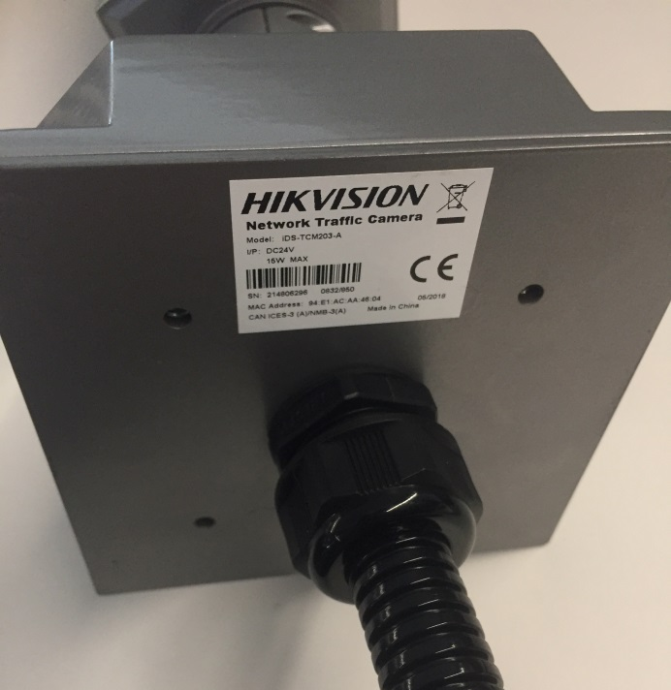

1.5.7 Install camera with universal bracket and steel hoop
I. There are two holed threaded holes on the bottom side of camera, which is for connection with universal bracket as below.
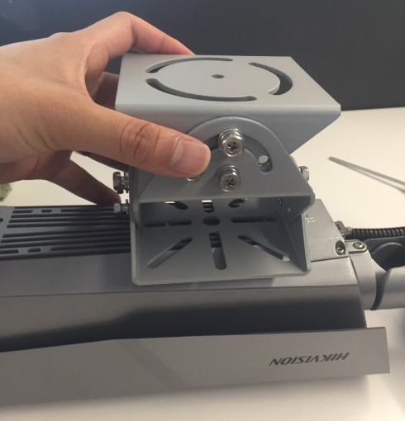
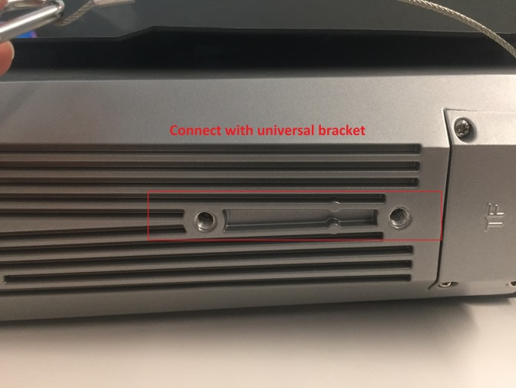

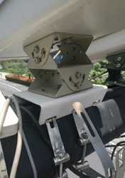

1.5.8 Install pipe and cabling from the side
Combine seal cover and cushion ring together.
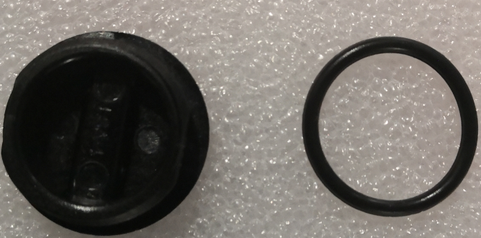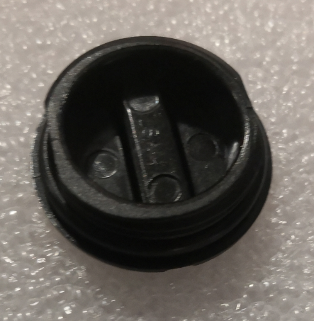
Screw seal cover to the hole on the back panel. And fix by screw ring.
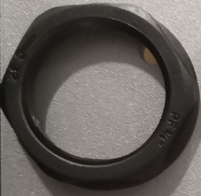
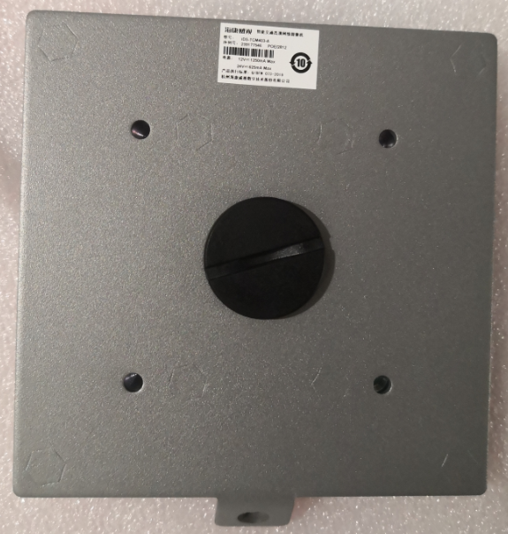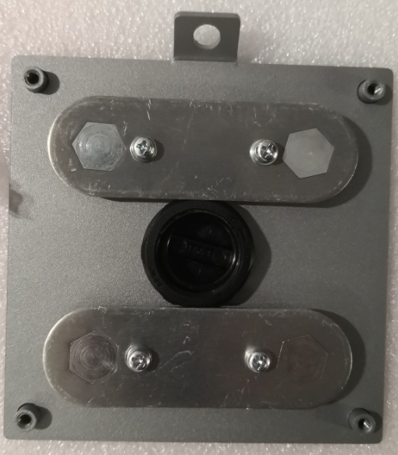
Screw and fix pipe with connector to the hole on side panel.
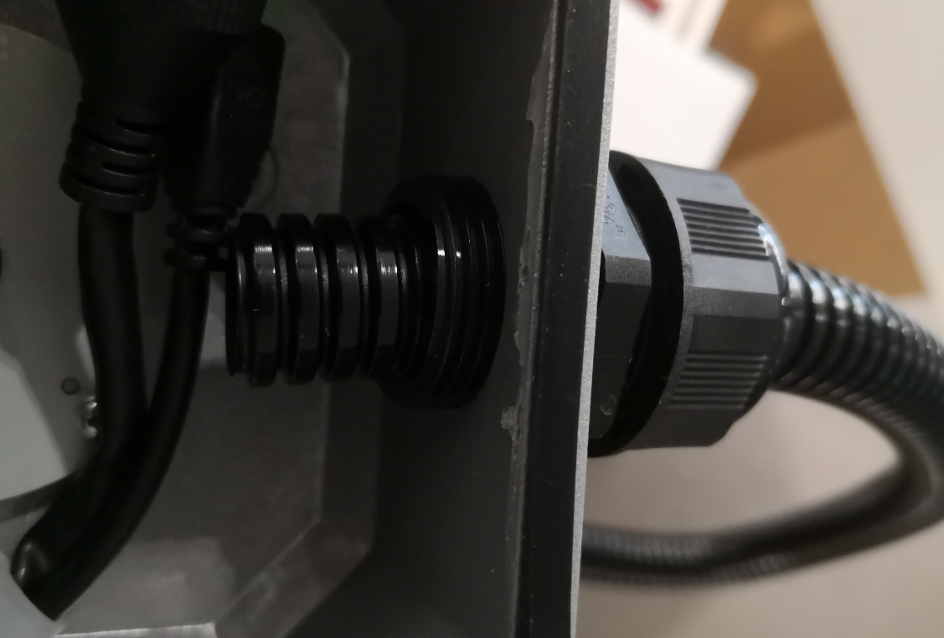

Chapter 2 Tools & Materials
Site tools list
Construction permit issued by transport management department | 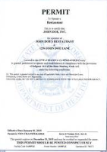
Crane | 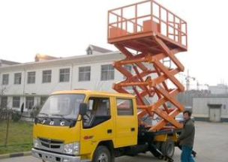  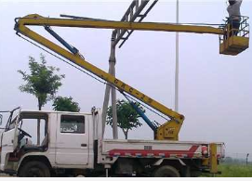
local vehicle number plate car | 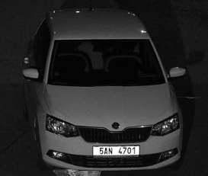
Ladder(3 meters height) | 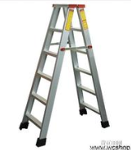
Safety rope | 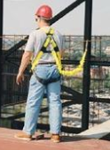
Safety helmet | 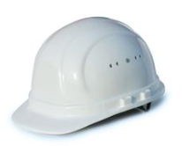
Reflective Vest | 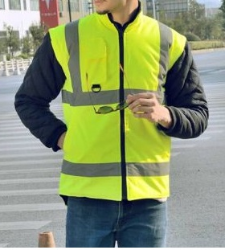
Reflective road cone | 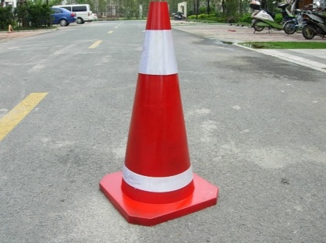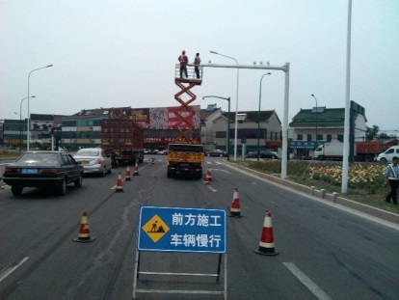
Road(lane) ahead closed mark | 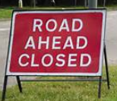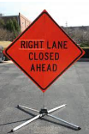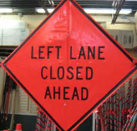
Net cable clamp | 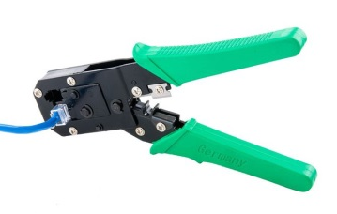
Spanner | 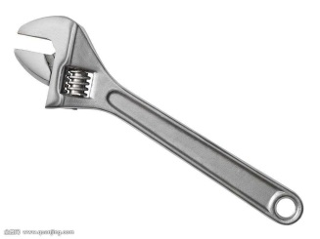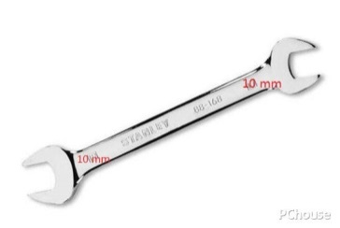
Screwdriver | 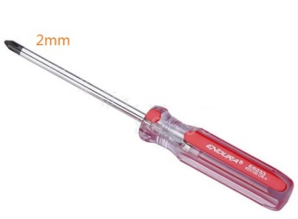  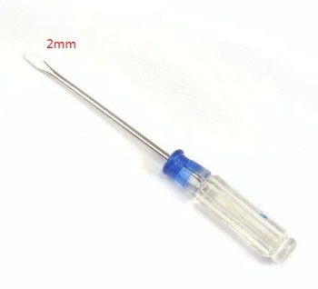
Hexagon socket key set | 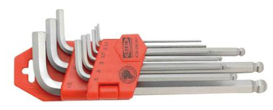
Meter ruler(100m) | 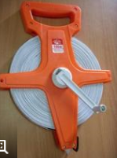
Multi meter
Power cable 1.5mm^2 | 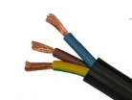
Net cables | 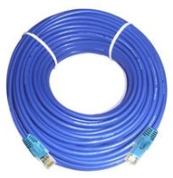
Light control signal cable | 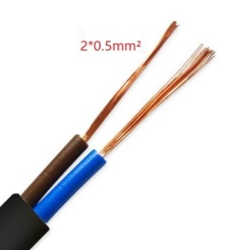
Control line(only used for intersection violations system) | 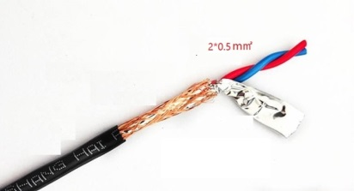
Plastic tie | 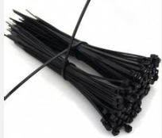
Electrical insulation type | 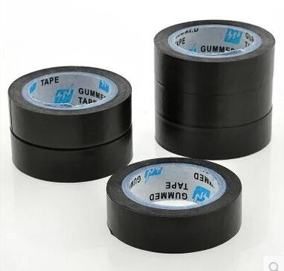
Corrugated pipe | 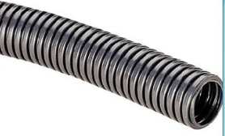
Main power for all the devices
Outdoor cabinet | 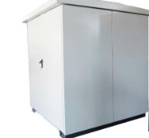

www.hikvision.com

