3rd generation of DeepinMind NVR V4.40.720_210311 Release Notes
(2021-4-15)
Firmware  Basic Information | Firmware Version: | V4.40.720_ build 210311
 | SDK Version: | V6.1.6.40_build20210204
 | Play Library (PlayCtrl.dll) | V7.3.8.45
 | Web version | V4.0.1.0build210309
 | Client version | V3.4.2.1 build20210310
Reason of Upgrade
Release new generation DeepinMind models and add new features.
Release new models
New naming rule: Models follow the new rule of NVR naming. The main change is that the number at the end that represents channels of intelligent function no longer appears.
New features
- Increase another engine
Now DeepinMind NVR increase an extra engine, so iDS-76/77/9600NXI-I/X support hybrid intelligence mode, you can configure two engine types simultaneously (Perimeter Protection, Face Recognition and Video Structuralization). The iDS-76/77/9600NXI-I/S can use Perimeter Protection only.
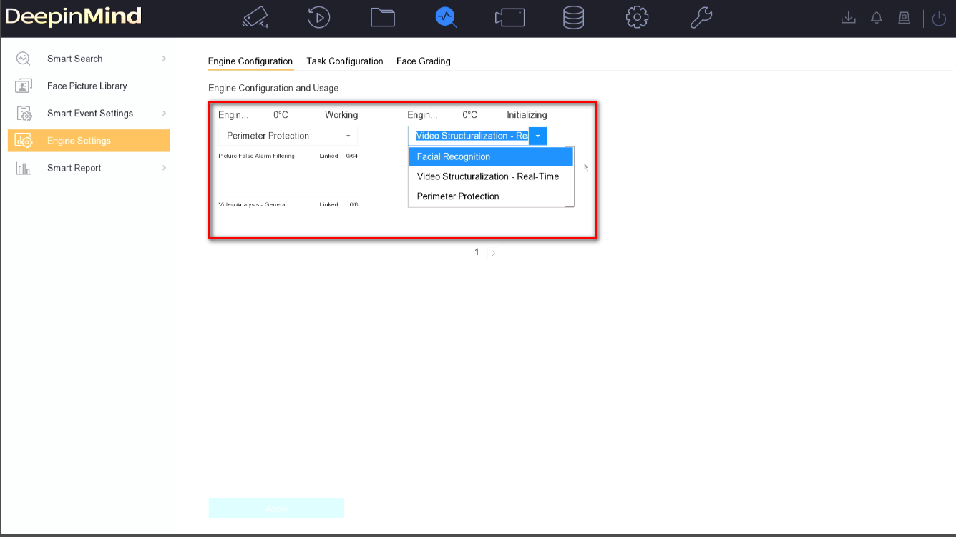
- Intelligent performance upgrade
Due to extra engine, now DeepinMind NVR can use more channels intelligent analysis. Please refer to the spec of corresponding models.
Modified functions
- Modified HDD access
Now it support access 10TB HDD.
- Modified face grading parameter
Due to the optimization of the algorithm for face detection, the range of the Pan Angle in face grading has been expanded from ±90 degrees to ±120 degrees.
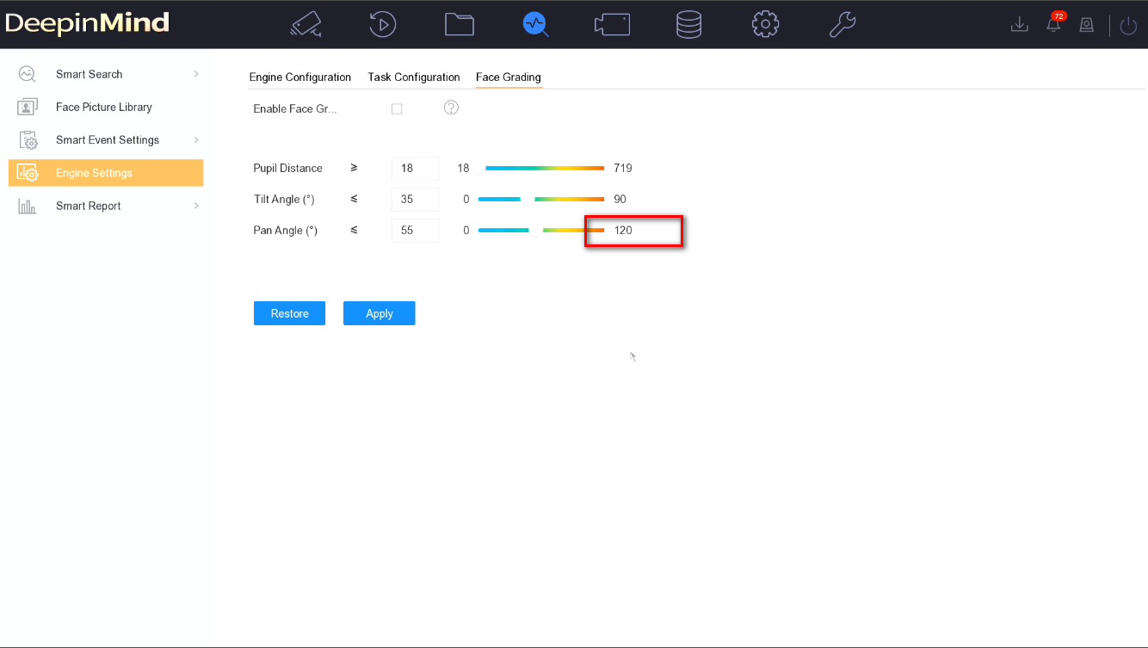
Related product list:
3rd generation of DeepinMind NVR | Overseas (8/16/32/64 channels)  iDS-6708NXI-I/FA  iDS-6708NXI-I/FA  iDS-7608NXI-I2/X  iDS-7608NXI-I2/X  iDS-7616NXI-I2/X  iDS-7616NXI-I2/X  iDS-7608NXI-I2/8P/X  iDS-7616NXI-I2/16P/X  iDS-7608NXI-I2/8P/X  iDS-7616NXI-I2/16P/X  iDS-9616NXI-I16/X  iDS-9616NXI-I16/X  iDS-9632NXI-I16/X  iDS-9632NXI-I16/X  iDS-9664NXI-I16/X  iDS-9664NXI-I16/X  iDS-9616NXI-I8/X  iDS-9616NXI-I8/X  iDS-9632NXI-I8/X  iDS-9632NXI-I8/X  iDS-9664NXI-I8/X  iDS-9664NXI-I8/X  iDS-7716NXI-I4/X  iDS-7716NXI-I4/X  iDS-7732NXI-I4/X  iDS-7732NXI-I4/X  iDS-7716NXI-I4/16P/X  iDS-7716NXI-I4/16P/X  iDS-7732NXI-I4/16P/X  iDS-7732NXI-I4/16P/X  iDS-7732NXI-I4/16P/S  iDS-9616NXI-I8/S  iDS-9632NXI-I8/S  iDS-9664NXI-I8/S  iDS-6716NXI-I/S  iDS-7732NXI-I4/S  iDS-7716NXI-I4/S  iDS-7716NXI-I4/16P/S  iDS-7732NXI-I4/16P/S  iDS-7732NXI-I4/S  iDS-7716NXI-I4/16P/S  iDS-7716NXI-I4/S  iDS-6716NXI-I/S  iDS-9664NXI-I8/S  iDS-9616NXI-I8/S  iDS-9632NXI-I8/S
Customer Impact and Recommended Action
This new firmware upgrade is to improve product performance, and will take effect automatically after upgrading from previous versions. We’d like to inform you the above changes. Also, we are sorry for any possible inconvenience of use-habit changes caused by this action.
For questions or concerns, please contact our local technical support team.
Note:
- Hikvision has all rights to alter, modify and cancel this notice.
- Hikvision doesn’t give any guarantee for old models’ stock.
- Hikvision is not liable for any typing or printing errors.
- For special model’s change details, please contact our local technical support team.

Hikvision Digital Technology CO., Ltd.
No. 555 Qianmo Road, Binjiang District, Hangzhou 310052, China
Tel: +86-571-8807-5998
FAX: +86-571-8993-5635
Email: support@hikvision.com

