Turbo HD DVR V4.26.120 build 210304 Release Notes
(2021-02-23)
Firmware  Basic Information | Firmware Version: | V4.26.120 build 210304
 | SDK Version:: | V6.1.6.4_build20200925
 | Onvif： | V2.2
 | Player： | 4.810mini
 | Player library： | 7.3.5.0
 | Web version： | V4.0.1 build 210105
 | Client version： | V3.5.0.4E

Reason of Upgrade
- Add some new features, modify some functions, and enhance product quality to meet the customers’ requirements.
Main update
- iDS-7204HQHI-M1/FA(C),iDS-7208HQHI-M1/FA(C),iDS-7208HQHI-M2/FA(C),iDS-7204HUHI-M1/FA(C),iDS-7204HUHI-M2/FA (C) are developed based on new platform.
- When enable motion 2.0, the audible warming is disabled as default.
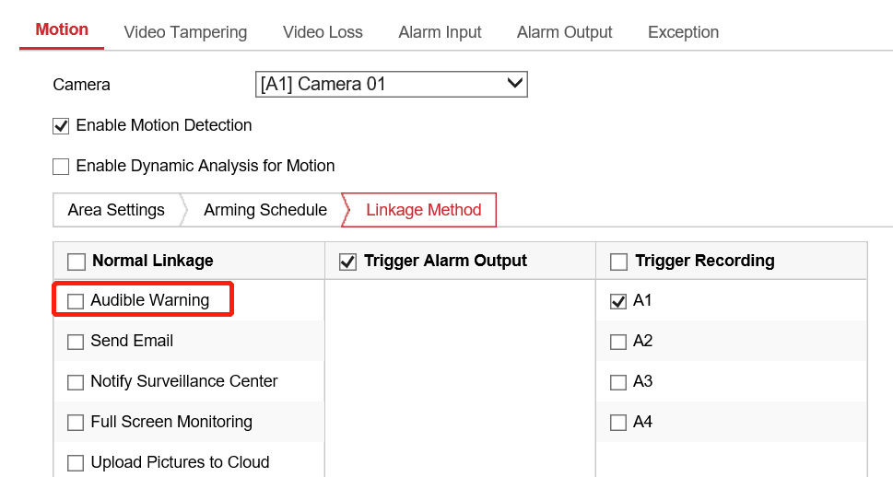

Available Modes:
K20A8FA | iDS-7204HQHI-M1/FA(C)  iDS-7208HQHI-M1/FA(C)  iDS-7208HQHI-M2/FA(C)  iDS-7204HUHI-M1/FA(C)  iDS-7204HUHI-M2/FA (C)

Customer Impact and Recommended Action
This new firmware upgrade is to improve product performance, and will take effect automatically after upgrading from previous versions. We’d like to inform you the above changes. Also, we are sorry for any possible inconvenience of use-habit changes caused by this action.
For questions or concerns, please contact our local technical support team.

Note:
- Hikvision has all rights to alter, modify and cancel this notice.
- Hikvision doesn’t give any guarantee for old models’ stock.
- Hikvision is not liable for any typing or printing errors.
- For special model’s change details, please contact our local technical support team.

Hikvision Digital Technology CO., Ltd.
No. 555 Qianmo Road, Binjiang District, Hangzhou 310052, China
Tel: +86-571-8807-5998
FAX: +86-571-8993-5635
Email: support@hikvision.com

