**Android Indoor Station Firmware V2.1.28_210803 Release Note**

**(2021-08-05)**

|  |  |
| --- | --- |
| Device Model | DS-KH9310-WTE1, DS-KH9510-WTE1 |
| Firmware Version | Android Indoor Station : V2.1.28_210803 |
| iVMS-4200 Version | Latest baseline |
| Hik-Connect APP | Latest baseline |

**Modify**

1. Verification code is empty by default.

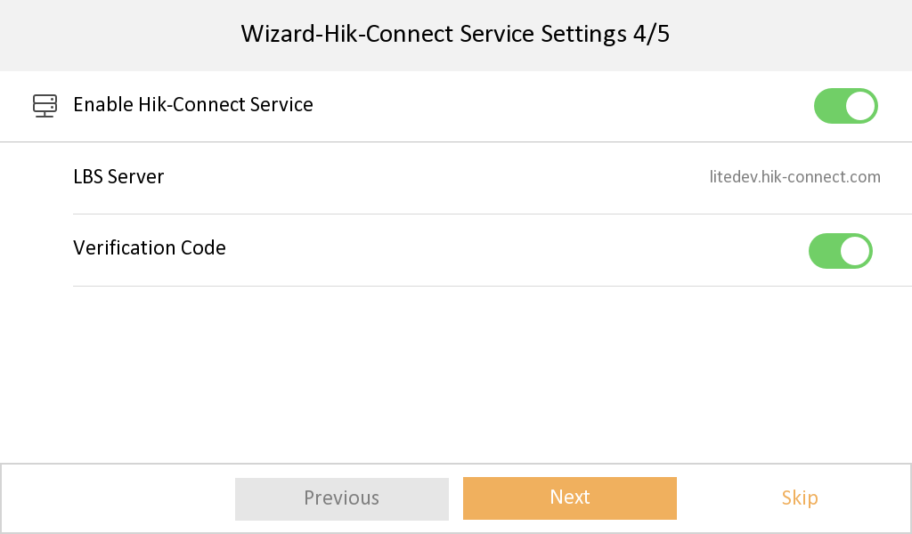

1. Hik-Connect Service Settings is changed to the place of Settings🡪 Advanced Settings🡪 Configuration🡪 System Maintenance.

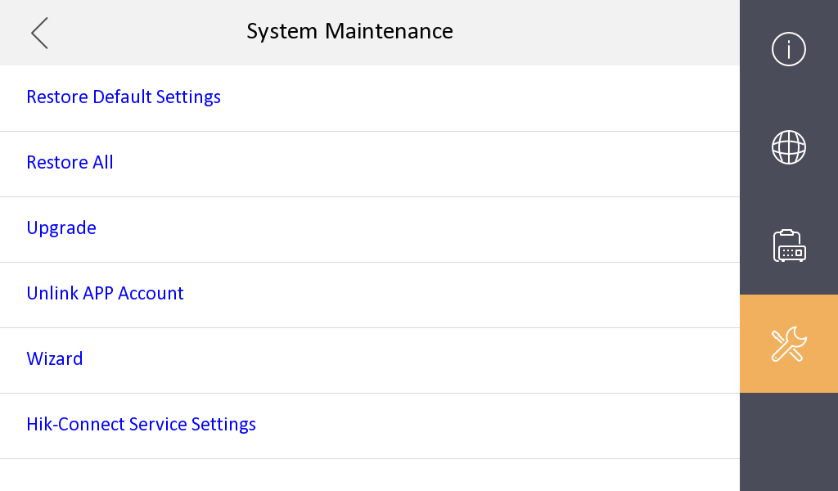

1. Fixed some bugs.

**Android Indoor Station Firmware V2.1.22_210616 Release Note**

**(2021-06-16)**

|  |  |
| --- | --- |
| Device Model | DS-KH9310-WTE1, DS-KH9510-WTE1 |
| Firmware Version | Android Indoor Station : V2.1.22_210616 |
| iVMS-4200 Version | Latest baseline |
| Hik-Connect APP | Latest baseline |

**Modify**

1. Optimize the compatibility with door station in protocol 1.0 firmware.

2. Solved the problem that the custom ringtone did not take effect after restarting.

**Android Indoor Station Firmware V2.1.22_210525 Release Note**

**(2021-06-03)**

|  |  |
| --- | --- |
| Device Model | DS-KH9310-WTE1, DS-KH9510-WTE1 |
| Firmware Version | Android Indoor Station : V2.1.16_210316 |
| iVMS-4200 Version | 3.4.0.10 Build201214 |
| Hik-Connect APP | 4.11.0.927220 |

**New Function**

1. On the basis of supporting English, French, Spanish, German, Italian, newly added

multi-language Polish, Portuguese (Brazil), Russian, Turkish, Hungarian, Dutch, Romanian, Czech, Bulgarian, Ukrainian.

2. Add Hik-Connect Service Settings in Wizard.



**Modify**

1. Hik-Connect service is disabled by default for privacy protection and add Enable Switch for verification code display in Hik-Connect Server Settings.





**Android Indoor Station Firmware V2.1.16_210316 Release Note**

**(2021-03-18)**

|  |  |
| --- | --- |
| Device Model | DS-KH9310-WTE1, DS-KH9510-WTE1 |
| Firmware Version | Android Indoor Station : V2.1.16_210316 |
| iVMS-4200 Version | 3.4.0.10 Build201214 |
| Hik-Connect APP | 4.11.0.927220 |

**New Function**

1. Repair the custom ringtone failure after restart。

**Modify**