Main station
V1.0.34_220223
Release Note (2022-03-11)

1．Firmware Basic Information
Device Model:  DS-KM9503 | Firmware Version | V1.0.34_220223
 | SDK Version | Latest baseline
 | iVMS 4200 Version | Latest baseline
Notes:
- Please update firmware to the latest version to ensure the perfect user experience.
- It is strongly recommended that you to upgrade the device which is based on a version 1.0.32 by a USB flash drive.
Step:
(1)Copy the “digicap.dav” file to the USB disk and connect to USB1 or USB2 ports.
(2)To [Configuration]> [System maintenance]>[upgrade] and then upgrade the device.
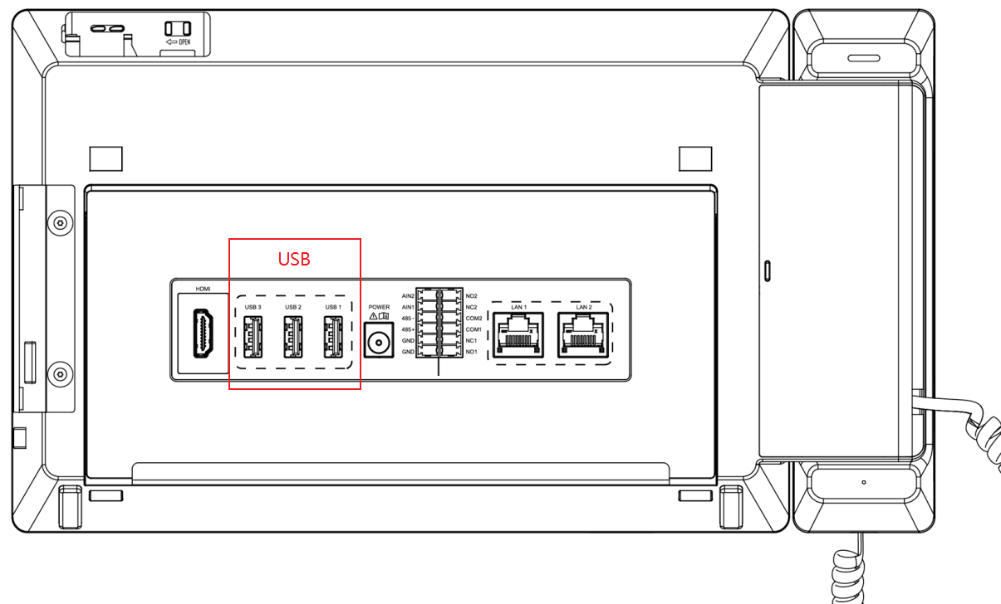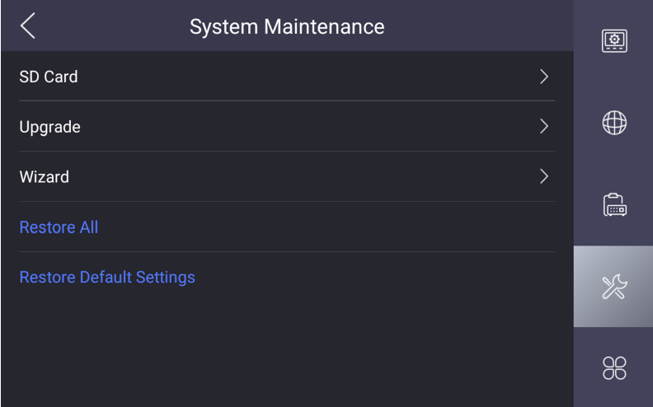
2. Reason for Upgrade
9 series main station has required for supporting for the increasing language.

3. New Features
Since the new version, the operating system languages include: English, French, Portuguese, Spanish, Russian, German, Italian, polish, Turkish, Vietnamese, Arabic, Czech, Hungarian, Dutch, Romanian, Bulgarian, Ukraine, Croatia, Serbia, Lithuania, Estonia, Latvia, Norway, Greece, and Denmark.

4. Modified
- Optimized the registration logic of Main station to improve the device accessing performance.
- Optimized the performance of the Third-party APP working in an internet environment. To make an improvement for the internet connecting.

Note:
- Hikvision has all rights to alter, modify and cancel this notice.
- Hikvision doesn’t give any guarantee for old models’ stock.
- Hikvision is not liable for any typing or printing errors.
- For special model’s change details, please contact our local technical support team.

Hikvision Digital Technology CO., Ltd.
No. 555 Qianmo Road, Binjiang District, Hangzhou 310052, China
Tel: +86-571-8807-5998
FAX: +86-571-8993-5635
Email: support@hikvision.com

