Video Intercom Firmware V1.5.1 Release Notes Station Release Note
(2019-02-19)
Device Model: | Firmware Version | Indoor Station/Master Station V1.5.1bulid190131  H0/H5 Platform Door Station V1.5.1build190130  H2 Platform Door Station V1.5.1build190130
 | SDK Version | HCNetSDK V6.0.0.25_build20181220
 | iVMS4200 Version | V2.7.1.1build20190111
 | Hik-Connect APP | 3.7.3.190115
 | Batch tools | V1.0.1.8build20190114

Reason of Upgrade
Optimize the legacy issues of the V1.5.0 baseline version and implement several new features;

New Features
1. The villa door station supports uploading the tamper alarm to main indoor station (Max.4), master station and iVMS-4200 Client;
2. The indoor station supports local display serial number and verification code;
1) The indoor station supports local display serial number in the Maintenance of the local UI;
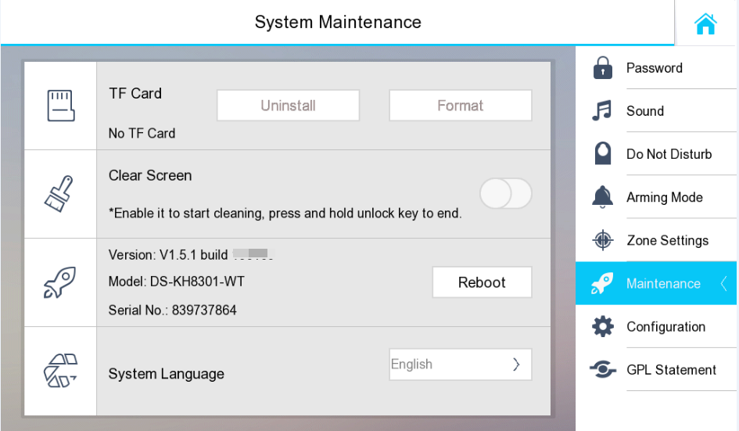
2) View the verification code in the Settings->Configuration->HikConnect;
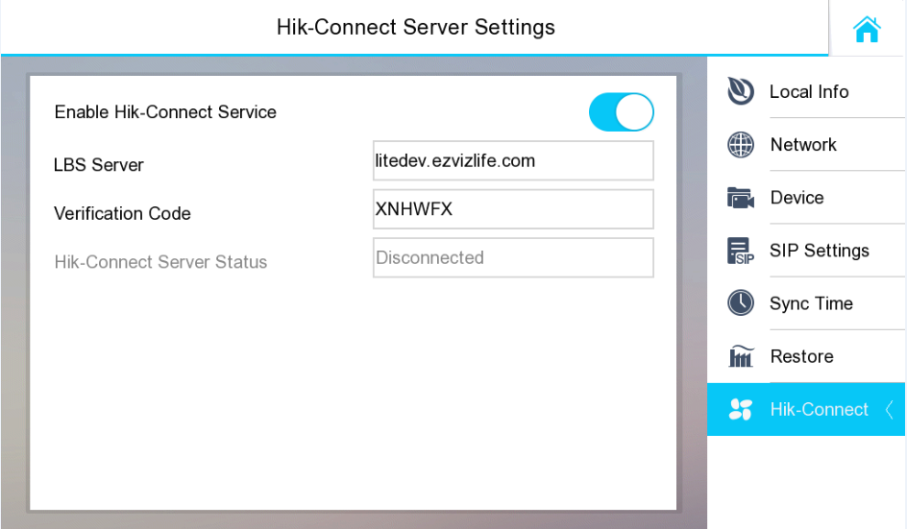
3. Door station support address list function;
1) Import the address list to the apartment door station through iVMS-4200, and support up to 500 households;
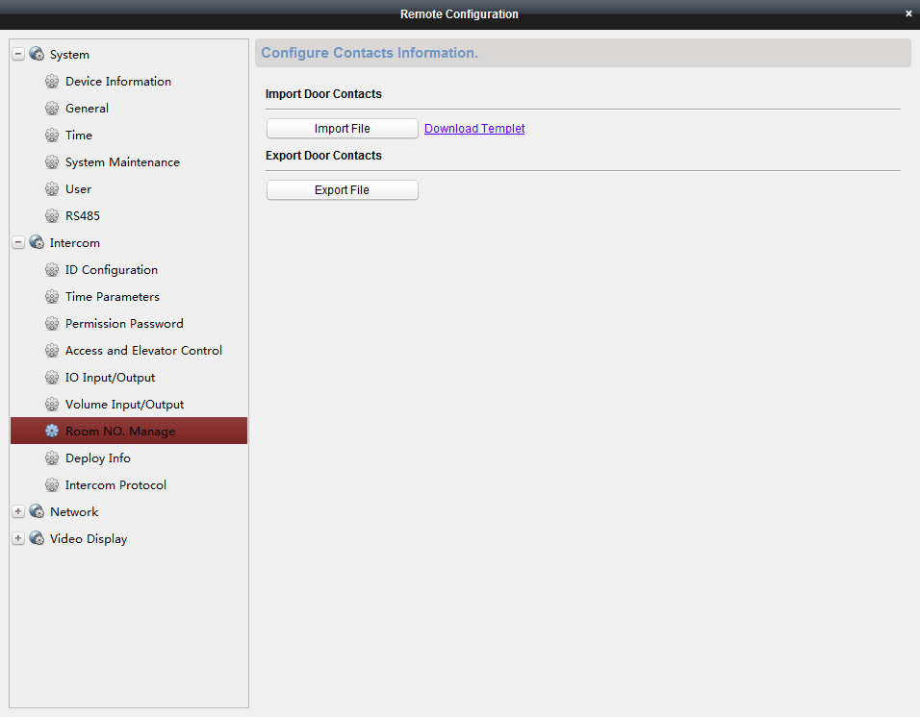
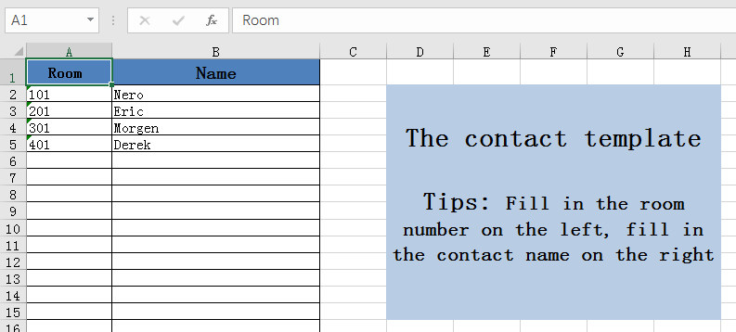
2) The apartment door station can view the address list, and the call can be made after selecting the corresponding person;
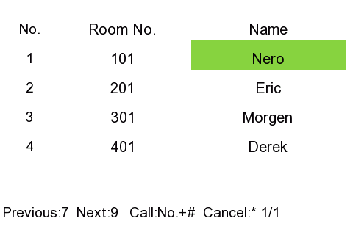
4. The touch sound and the call volume are separated;
1) The device can configure the touch sound and the call volume in the remote configuration interface;
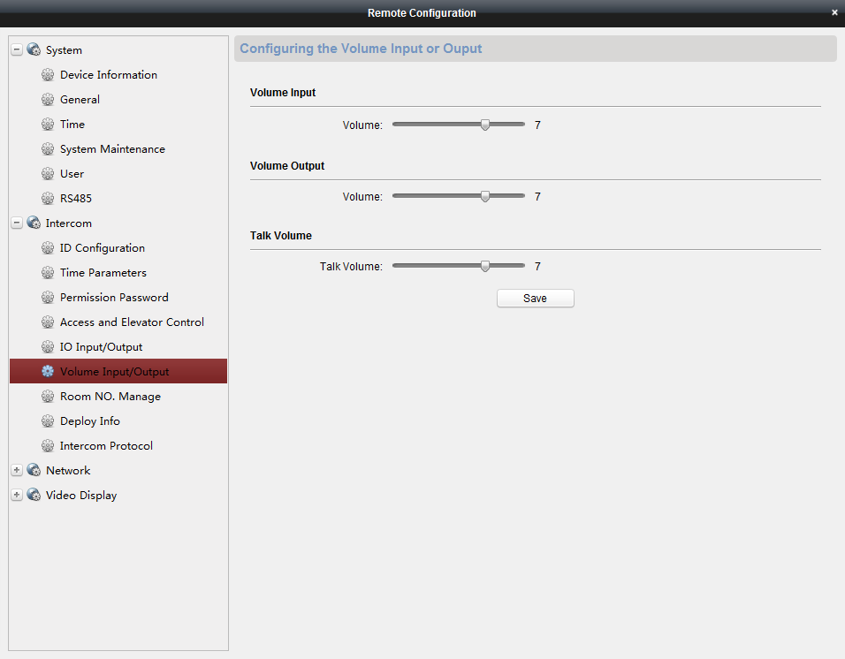
2) After the configuration is completed, the volume of the call between the door station and the indoor station depends on the call volume. The volume of local operation of the door station depends on the touch sound, and the default size is 7.
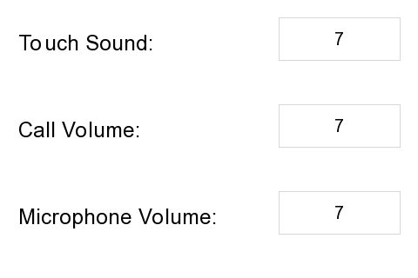
Modified Features
1. The door station removes the prompt that ‘I am not at home currently, please leave the message’, directly prompts ‘Please press the key and leave the message’;
2. The door station and indoor station floor number can be set to 0.
3. Modify the mechanism of the villa door station call master station.
1) Cancel the difference between long press and short press.
2) Can choose to call indoor station or master station.
The configuration is as shown below.
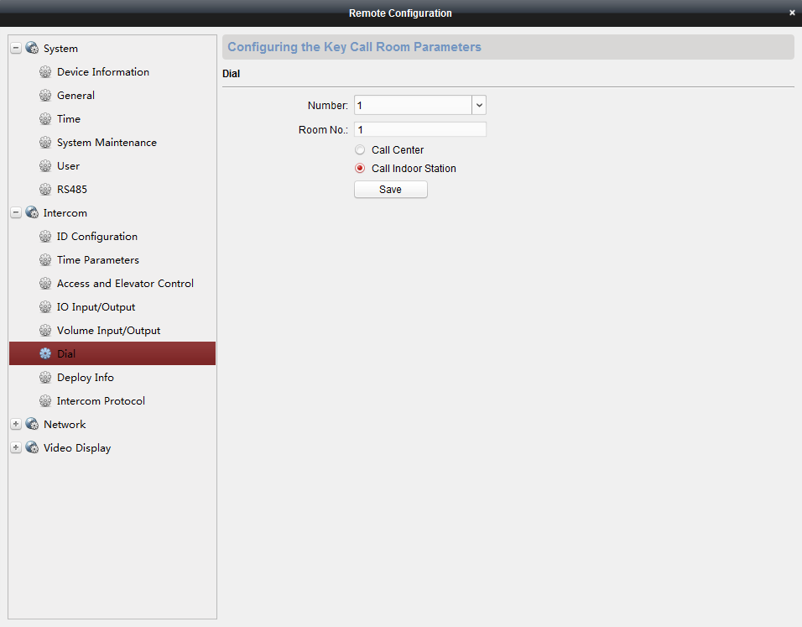

Fix Bug
1. Fix a bug that when the indoor station is restarted, the imported ringtone will be invalid;
2. Fix a bug that iVMS-4200 client fails to synchronize time with indoor station;
3. Fix a bug that the DVR and NVR cannot add door stations for recording;
4. Fix a bug that indoor station is not compatible with preview new IP camera (5serie & 7 serie).

Customer Impact and Recommended Action
This new firmware upgrade is to improve product performance, and will take effect automatically after upgrading from previous versions. We’d like to inform you the above changes. Also, we are sorry for any possible inconvenience of use-habit changes caused by this action.
For questions or concerns, please contact our local technical support team.
Note:
- Hikvision has all rights to alter, modify and cancel this notice.
- Hikvision doesn’t give any guarantee for old models’ stock.
- Hikvision is not liable for any typing or printing errors.
- For special model’s change details, please contact our local technical support team.

Hikvision Digital Technology CO., Ltd.
No. 555 Qianmo Road, Binjiang District, Hangzhou 310052, China
Tel: +86-571-8807-5998
FAX: +86-571-8993-5635
Email: support@hikvision.com

