Device Model: | Firmware Version | Indoor Station/Master Station V1.5.0bulid180622  H0/H5 Platform Door Station V1.5.0build180613  H2 Platform Door Station V1.5.0build180623
 | SDK Version | HCNetSDKV5.3.5.10_build20180108_win32
 | iVMS4200 Version | V2.7.1.9 build20180604
 | Hik-Connect APP | 3.4.1.0402
Video Intercom Firmware V1.5.0 Release Notes (2018-08-09)
Note: After upgrading to new firmware, manually restore default setting for fully upgrade.

Reason of Upgrade
Added or modified functions, enhance products quality and meet customers’ requirements.
Update the statement of standard sip

New Features
- Support 5 (English, French, Portuguese, Russian, Spanish) system language and voice prompt tone. Language can be selected in iVMS4200 remote configuration or in device local interface and will change after reboot.
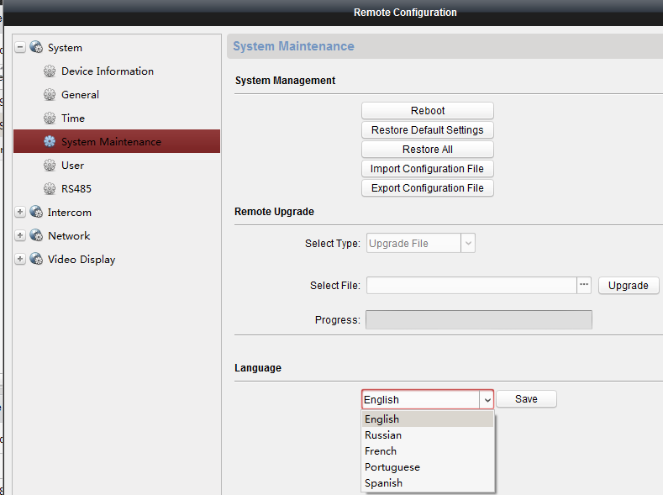
- Indoor station and KD series door station support standard SIP protocol, it can be selected in in iVMS4200 remote configuration or in device local interface(only indoor station) and will change after reboot.
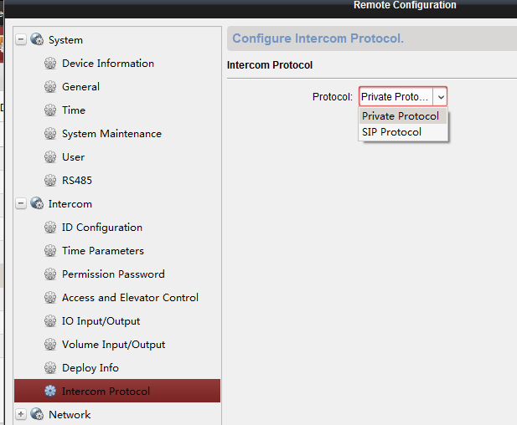
Stanard SIP Protocal Version: Sip 2.0
Video Format: H.264
Audio Fromat: G.711U
SIP Server tested: Brekeke
SIP Server not compatible : 3CX
SIP Phone tested:
(1) YEALink (T46G): only audio intercom
(2) Grandstream (GXV3275): audio & video intercom
Function support & not support with standard sip protocol mode:
(1) Master station, indoor station and door station video intercom
(2) Master station, indoor station monitoring door station
(3) Master station, indoor station and SIP phone unlocking door station
(4) KV series villa door station do not support standard SIP
(5) Indoor extension mode not supported
(6) Sub door station mode not supported
(7) APP connection not supported
(8) Door phone mode not supported
(9) Only works in local network
- Support control two locks:
- Lock-1 is the lock connected directly to the relay of door station, and lock-2 is the lock connected to security module DS-K2M060 and security module use RS485 to connect to door station (security module RS485 address dial “1”, and choose “access control module” for the RS485 mode)
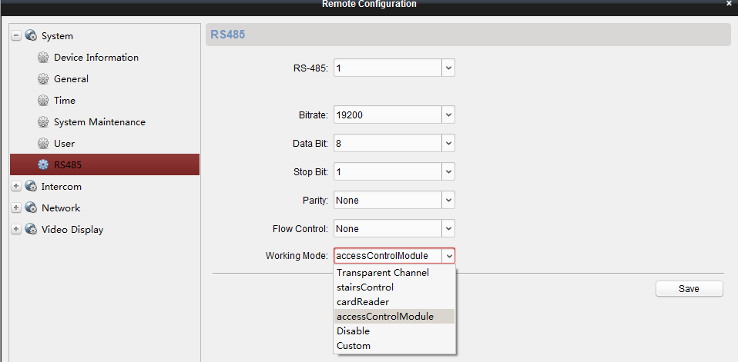
- iVMS4200, indoor station and Hik-Connect can control 2 locks.
- For mater station and DS-KH6210-L, Long press unlock button to unlock lock-2, short press unlock button to unlock lock-1.
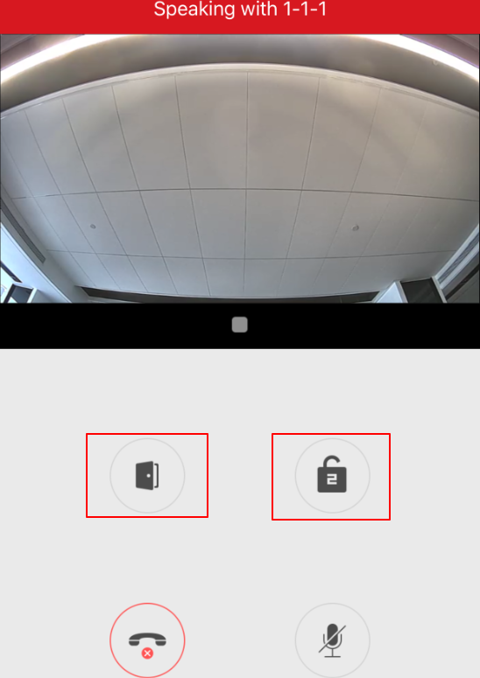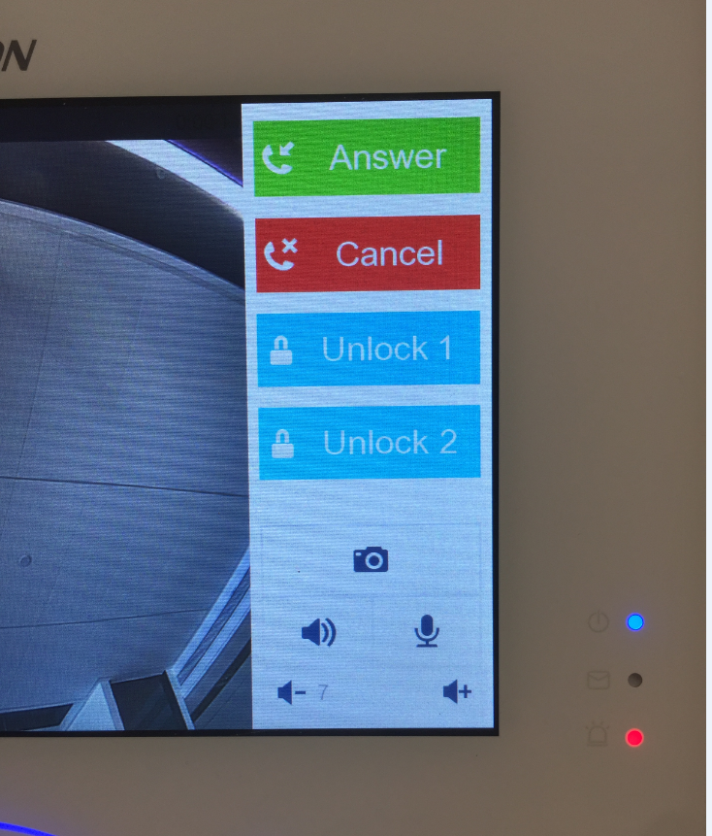
- Security mode for door station support to connect exit button, not support to connect wiegand card reader.
- Support 3 network connecting modes for Hik-Connect application :
- Indoor station only use UTP which can connect to the internet, it can connect to the cloud and support Hik-Connect application.
- The –W indoor station only use Wi-Fi which can connect to the internet, it can connect to the cloud and support Hik-Connect application.
- The –W indoor station use both Wi-Fi and UTP, when the Wi-Fi can connect to the internet, it can connect to the cloud and support Hik-Connect application.
- Main indoor station and indoor extensions can call between each other:
Dialing format: 0-No. Main indoor No. is 0, other extension is 1 to 5.
- When Indoor station/master station monitoring door station, there is a icon ‘Enbale’ to trigger 2-way audio between indoor station and door station(only support in private sip mode, standard sip mode cannot support).
- When monitoring door station, iVMS4200 can also enable two way audio with door station. It is not recommend to do video intercom between indoor station and door station when iVMS4200 two way audio is enabled with door station.
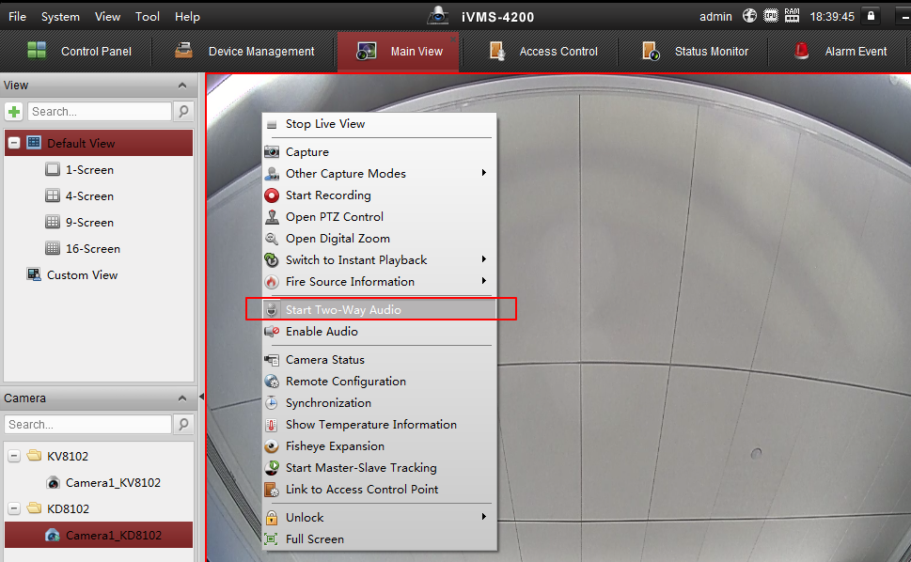
- Both KD&KV series door station can call iVMS4200. For KV series, long press call button to call iVMS4200 by default, or short press call button by setting the call mode in iVMS4200.
- Door station can also upload un-authentication card swiping record to iVMS4200.
- Door station and indoor station can be armed by multiple channels(maximum 8). Alarm information will upload to every arming channel, for example iVMS4200 and NVR, and iVMS4200 can show arming channel list in remote config>intercom>arm information
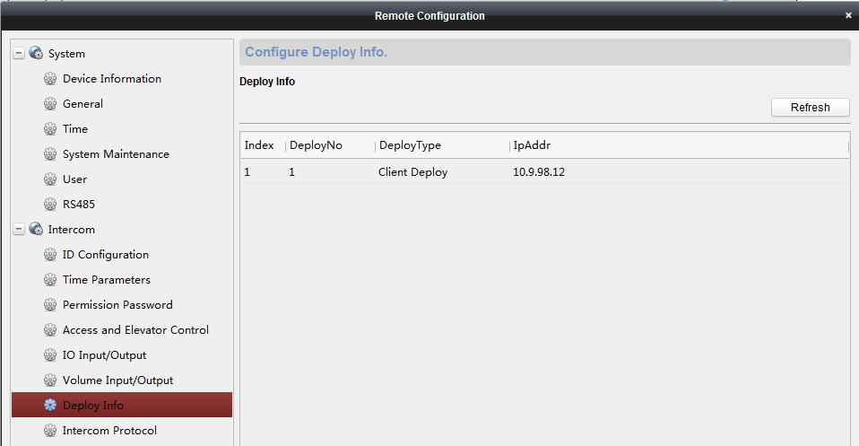
- Door station can also be used as card issuer to get card number when adding card in iVMS4200.
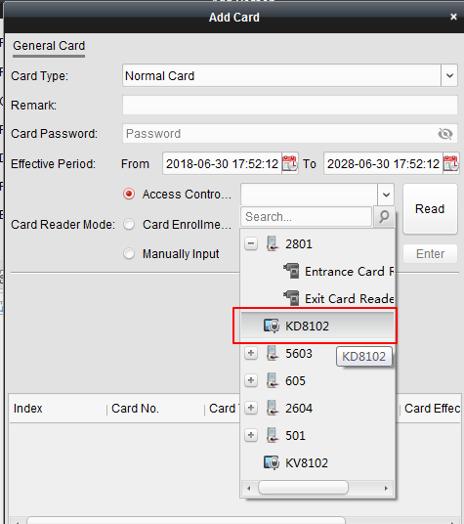
- Door station can issue card either by swipe master card or input issue card password locally. Door station’s issue card password (6 bits issue card password) can be set on iVMS4200.
- iVMS4200 support to set door station’s own public unlocking password(3 public unlocking passwords).
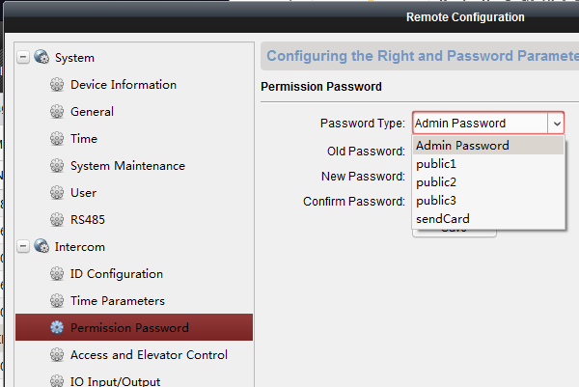
- One button push to turn off indoor station screen.
- Support domain NTP server address for time adjusting.
- The alarm-in port on indoor station can work as a ring doorbell port. If this is a “on -off” button connect to the port, and you push the button, then there will be a ringtone made by indoor station.
Modified Features
- Indoor station has room number and floor number. Room number range is 1~9999 and floor number range is 1-999.
Floor number is only used for elevator controller. If there is no elevator controller in the system, then no need to set floor number:
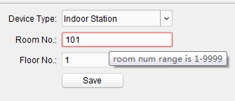
- Activation Password can support maximum 16 bits.
- Improve video stream stability in Hik-Connect, support P2P streaming.
- KD8 series door station supports 10000 cards when it is in door station mode and 50000 cards in outer door station mode;
KD3002 door station supports 10000 cards when it is in door station mode and 10000 cards in outer door station mode;
KV series villa station supports 2500 cards.

Customer Impact and Recommended Action
This new firmware upgrade is to improve product performance, and will take effect automatically after upgrading from previous versions. We’d like to inform you the above changes. Also, we are sorry for any possible inconvenience of use-habit changes caused by this action.
For questions or concerns, please contact our local technical support team.
Note:
- Hikvision has all rights to alter, modify and cancel this notice.
- Hikvision doesn’t give any guarantee for old models’ stock.
- Hikvision is not liable for any typing or printing errors.
- For special model’s change details, please contact our local technical support team.

Hikvision Digital Technology CO., Ltd.
No. 555 Qianmo Road, Binjiang District, Hangzhou 310052, China
Tel: +86-571-8807-5998
FAX: +86-571-8993-5635
Email: support@hikvision.com

