DS-K1A802A Series Terminal V1.3.0_build200321
Release Note (2020-04-10)
Device Model:  DS-K1A802AF(-B)  DS-K1A804AMF(-B)  DS-K1A804AEF(-B) | Firmware Version | ACS_1A802A_J1_EN_GM_V1.3.0_build200321
 | SDK Version | V6.1.4.10 build20200215
 | iVMS 4200 Version | V3.2.1 (will release at middle of May)
NOTE:
Firmware for DS-K1A802A series is compatible with DS-K1A802 series.

New Features
- Support ISAPI protocol (port 80);
- Support ISUP5.0 and not compatible with Ehome 4.0 and below version;
- Support 11 language: English, Spanish, Italian, French, Portuguese (Brazilian), Vietnamese, Arabic, Thai, Turkish, Indonesian, Ukrainian;
- Support authentication with pin code only (Need V3.2.1 or later version iVMS4200 );
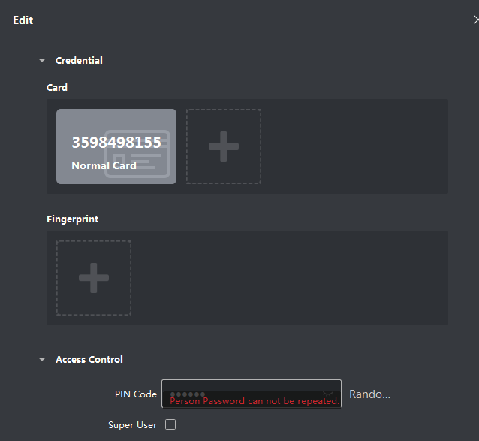

- Support export local device access records (must be encrypted) to USB pan drive and import to iVMS4200 (Need V3.2.1 or later version iVMS4200);
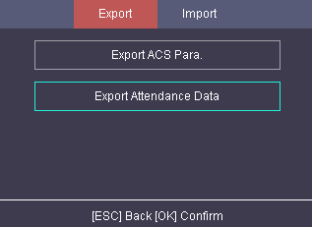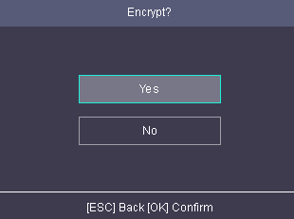
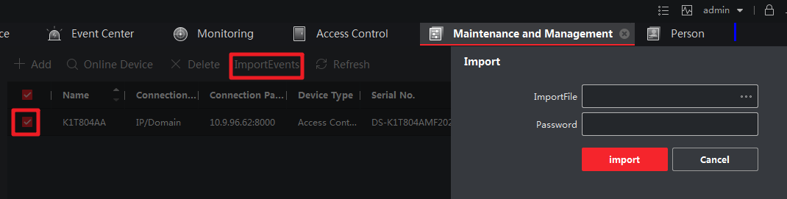

Basic Features
- Storage: Up to 3000 valid cards; Up to 100,000 event records; Up to 150,000 attendance records;
Note: Swiping Card is Not Available for DS-K1A802AF(-B).
- Fingerprint capacity: Up to 3000 fingerprints; up to 10 fingerprints for each person.

Customer Impact and Recommended Action
This new firmware upgrade is to improve product performance, and will take effect automatically after upgrading from previous versions. We’d like to inform you the above changes. Also, we are sorry for any possible inconvenience of use-habit changes caused by this action.
For questions or concerns, please contact our local technical support team.
Note:
- Hikvision has all rights to alter, modify and cancel this notice.
- Hikvision doesn’t give any guarantee for old models’ stock.
- Hikvision is not liable for any typing or printing errors.
- For special model’s change details, please contact our local technical support team.

Hikvision Digital Technology CO., Ltd.
No. 555 Qianmo Road, Binjiang District, Hangzhou 310052, China
Tel: +86-571-8807-5998
FAX: +86-571-8993-5635
Email: support@hikvision.com

