DS-K1T105A Series Terminal V1.3.1_build200528
Release Note (2020-06-06)
Device Model:  DS-K1T105AMF  DS-K1T105AEF | Firmware Version | ARM: ACS_1T201A_AI2_CN_GM_V1.3.1_build200528  MCU: ACS_DS-K1T201A_M2pro_GML_GM_V2.0.0_build200526
 | SDK Version | No update
 | iVMS 4200 Version | iVMS-4200 AC(V1.0.3.15_E)
NOTE:
Firmware for DS-K1T105A series is not compatible with DS-K1T105 series.

New Features
- Max. 100,000 users, Max.100.000 cards, and Max. 300,000 access control events capacity;
- “Based on ID” person data structure;
- Supports ISUP5.0 protocol;
- Supports ISAPI protocol;
- Support only use pin code to open door (Setting on iVMS 4200 or HCP );
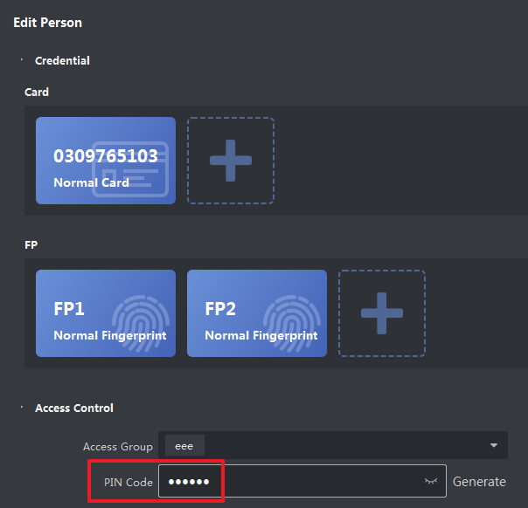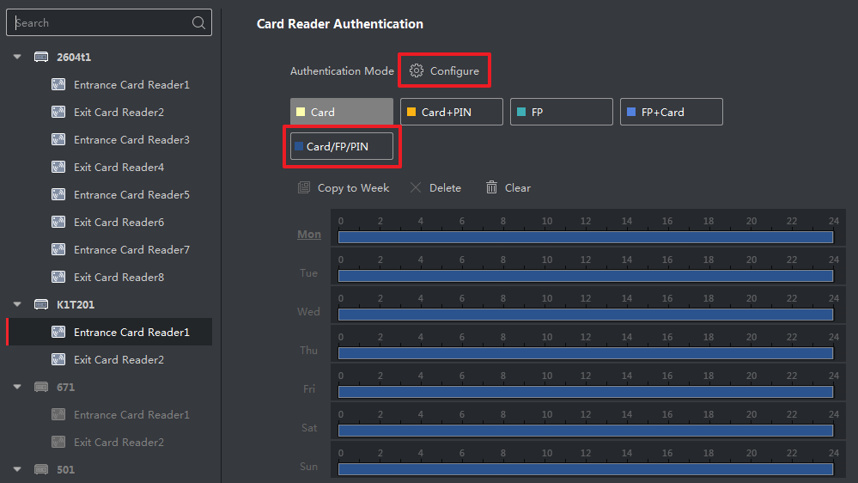
- Support Advanced functions: Multi-factor authentication, Anti-passing back, First-person in/authentication;
- Support voice prompt for open door remotely (from 4200 or other platform);

Customer Impact and Recommended Action
This new firmware upgrade is to improve product performance, and will take effect automatically after upgrading from previous versions. We’d like to inform you the above changes. Also, we are sorry for any possible inconvenience of use-habit changes caused by this action.
For questions or concerns, please contact our local technical support team.
Note:
- Hikvision has all rights to alter, modify and cancel this notice.
- Hikvision doesn’t give any guarantee for old models’ stock.
- Hikvision is not liable for any typing or printing errors.
- For special model’s change details, please contact our local technical support team.

Hikvision Digital Technology CO., Ltd.
No. 555 Qianmo Road, Binjiang District, Hangzhou 310052, China
Tel: +86-571-8807-5998
FAX: +86-571-8993-5635
Email: support@hikvision.com

