DS-K1T331 Series MinMoe Terminal
Release Notes (2020-06-05)
Device Model:  DS-K1T331  DS-K1T331W  Naming Rule:  W for WIFI | Firmware Version | ACS_331_AI2_EN_GM_ V3.1.4_build200602.zip
 | SDK | Latest baseline
 | iVMS-4200 Client Version | iVMS-4200 AC(V1.0.3 _E build200506).exe

Reason of Upgrade
Add new features, fix bugs, enhance products quality and meet customers’ requirements.

New Features
- Add new languages: Vietnamese

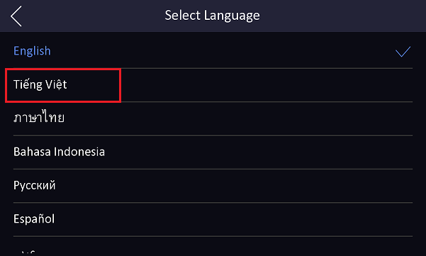

Modified Features
1.Bug fix and enhance user experience

Customer Impact and Recommended Action
This update refers to function/compatibility improvement and will take effect automatically after the Date of Change. We are very sorry for any inconvenience of use-habit changes caused by this action.
For any questions and request for this firmware, please contact our local technical support team.
Note:
- Hikvision reserves the right to change, alter or withdraw the above notification without prior notice.
- Product design and specifications are subject to change without prior notice.
- The Hikvision firmware may contain errors known as errata, which may cause the product to deviate from published specifications. Current characterized errata are available on request.
- Hikvision is not liable for any typing or printing errors.

Hikvision Digital Technology CO., Ltd.
No. 555 Qianmo Road, Binjiang District, Hangzhou 310051, China
Tel: +86-571-8807-5998
FAX: +86-571-8993-5635
Email: overseabusiness@hikvision.com

