K1T604 Series Face Recognition Terminal
Release Notes (2018-05-22)
Device Model:  K1T604M  K1T604MF | Firmware Version | MCU: ACS_DS-K5604_GML_STD_V1.0.0_build180305  ARM: ACS_1T604__AI0_EN_GM_V1.0.0_build180425
 | SDK Version | HCNetSDKV5.3.5.25_build20180305_win32
 | EHome Version | EhomeSDK_V1.2.1.5_build20171101
 | 4200 Version | V2.6.8.8 build20180423

Main Features
- 10000 face pictures, 50000 cards, 5000 fingerprints.
- Multiple authentication mode: face, fingerprint, card, password.
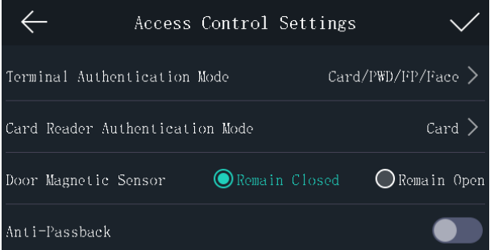
- Support face and fingerprint remote collection function on client software.
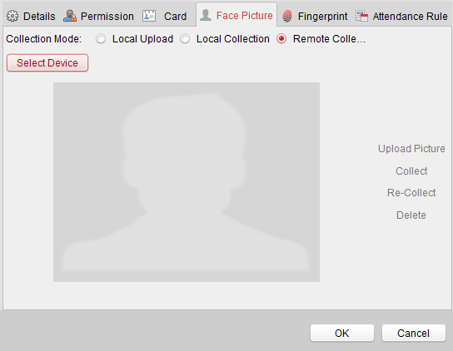
- Face picture and fingerprint data can be applied to the device via TCP/IP or uploaded to the device
via the USB flash drive.
- 2 MP wide-angle dual-lens with WDR function.
- Dual network ports, support ehome and network SDK protocol.
- Upload offline device events automatically to client software.
- Abundant event linkage setting on client software.
- RS485 output mode: send card number to controller when permission proved, no output when permission denied; RS485 input mode: can connect external RS485 card reader.
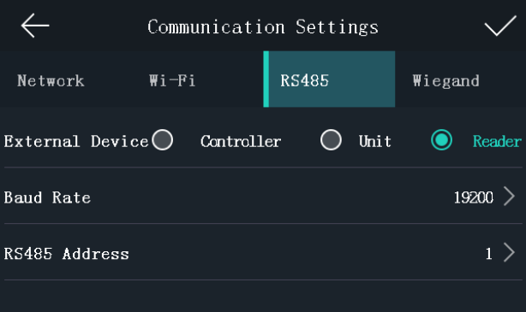
- Support video intercom and live view.
- Support exporting access event data, user data, face picture, access control parameter, captured picture to USB flash drive.
- Support importing User Data, User Profile Picture, ACS Parameters from USB flash drive.
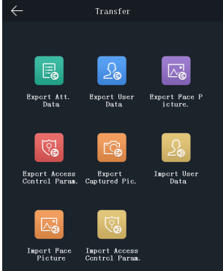

Customer Impact and Recommended Action
This new firmware upgrade is to improve product performance, and will take effect automatically after upgrading from previous versions. We’d like to inform you the above changes. Also, we are sorry for any possible inconvenience of use-habit changes caused by this action.
For questions or concerns, please contact our local technical support team.
Note:
- Hikvision has all rights to alter, modify and cancel this notice.
- Hikvision doesn’t give any guarantee for old models’ stock.
- Hikvision is not liable for any typing or printing errors.
- For special model’s change details, please contact our local technical support team.

Hikvision Digital Technology CO., Ltd.
No. 555 Qianmo Road, Binjiang District, Hangzhou 310052, China
Tel: +86-571-8807-5998
FAX: +86-571-8993-5635
Email: support@hikvision.com

