DS-K1T604 Series Face Recognition Terminal V1.1.1build190423 Release Notes
Device Model:  K1T604M  K1T604MF | Firmware Version | Hicore: ACS_5604_17_AI0_EN_GM_V1.1.1_build190423  MCU: ACS_DS-K1T604_GML_STD_V1.0.0_build190220
 | SDK Version | HCNetSDKV5.3.6.35_build20180830_win32
 | 4200 Version | V2.6.10.17
 | Ehome Version | EhomeSDK_V1.2.1.13_build20180803_win32
Reason of Upgrade
Add or modify functions, fix bugs, enhance products quality and meet customers’ requirements.

Modified Features
- New local UI style Design;
- Improve face anti-spoofing detection performance;
- Upgrade to new generation face recognition algorithm.
- Support to enable/disable DHCP function locally.
- Support calling indoor station. (Change your network cable to LAN2 terminal if you want to use this function. LAN1 IP address can not be used for calling indoor station)
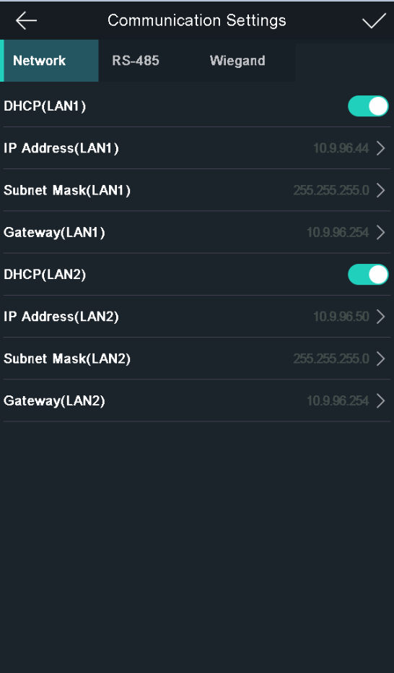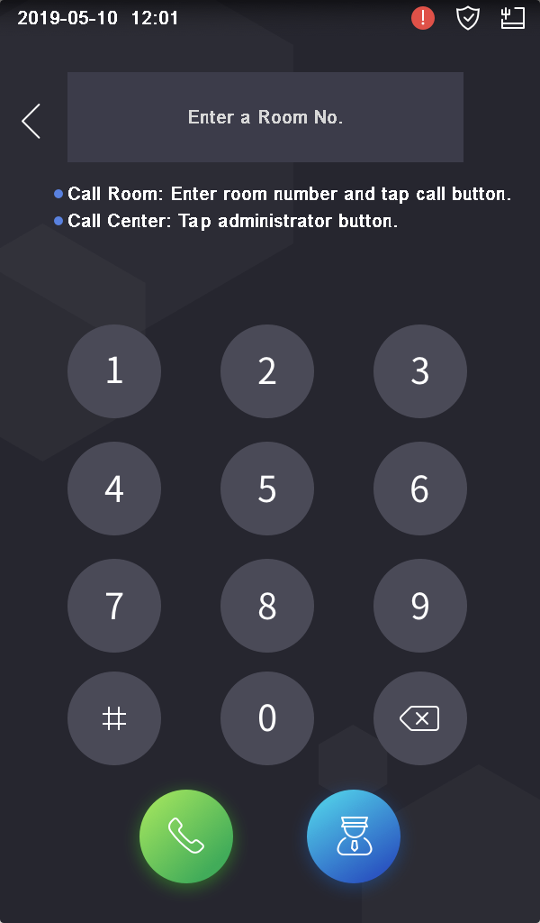
- Other bugs fixed.

Customer Impact and Recommended Action
This new firmware upgrade is to improve product performance, and will take effect automatically after upgrading from previous versions. We’d like to inform you the above changes. Also, we are sorry for any possible inconvenience of use-habit changes caused by this action.
For questions or concerns, please contact our local technical support team.
Note:
- Hikvision has all rights to alter, modify and cancel this notice.
- Hikvision doesn’t give any guarantee for old models’ stock.
- Hikvision is not liable for any typing or printing errors.
- For special model’s change details, please contact our local technical support team.

Hikvision Digital Technology CO., Ltd.
No. 555 Qianmo Road, Binjiang District, Hangzhou 310052, China
Tel: +86-571-8807-5998
FAX: +86-571-8993-5635
Email: support@hikvision.com

