K1T607 Series Face Recognition Terminal
Release Notes (2019-09-29)
Device Model:  DS-K1T607E/EF/MW/MFW  DS-K1T607PE/PEF/PMW/PMFW  DS-K1T607TE/TEF/TMW/TMFW  Naming Rule:  E for EM card, M for M1 card,  W for WIFI | Firmware Version | ACS_01_H10_EN_STD_V2.0.0_190920
 | SDK | HCNetSDKV6.1.0.11_build20190611_win32 HCEhomeSDKV2.2.1.1_build20190410_win32
 | iVMS-4200 Client Version | iVMS-4200 AC(V1.0.2.9_E).exe

Reason of Upgrade
Add or modify functions, fix bugs, enhance products quality and meet customers’ requirements.

New Features
- Support deep mode(one time configuration after activate device)
- Support for person ID-centric and compatible with card-centric
- Support wiegand26 input and output;
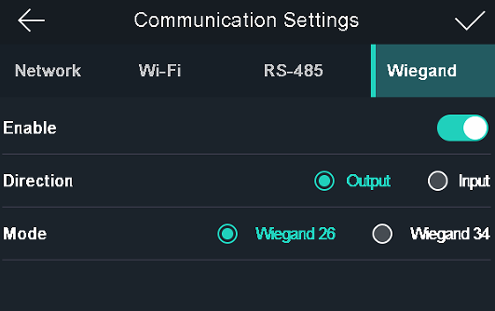
- Support check in/check out/break out/break in/overtime in/overtime out attendance status selection after successfully verified.
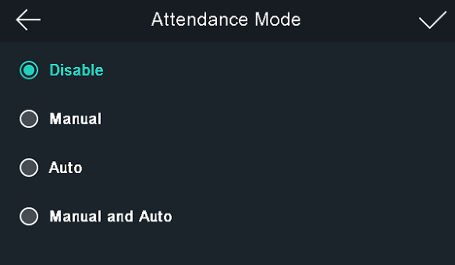
- Support device admin role, after long press main screen, enter device menu after input activation password or administrator’s(if created) face/card/fingerprint successfully verified.
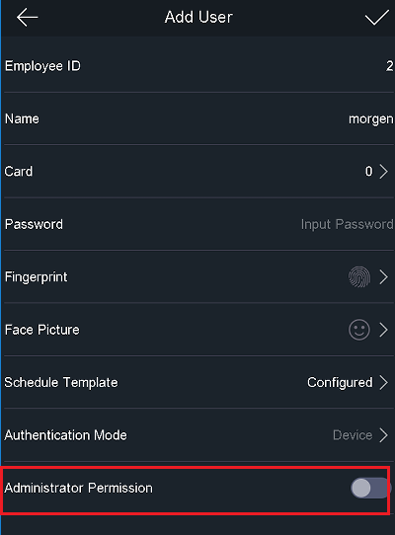

Modified Features
- Improve face anti-spoofing detection performance;
- Fixed a problem where some face photos failed to sync to the device；
- Optimize the white border of the image when registering face photos locally on the device;

Customer Impact and Recommended Action
This new firmware upgrade is to improve product performance, and will take effect automatically after upgrading from previous versions. We’d like to inform you the above changes. Also, we are sorry for any possible inconvenience of use-habit changes caused by this action.
For questions or concerns, please contact our local technical support team.
Note:
- Hikvision has all rights to alter, modify and cancel this notice.
- Hikvision doesn’t give any guarantee for old models’ stock.
- Hikvision is not liable for any typing or printing errors.
- For special model’s change details, please contact our local technical support team.

Hikvision Digital Technology CO., Ltd.
No. 555 Qianmo Road, Binjiang District, Hangzhou 310052, China
Tel: +86-571-8807-5998
FAX: +86-571-8993-5635
Email: support@hikvision.com

