DS-K1T671 Series Face Recognition Terminal
Release Notes (2019-10-21)
Device Model:  DS-K1T671M/MF  DS-K1T671TMW/TMFW  Naming Rule:  M for M1 card, W for WIFI, F for fingerprint | Firmware Version | ARM：ACS_01_AI3_CN_STD_V2.1.1_191015  MCU：ACS_DS-K1T671_ST1_GML_GM_V1.0.0_build191014
 | SDK | HCNetSDKV6.0.2.5_build20190105_win32 EhomeSDK_V1.2.1.13_build20180803_win32
 | iVMS-4200 Version | iVMS-4200 AC V1.0.2.14build190929

Reason of Upgrade
New model DS-K1T671 series, DS-K1T671T series face recognition terminals first time released.

New Features
- 7 inch LCD touch screen with large screen ratio, 2 MP wide-angle dual-lens camera with WDR feature;
- Connect external card reader or access controller via RS485 or Wiegand26/34 protocol
- Face recognition duration ＜ 0.2 s/User; face recognition accuracy rate ≥ 99%
- Face, card, fingerprint, event capacity
 | Face | Card (M1) | Fingerprint | Event
DS-K1T671 series | 5,000 | 6,000 | 5,000(model with F) | 50,000
DS-K1T671T series | 20,000 | 50,000 | 5,000(model with F) | 100,000

- Network
Support TCP/IP, adapt to LAN(network) or WAN(ehome) network environment
Optional WIFI function (model with W)
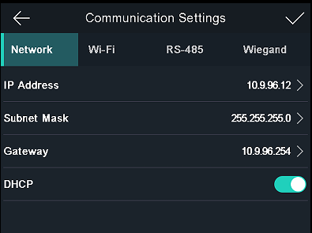
- Video intercom;
- Video intercom with platform or client software;
- Video intercom with indoor station
- Video intercom with master station
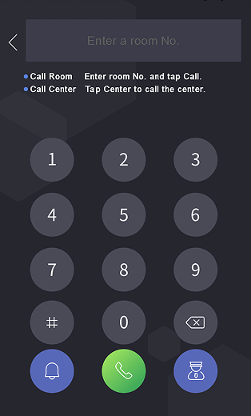

- Function
- People-centered design, that is, the person number is a unique key, each person support maximum 5 cards
- Support ISAPI protocol;
- Multiple verification modes: QR code, card, fingerprint and face
- Face recognition in dark environment;
- Face recognition distance ranges from 0.3 to 3 meters;
- Live face detection function with 3 levels: Normal, High and Higher
- Remote live view via RTSP protocol; encoding mode: H.264
- Support ISAPI protocol
- Support check in/check out/break out/break in/overtime in/overtime out status;
- Support Hik-Connect mobile App to realize remote video intercom and unlock function;
- Optional fingerprint recognition module(model with F)
- Support auto-upgrade function, when device boot, it will automatically read upgrade file digicap.dav from USB flash drive(if inserted) and update automatically.
- Multiple method to add face and fingerprint(model with F) data to terminal, register from device local menu, synchronize from client software, or upload via USB flash drive.

Customer Impact and Recommended Action
This new firmware upgrade is to improve product performance, and will take effect automatically after upgrading from previous versions. We’d like to inform you the above changes. Also, we are sorry for any possible inconvenience of use-habit changes caused by this action.
For questions or concerns, please contact our local technical support team.
Note:
- Hikvision has all rights to alter, modify and cancel this notice.
- Hikvision doesn’t give any guarantee for old models’ stock.
- Hikvision is not liable for any typing or printing errors.
- For special model’s change details, please contact our local technical support team.

Hikvision Digital Technology CO., Ltd.
No. 555 Qianmo Road, Binjiang District, Hangzhou 310052, China
Tel: +86-571-8807-5998
FAX: +86-571-8993-5635
Email: support@hikvision.com

