DS-K1T804 Series Terminal V1.2.3_build191008
Release Note (2019-10-12)
Device Model:  DS-K1T804F/MF/EF | Firmware Version | ARM: ACS_1T804_M0_EN_GM_V1.2.3_build191008  MCU: ACS_Extending_Module_GML_GM_V1.2.1_build190802
 | SDK Version | HCNetSDKV6.1.0.151_build20190918
NOTE:
If you upgrade ARM firmware from v1.1.x .
Don’t reboot device directly!
Choose restore all after upgrade.
This is because new firmware’s data structure is not compatible with old firmware. Rebooting directly will lead to devise crash. It is recommend to upload all the old data to client software (iVMS4200) before upgrade, and apply all data to devise again when upgrade finish.
If you upgrade from firmware 1.2.x, you can directly reboot the device.

Reason of Upgrade
Add or modify functions, fix bugs, enhance products quality and meet customers’ requirements.
Modified Features
- Fix multi-language display bugs;
- Improve device events uploading stability in Ehome protocol
- Support NFC function. This function is enabled by default.
- M1 card encryption is disabled by default.
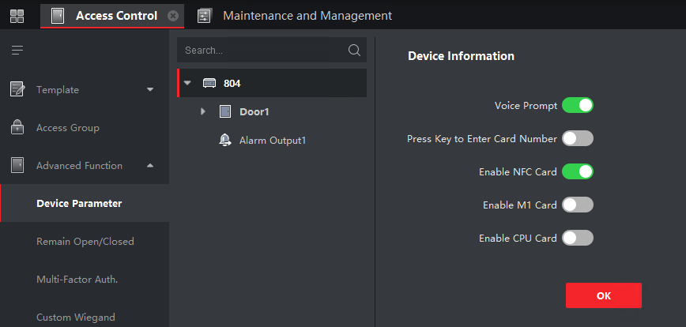

Customer Impact and Recommended Action
This new firmware upgrade is to improve product performance, and will take effect automatically after upgrading from previous versions. We’d like to inform you the above changes. Also, we are sorry for any possible inconvenience of use-habit changes caused by this action.
For questions or concerns, please contact our local technical support team.
Note:
- Hikvision has all rights to alter, modify and cancel this notice.
- Hikvision doesn’t give any guarantee for old models’ stock.
- Hikvision is not liable for any typing or printing errors.
- For special model’s change details, please contact our local technical support team.

Hikvision Digital Technology CO., Ltd.
No. 555 Qianmo Road, Binjiang District, Hangzhou 310052, China
Tel: +86-571-8807-5998
FAX: +86-571-8993-5635
Email: support@hikvision.com

