K1T8105 Series Face Recognition Terminal
Release Notes (2019-08-04)
Device Model:  DS-K1T8105E  DS-K1T8105M | Firmware Version | ARM: ACS_8105_EN_GM_V1.01_build190724  MCU: ACS_MCU-TRIANGLE_GML_GM_V1.0.0_build190624
Note: Upgrade both MCU and ARM firmware together to achieve fully upgrade.

Reason of Upgrade
Add or modify functions, fix bugs, enhance products quality and meet customers’ requirements.

New Features
- Directly quit virtual keypad interface by click any blank part of screen, no need to click down arrow icon.
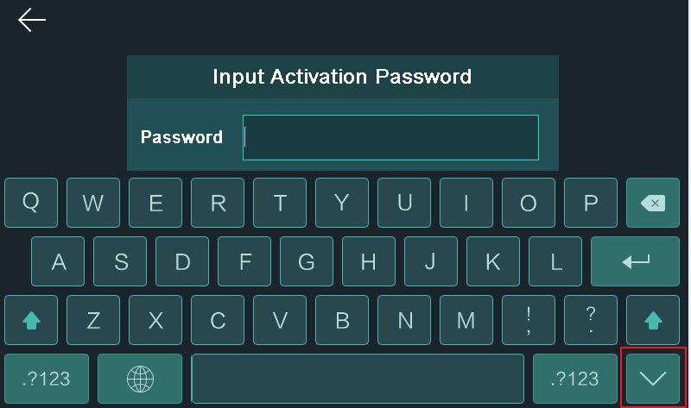
- Add “return” icon on attendance status select interface.
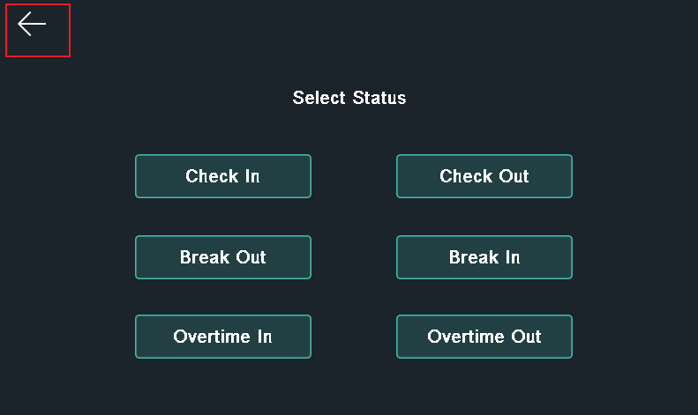
- Optimize local authentication result display time;
- Improve device log recording;
- Improve time zone and DST setting;
- Fix known bugs.
Customer Impact and Recommended Action
This new firmware upgrade is to improve product performance, and will take effect automatically after upgrading from previous versions. We’d like to inform you the above changes. Also, we are sorry for any possible inconvenience of use-habit changes caused by this action.
For questions or concerns, please contact our local technical support team.
Note:
- Hikvision has all rights to alter, modify and cancel this notice.
- Hikvision doesn’t give any guarantee for old models’ stock.
- Hikvision is not liable for any typing or printing errors.
- For special model’s change details, please contact our local technical support team.

Hikvision Digital Technology CO., Ltd.
No. 555 Qianmo Road, Binjiang District, Hangzhou 310052, China
Tel: +86-571-8807-5998
FAX: +86-571-8993-5635
Email: support@hikvision.com

