RS485 to Wiegand Module V2.0.1build 180829 Release Note (2018-09-05)
Device Model:  DS-K110X Series Card Reader | Firmware Version | V2.0.1build 180829

Function:
- DS-K110X series card reader receive card number information by RS485 terminal, and output card number information by standard wiegand 26/34.
- Use card reader’s 6th dip switch to choose wiegand 26 or wiegand 34 output mode. Note to change dip switch when card reader is power off.

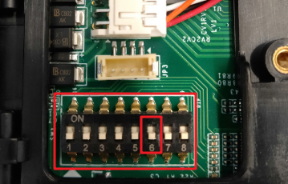
6th dip switch | Down position | wiegand 34
 | Up position | wiegand 26

Note:
Card number format request:
- wiegand 34: 10 digits, number should less than 4294967295
- wiegand 26: 8 digits, the first 3 digits should less than 256, the last 5 digits should less than 65536

Customer Impact and Recommended Action
This new firmware upgrade is to improve product performance, and will take effect automatically after upgrading from previous versions. We’d like to inform you the above changes. Also, we are sorry for any possible inconvenience of use-habit changes caused by this action.
For questions or concerns, please contact our local technical support team.
Note:
- Hikvision has all rights to alter, modify and cancel this notice.
- Hikvision doesn’t give any guarantee for old models’ stock.
- Hikvision is not liable for any typing or printing errors.
- For special model’s change details, please contact our local technical support team.

Hikvision Digital Technology CO., Ltd.
No. 555 Qianmo Road, Binjiang District, Hangzhou 310052, China
Tel: +86-571-8807-5998
FAX: +86-571-8993-5635
Email: support@hikvision.com

