How to update the panel version of 1100KI
Attention: The PC with firmware and the keyboard should be in the same network segment.
- Use SecureCRT to open Serial port of keyboard（Baud rate 115200,8,1），input“miscCmd”(as shown)
- Click the setting tool kbtool，choose“远程升级键盘Remote upgrade keyboard”，enter and then choose “键盘面板升级Keyboard panel upgrade”，and then chose the firmware, set the IP and password of keyboard, (as shown)，click“升级upgrade”.
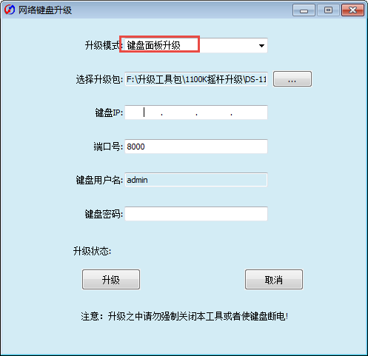
3、Check the serial print information of upgrading. The keyboard will restart after upgrading.

