Thermal VCA Configuration guidance
Contens
Thermal VCA Configuration guidance 1
Chapter 1 VCA better performance configuration suggestions 2
1. Max Distance of VCA Trigger Alarm 2
2. VCA Main Configuration Recommendation 2
Chapter2 VCA Common Issues troubleshooting and solutions 7
【False Alarm】 7
1. Unmathed target box caused false alarm 7
2. Animal false alarm from near side 7
3. Random box false alarm 8
4. Device shaking false alarm 9
【Missing Alarm】 10
1. Low temperature difference 10
2. Narrow Scene missing alarm 11

In order to ensure better VCA detection effect and fast delivery in thermal perimeter project, this document mainly introduces following two parts:
- VCA better performance configuration suggestions
- VCA Common Issues troubleshooting and solutions

Chapter 1 VCA better performance configuration suggestions

1. Max Distance of VCA Trigger Alarm
Ensure that the VCA rules are drawn within the max VCA alarm trigger distance of the device.
Different device have different VCA trigger distances according to resolution are as follows:
Resolution | Human trigger VCA Alarms（Meters）
160×120 | Focal Length*7
384×288 | Focal Length*10
640×512 | Focal Length *10
Table 1 Max VCA Trigger Alarm Distance
The max human VCA trigger alarm distance for DS-2TD2617-6/V1 is 42 meters.
The max human VCA trigger alarm distance for DS-2TD2136-15/V1 is 150 meters.

2. VCA Main Configuration Recommendation
Please upgrade the latest firmware and camera module firmware to the device firstly. You can contact with regional technical support team for latest firmware.
The specific VCA configuration is as follows.
- Set 3 segmental rules which divided into near, middle, far from device to cover all detection distances.
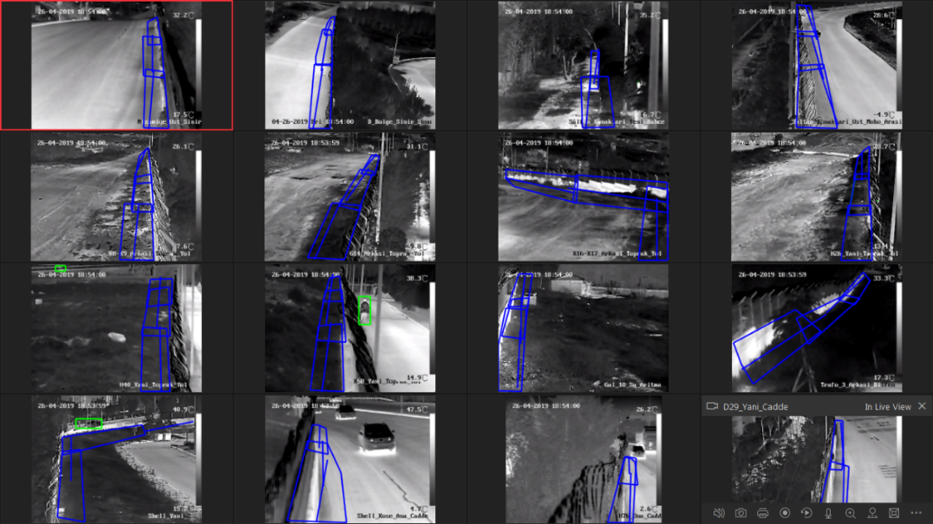
Figure 1 3 Segmental rules
- It is suggested that the detection targets can be selected as Human & Vehicle under each rule.
Note:
The algorithm will outputs the target box as human directly without classification for targets < 10*10 in default distant view, so the selection of this item will not bring the false alarm and missing alarm.
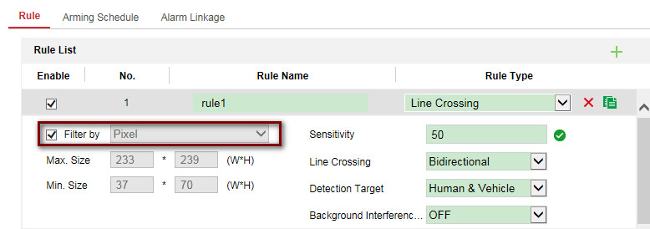
Figure 2 Rule1 Configuration
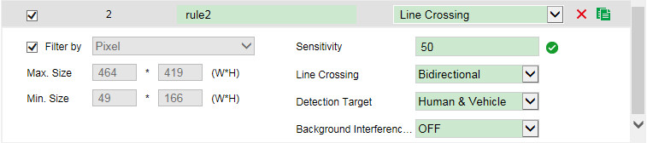
Figure 3 Rule 2 Configuration
- Set the Max Size and Min Size according to the rules in different distances. 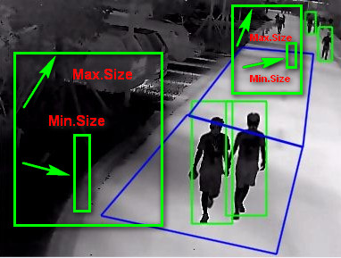
Figure 4 Pixel Filter for different rules
The reason for segmental rules configuration:
The deep learning algorithm classification needs at least 10*10 pixels like as focal length *3 meters. If target smaller than this size, it make precise classification difficultly. So it needs to enable the pixel filter for each rules.
Pixel filter tips：
1） Due to the main difference between human and animal is the height. Just concern the height of animal.
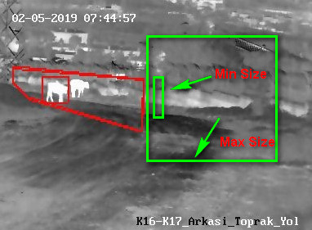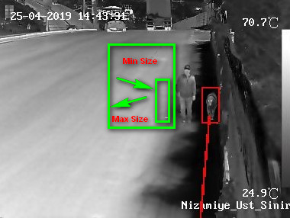
Figure 5 Pixel filter for animals Figure 6 Pixel filter for animals
2）It can refer to the real target in the scene to draw the size, and make sure 1.2 times redundancy of Min.Size and Max.Size.
d）VCA Info display：
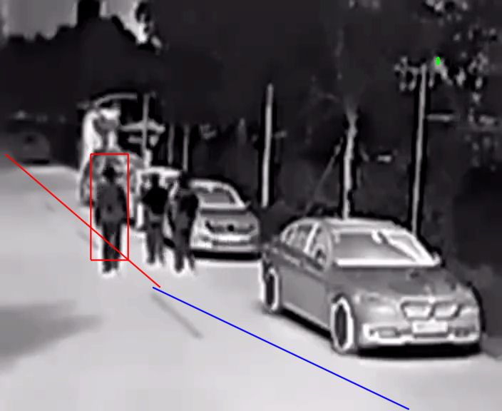
Figure 7 VCA Info Display
1. Select display VCA Info by Player if VCA Info shows in IE or iVMS-4200.
Figure 8 Display VCA Info by Player
Meanwhile enable the rule info in local configuration page.
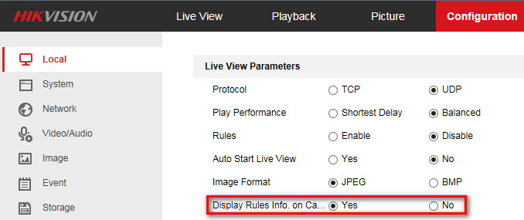
Figure 9 Enable the rule info display
2. If VCA Info need to be displayed on the third-party platform or local GUI of NVR, you can select display VCA Info by video.
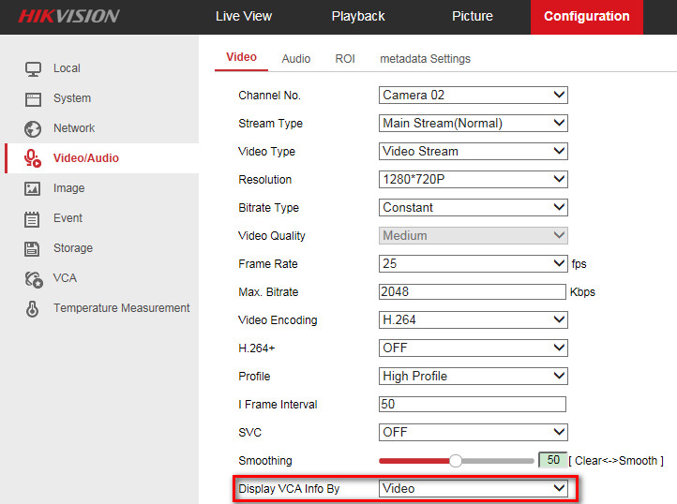
Figure 10 Display VCA Info Video

Chapter2 VCA Common Issues troubleshooting and solutions
Note：Make sure upgrade the latest firmware and camera module firmware to the device.
You can contact with regional technical support team for latest firmware.

【False Alarm】
- Unmathed target box caused false alarm
Phenomenon:
False alarm caused by bigger target box than real target.
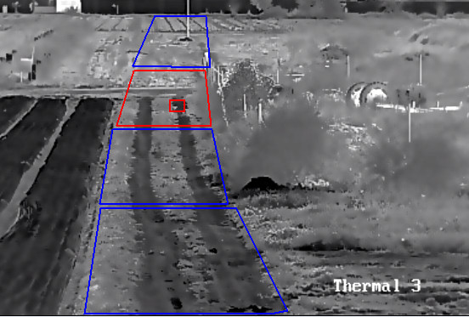
Figure 11 Target box mismatches the real small target
Solution:
- Contact with HQ support to obtain the fixed firmware.
- Upgrade the fixed firmware to generate the matched box of target’s real size in far side. Then adjust the pixel filter again.
- If still has issue, please help to collect the issue videos for further checking.
- Animal false alarm from near side
Phenomenon:
Animal with obvious features still occurs false alarm.
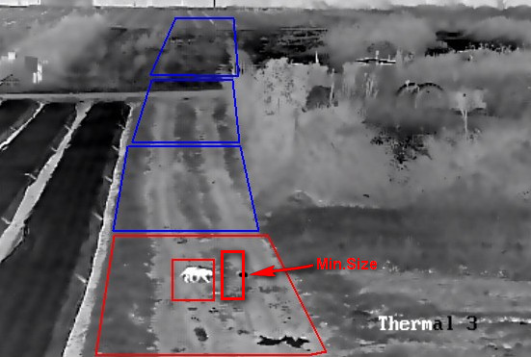
Figure 12 Animal false alarm in near side
Solution:
- Enable the pixel filter to avoid the animal false alarm with the height of Min.Size.
b．Meanwhile collect more samples for training.
- Random box false alarm
Phenomenon:
False alarm caused by Random box without real targets. And cannot all reduced by pixel filter.
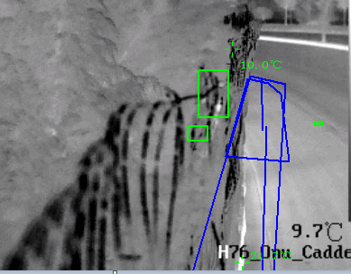
Figure 13 Random Box
Solution:
Contact with HQ support to obtain the fixed firmware.
- Device shaking false alarm
Phenomenon:
False alarm caused by device shaking when there is heavy wind.
The algorithm will generate the target box when device shaking, and cannot distinguish the real target normally.
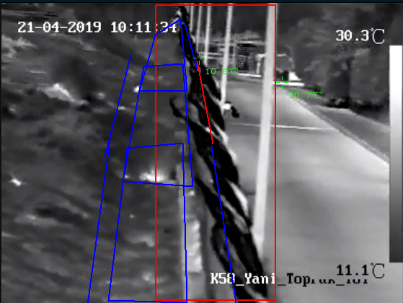
Figure 14 Device Shaking
Solution:
- Make sure mounting the device firmly.
Note:
This false alarm cannot reduced by configuration.

【Missing Alarm】
- Low temperature difference
Phenomenon:
The device can’t detect the human box especially environment temperature is similar as human body.
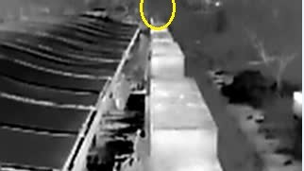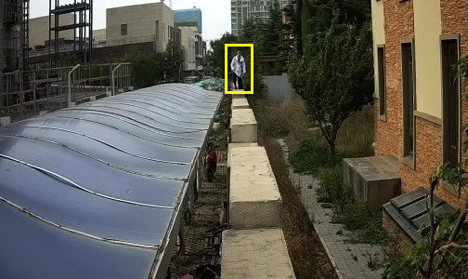Figure15 Thermal low temperature difference View Figure16 Optical View
Solution:
Please contact regional technical support to collect the raw data, then R&D will do further checking.
Note：It’s decided by thermal image principle.
It usually occurs at noon when the ambient temperature is about 30 centigrade.
There is no such issue at night.
- Narrow Scene missing alarm
Phenomenon：
Targets pass the line quickly in the narrow scene, failing to generate target box in time and no alarm.
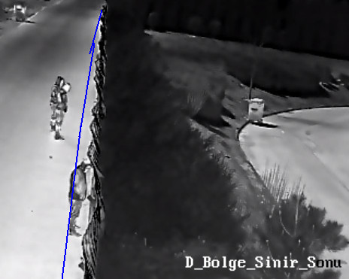
Figure 17 Narrow Scene
Solution：
- Set the line crossing and intrusion together.
Due to intrusion rule can detect the alarm even the target box generating within the area.
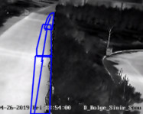
Figure 18 Rule adjustment for narrow scene
- Decrease the axis movement value to 1, make the target generation easily.
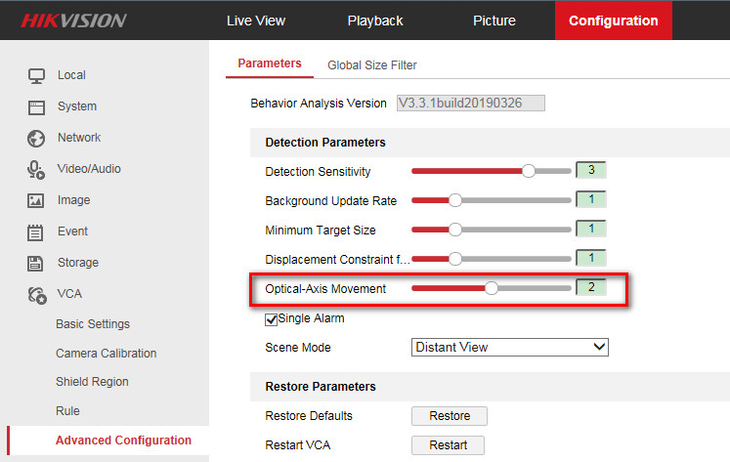
Figure 19 Optical-Axis Movement configuration
- Increase the detection sensitivity of Line Crossing and intrusion rules to 70. It can be further adjusted according to actual test. 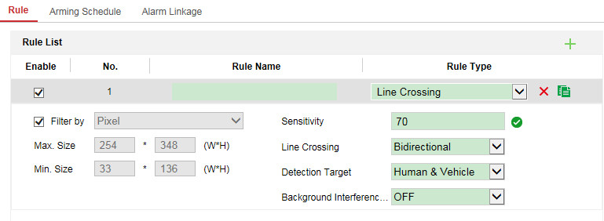
Figure 20 Sensitivity configuration of rule

