Thermal VCA Main Configuration Guidance
In order to ensure better VCA detection effect and fast delivery in thermal perimeter project, this document will provide some VCA better performance configuration suggestions.
This document is for Technical & Product Support use.
VCA Main Configuration Recommendation:
- Please upgrade the latest firmware and camera module firmware to the device firstly.
All firmware can be found in 400FTP. Download path is as follows.
ftp://hikftp.hikvision.com:400/Product%20File(Overseas)/17%20Thermal/02%20Product%20support/01%20Firmware/
- The specific VCA configuration is as follows.
- Set 3 segmental rules which divided into near, middle, far from device to cover all detection distances.
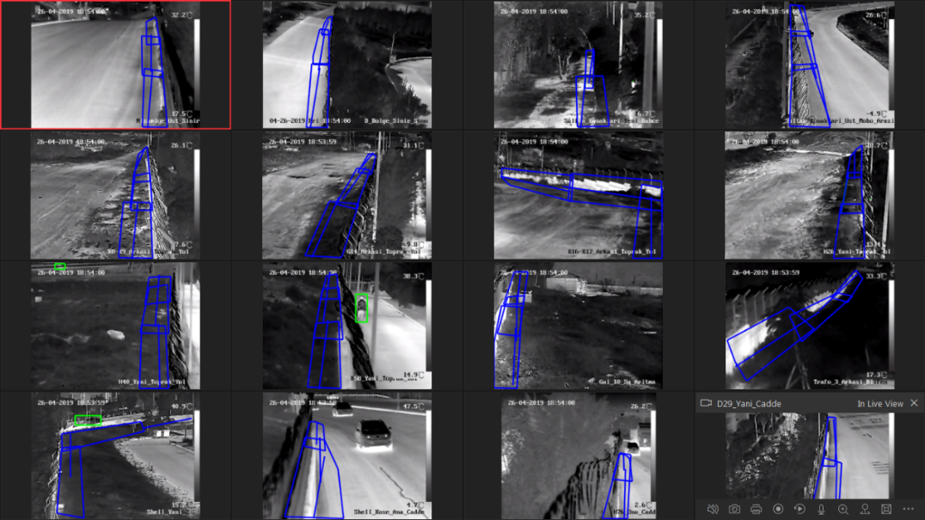
Figure 1 3 Segmental rules
- It is suggested that the detection targets should be selected as Human & Vehicle while setting each rule.
Note:
The algorithm will outputs the target box as human directly without classification for targets < 10*10 in default distant view, so the selection of this item will not bring the false alarm and missing alarm.
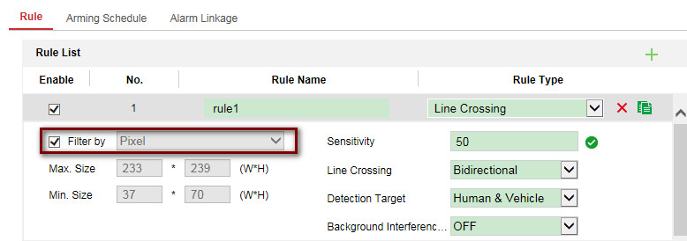
Figure 2 Rule1 Configuration
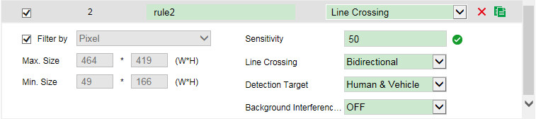
Figure 3 Rule 2 Configuration
- Set the Max Size and Min Size according to the rules in different distances. 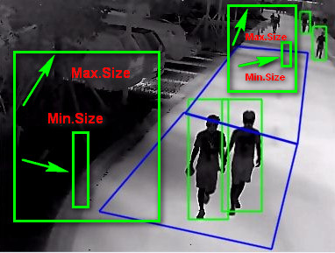
Figure 4 Pixel Filter for different rules
The reason for segmental rules configuration:
The deep learning algorithm classification needs at least 10*10 pixels like as focal length *3 (meters). If target is smaller than this size, it makes precise classification difficultly. So it needs to enable the pixel filter for each rule.
Pixel filter tips:
1） The VCA alarm will be triggered when width and height of target greater than the Min size and smaller than the Max size. Therefore, the algorithm will filter the target witch its width or height does not meet the size settings. Take the height of Min size filter settings for example.
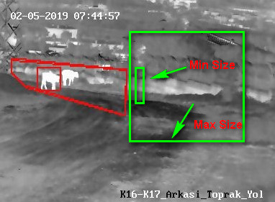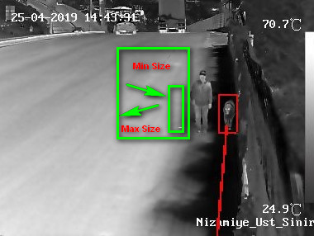
Figure 5 Pixel filter for animals Figure 6 Pixel filter for animals
2）You can configure the Max size to filter the big boxes caused by device shaking. The size of width or height should greater than size of human and car.
3）It can refer to the real target in the scene to draw the size, and reserve 1.2 times to draw Min Size and Max Size.
d）VCA Info display：
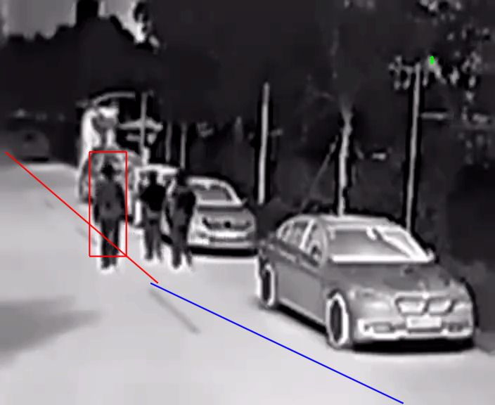
Figure 7 VCA Info Display
1. Select display VCA Info by Player if VCA Info shows in IE or iVMS-4200.
Figure 8 Display VCA Info by Player
Meanwhile enable the rule info in local configuration page.
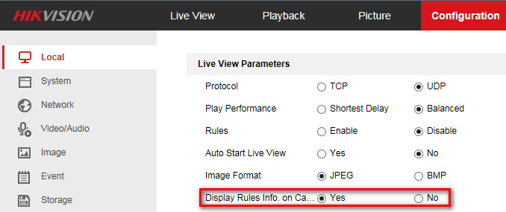
Figure 9 Enable the rule info display
2. If VCA Info need to be displayed on the third-party platform or local GUI of NVR, you can select display VCA Info by video.
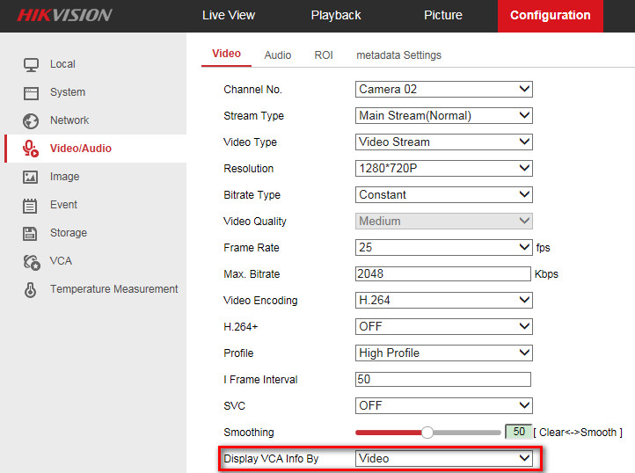
Figure 10 Display VCA Info Video
More details can be found from following 400FTP path.
ftp://hikftp.hikvision.com:400/Product%20File(Overseas)/17%20Thermal/02%20Product%20support/09%20How%20to/01%20VCA/

First Choice for Security Professionals
HIKVISION Technical Support

