How to configure fire source detection for thermal camera

Preparation
- login the device via web browser
- Enter Configuration>System>Maintenance>VCA Resource Type
Select Fire Detection（or Temperature Measurement +Fire Detection）as VCA Resource Configuration.
Note:

Steps:
- Enter Local, then enable Locate Highest Temperature and Frame Fire Point.
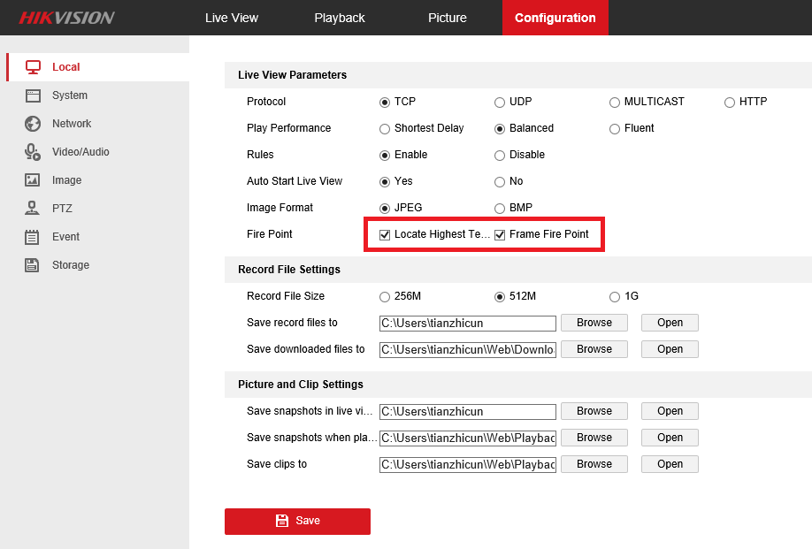
After ticking the two options, the fire source will be located like the following image.
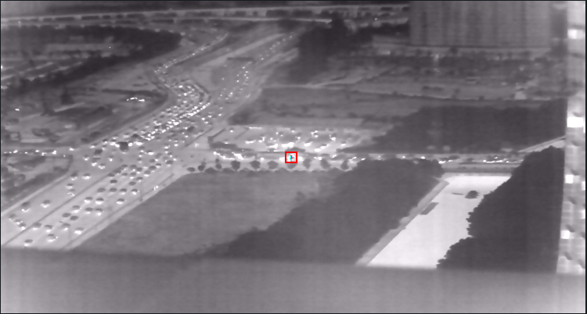
- Enter Event>Smart Event, bullet camera and PTZ camera have different interfaces of the fire detection.
(1).For bullet camera, there is only a switch to enable the function and a option to adjust the sensitivity.
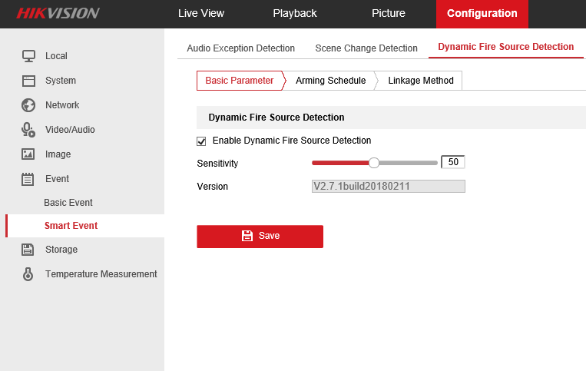
(2).For PTZ cameras, as we can see in the image below, it has more parameters concerned about the effect.
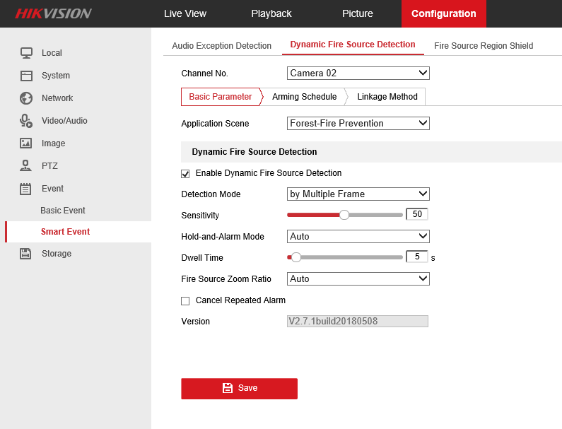
- Enable Dynamic Fire Source Detection:
The Switch of this function, it can decide if the function could take effect.
- Application Scene:
There are four modes to select: Forest-Fire Prevention, Straw Burning, High-building and Indoor/perimeter. The cameras will adapt different algorithms to detect the fire source after choosing different mode.
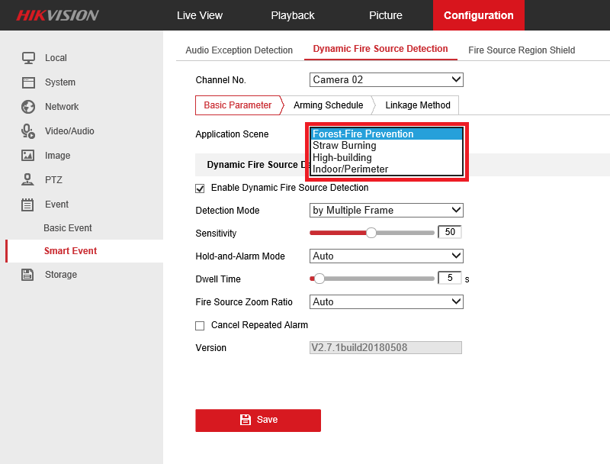
Except the Forest-Fire Prevention, the three rest mode need to be filled in the Installation Height.
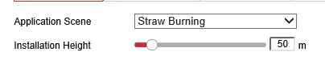
- Normal Mode:
by Single Frame: After the camera finding a suspect, it will alarm directly.
by Multiple Frame: After finding a suspect, it will have a further judge to confirm if it is a fire source.
Although the Multiple Frame mode needs more time to alarm(about 1s later than Single Frame), but it can reduce false alarm effectively. So it is recommended to use the by Multiple Frame mode.
- Sensitivity:
It can control the threshold that the camera judging if it is fire source. It is recommended to set it as 50. And it is about 40~70 for most scenes.
- Hold-and-Alarm Mode:
Auto: You can set the time(0~120s) the camera dwells each time it find a fire point.
Manual: After finding a fire point, the camera will stop and a frame will be popped up in the Live View interface, only after clicking OK, the camera could continue to move and detect.
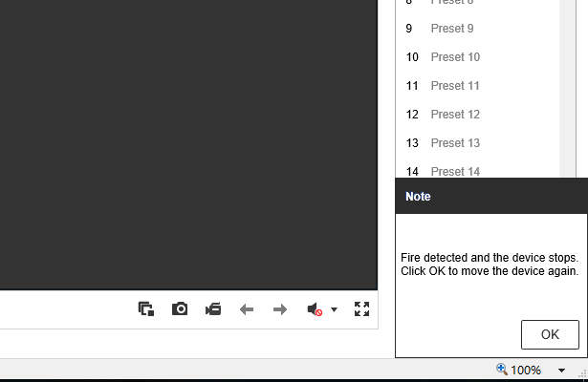
- Fire Source Zoom Ratio:
Auto: The optical channel will zoom in until the field of view is same as thermal channel.
Manual: Set the ratio as you want, each time after find the fire point, the optical channel will zoom in till the ratio you set.
- Cancel Repeat Alarm:
The device will alarm only one for the same fire point after ticking it..
3.Fire Source Region Shield
For some special scenes, although there are some areas in the image but we don’t mean to detect it.
(1).First enable Fire Source Region Shield
(2).Then draw area on the position that you don’t want to detect and click Add.
(3).Click Display Shield Area to let it be translucent, or the area will be absolutely transparent.
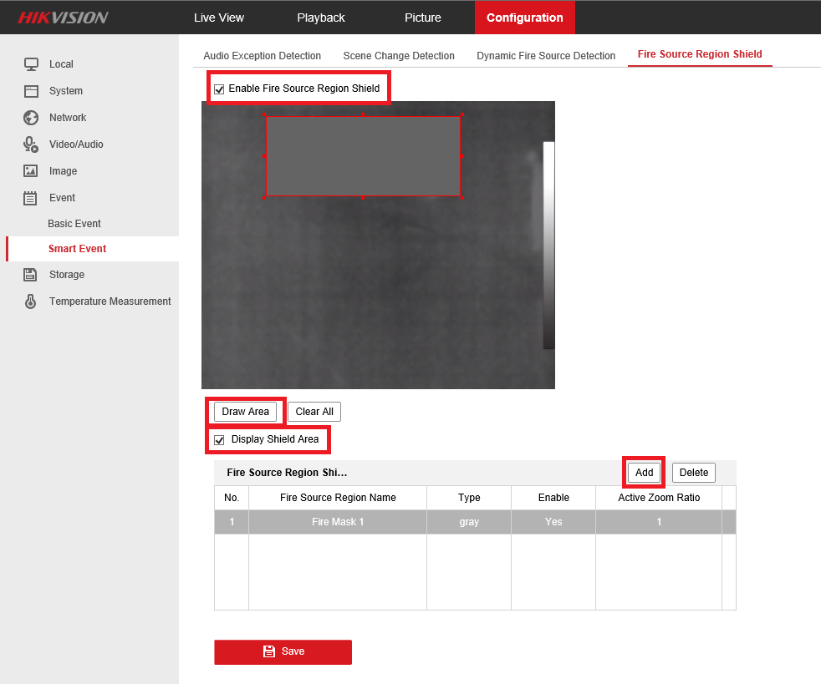
4.Patrol Mode
There are two kinds of patrol modes we usually select when detecting fire source.
1.Preset Patrol
After the fire source detection configuration, we can set a preset patrol to let the camera detect more scenes.
(1).In Live View, move the PTZ to the areas might appear fire source.
(2).Click the set Button to save the presets.
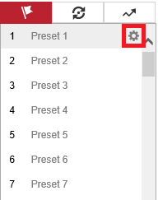
(3).Click Set to set patrol path, the dwell time and move speed can be adjusted on the basis of the real scenario.
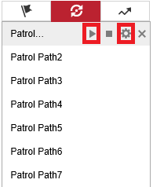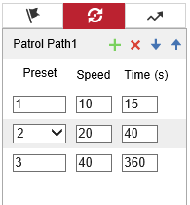
(4).Click the Click the Strat button to excute the patrol path. When the camera move to one preset and stop, it will start to detect fire source automatically.
2.Linear Scan
In this mode, we don’t need to set any preset, but four limit positions need to be set.
(1).First enter Configuration>PTZ>Linear Scan, click Enter Area Settings, it will appear a hint that tell you to set the Left Limit.
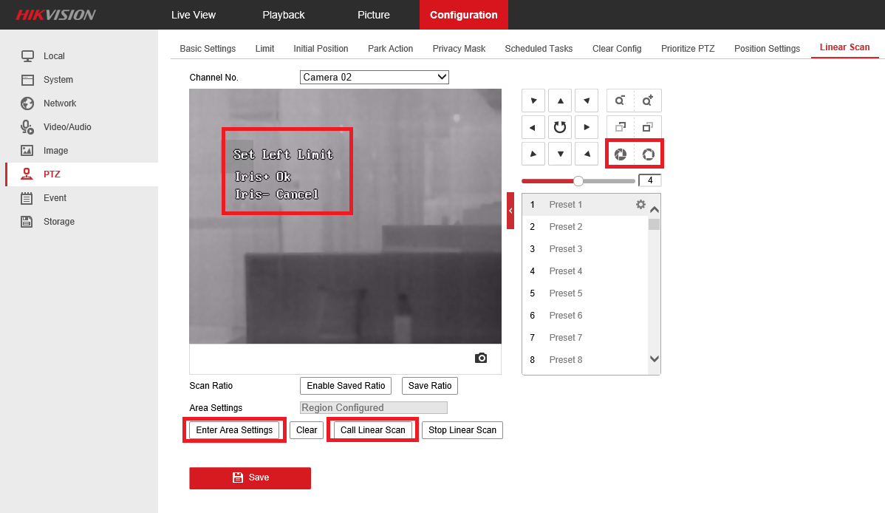
(2).Move PTZ to the left of the detection area you want, then click Iris+ to confirm.
(3).Then set the Right/Up/Down Limit in the same way. It means the right/top/bottom of the detection area.
(4).Click Call Linear Scan to start, the speed can be adjusted by changing the Auto Scan Speed in Basic Settings.
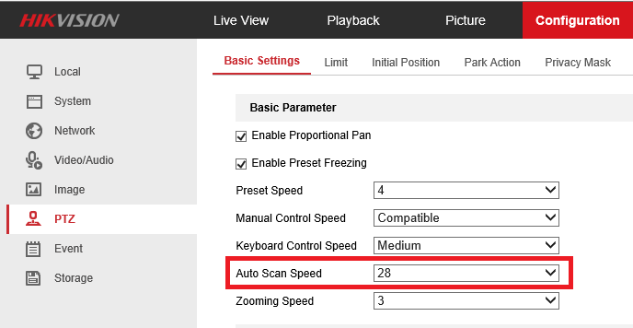

First Choice for Security Professionals
HIKVISION Technical Support

