Preparation
- The status of Hybrid SAN must be Working
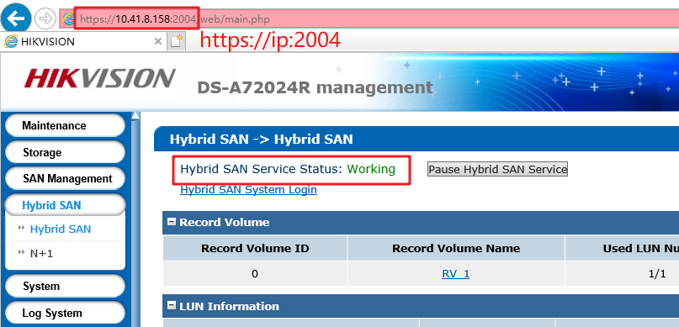
- Support V236-2 and above versions to upgrade, Version below V236-2 please upgrade to V236-2 first

- V238-8 Firmware
Please check the capacity of each patch after you download from the FTP.

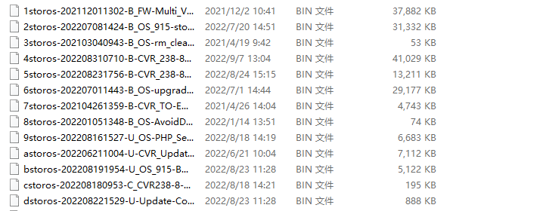

How to Upgrade Hybrid SAN Firmware to V238-8（via web）

Upgrade 1storos-202112011302-B_FW-Multi_V2.33sp4-915.bin

Note:
Please wait 3 minutes after it shows below tips, and this is a combined package, please enter the upgrade log interface to double check if all the patches upgrade success or not.
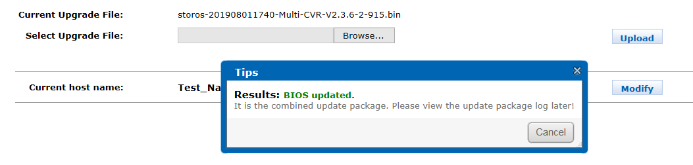

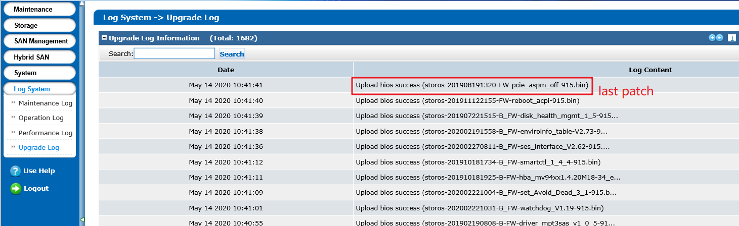

Upgrade 2storos-202207081424-B_OS_915-storOS_N66313_CVR238-915.bin

Upgrade 3storos-202103040943-B_OS-rm_cleardom.php-915.bin

Upgrade 4storos-202208310710-B-CVR_238-8_Oversea_Main_Release-915.bin

Upgrade 5storos-202208231756-B-CVR_238-8_Oversea_HikLib_Release-915.bin

Upgrade 6storos-202207011443-B_OS-upgrade_httpd2.4.54_php5.6.38_ssl1.0.2r_ssh9.0p1_bash4.4.12_wget1.11.1-915.bin

Upgrade 7storos-202104261359-B-CVR_TO-EN-STD-VERSION-915.bin

Upgrade 8 storos-202201051348-B_OS-AvoidDomFull_V1.1.6-915.bin

Upgrade 9storos-202208161527-U_OS-PHP_Security_N65145_V1.0-915.bin

Upgrade astoros-202206211004-U-CVR_Update_WebSec_WithBack_Final-915.bin

Upgrade bstoros-202208191954-U_OS_915BML_StorOSManager_EN_V2.3-915.bin

Upgrade cstoros-202208180953-C_CVR238-8-dvrhkHK_PlayBackDataCallBackbegintime-915.bin

Upgrade dstoros-202208221529-U-Update-Command_Line_Tools-915.bin

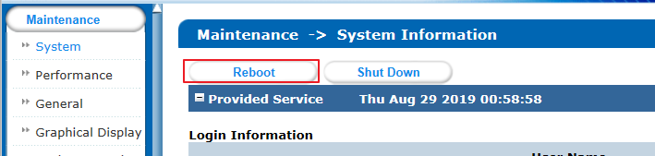
Reboot

2. for daul controller(must login to the real IP for upgrading)

- Login to the master controller first and then upgrade follow above steps
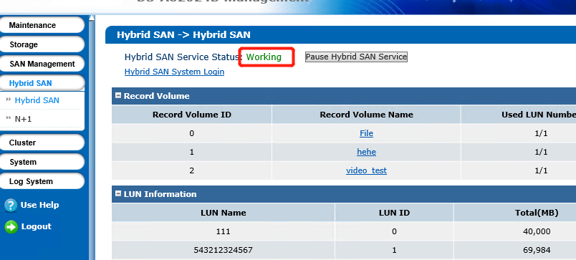
- Then login to the backup controller and then upgrade follow above steps
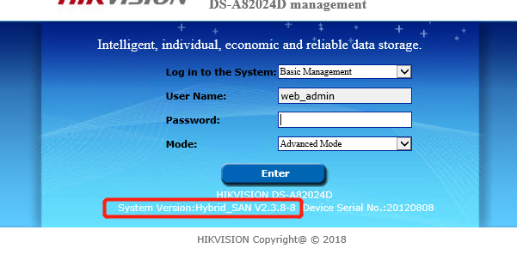
- Then reboot the master and backup controller after finishing the upgrading until the two controllers restart again, check the version on the web page
- Check recording and dual-controller status last

First Choice for Security Professionals
HIKVISION Technical Support

