How to Upgrade Network Storage Firmware (232-4&232-5 to 232-6)
For dual-controller device
Note: Firstly, make sure your dual-controller device deploy in correct mode. As dual-controller device have two controllers, each controller have an IP separately , and we also need create a resource IP , so before you upgrade for the dual-controller device , let it work in dual-controller mode. You can check the Cluster interface in the 2004 page shown as below.
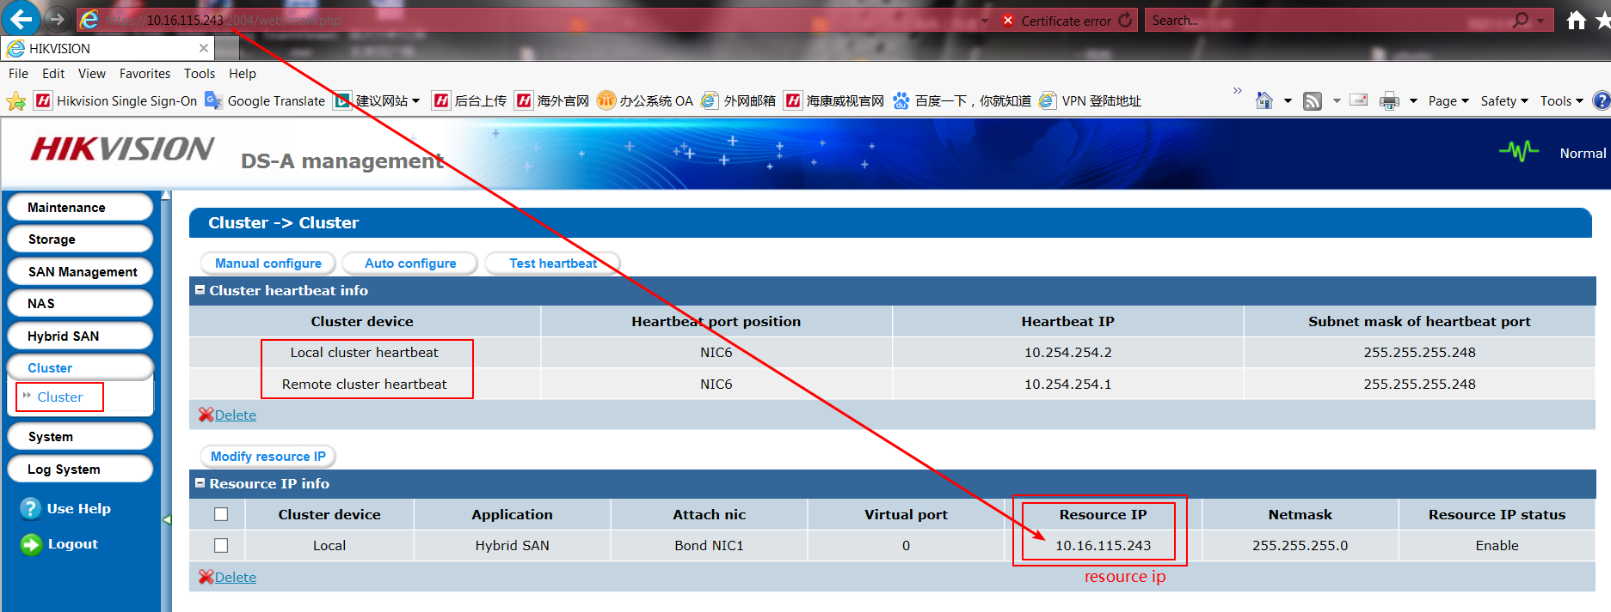
The device should upgrade to 232-4&232-5 first. And it only allow to upgrade when device CVR status is working. So the right step should be
- Login resource ip to check CVR service (https://IP (resource):2004) .Make sure the CVR service status is Working.
- Then you need to upgrade in two controller separately, login in https://IP (controller A):2004 and https://IP (controller B):2004; Do the upgrade operation in these two controller physical ip.
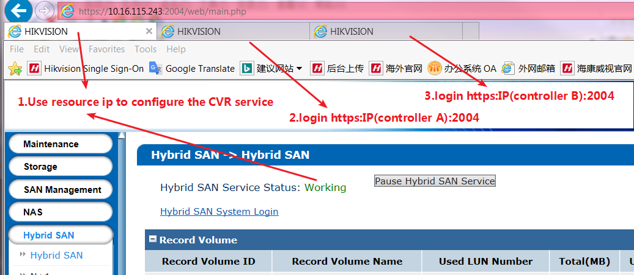
232-6 Firmware Package:

Steps:
Step1: Upgrade 1storos-201606141705-B_OS-BiosSize-915.bin in controller A, then do same operation in controller B
Controller A:
Please wait several minutes until it shows below tips
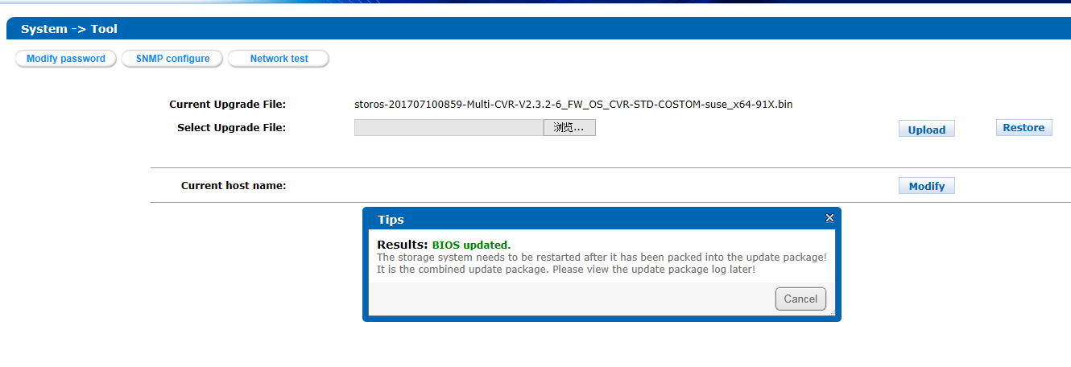
Controller B:
Please wait several minutes until it shows below tips
Step2: Reboot both of controller A and controller B

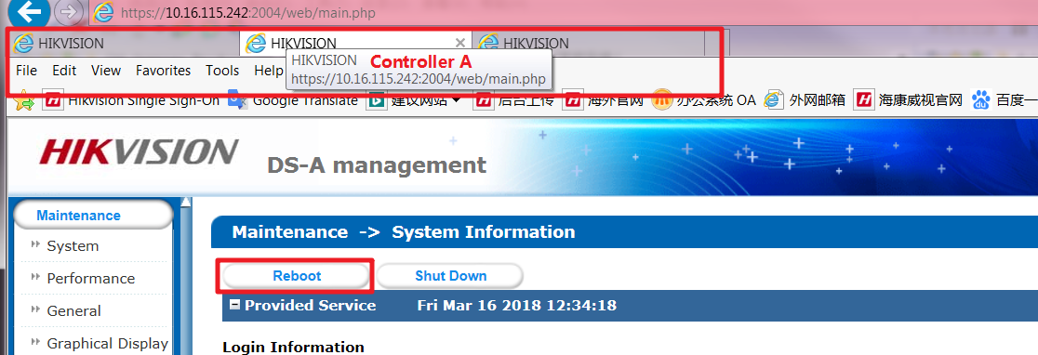

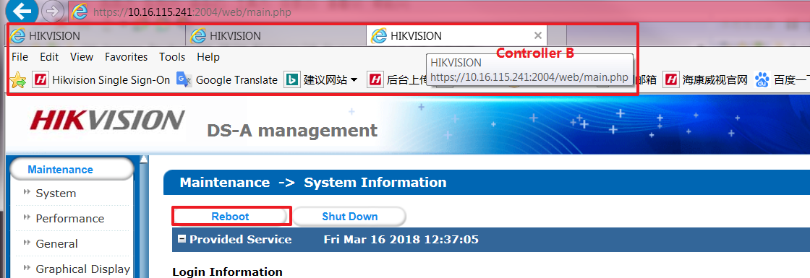
Step3: Upgrade 2storos-201711211501-Fix_CVRService_For_Mars-CVR2.3.X-915.bin (Special for dual controller device ) in controller A, then do same operation in controller B
Controller A:
Please wait several minutes until it shows below tips
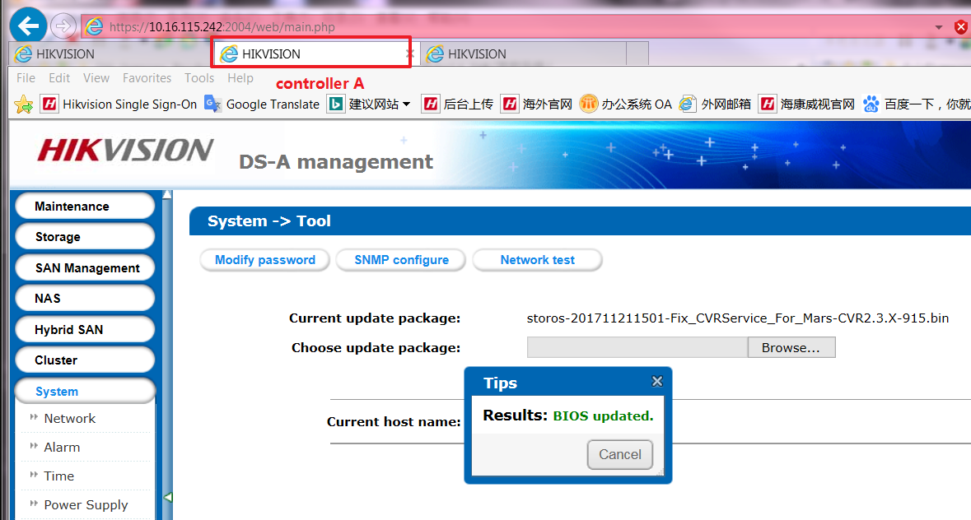
Controller B:
Please wait several minutes until it shows below tips
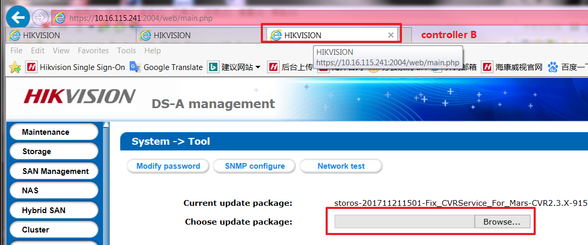

Step4: Upgrade 3storos-201705091035-C_CVR231-4_CVR232-6-hk9000server316-9_add_upgradeserver-91Xin controller A,
Step5: Upgrade 4storos-201707100859-Multi-CVR-V2.3.2-6_FW_OS_CVR-STD-COSTOM-suse_x64-91X in controller A,
Step6: Upgrade 5storos-201409291645-naz_db_init_CVR_V231-suse_x64-91X in controller A,

Step7: then do same step4、step5、step6 in controller B

Step8: Reboot both of controller A and controller B.

Upgrade done：login resource IP and check the version

First Choice for Security Professionals
HIKVISION Technical Support

