How to Upgrade Network Storage Firmware (V2.3.4/V2.3.4-2>>V2.3.5-2)
For dual-controller device
Note: Firstly, make sure your dual-controller device deploy in correct mode. As dual-controller device have two controllers, each controller have an IP separately , and we also need create a resource IP , so before you upgrade for the dual-controller device , let it work in dual-controller mode. You can check the Cluster interface in the 2004 page shown as below.
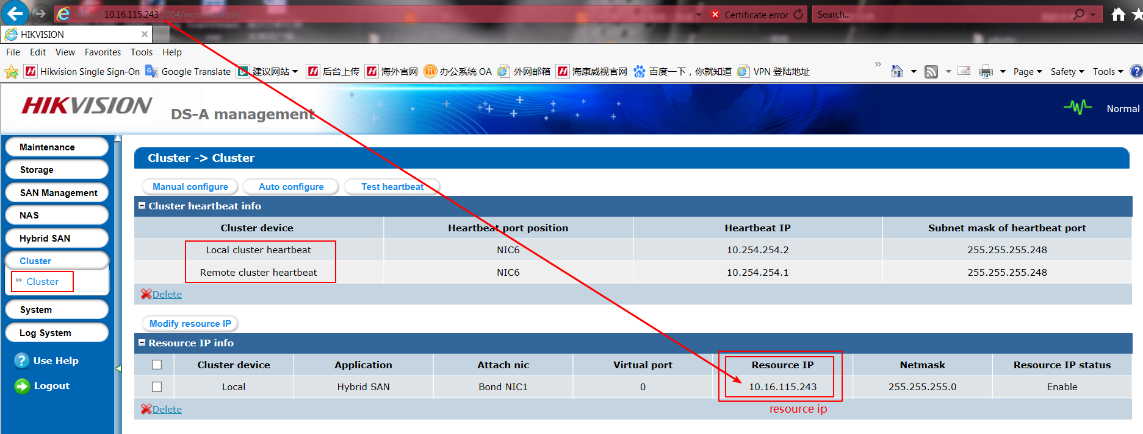
The device should upgrade to V2.3.5-2 first. And it only allow to upgrade when device CVR status is working. So the right step should be
- Login resource ip to check CVR service (https://IP (resource):2004) .Make sure the CVR service status is Working.
- Then you need to upgrade in two controller separately, login in https://IP (controller A):2004 and https://IP (controller B):2004; Do the upgrade operation in these two controller physical ip.
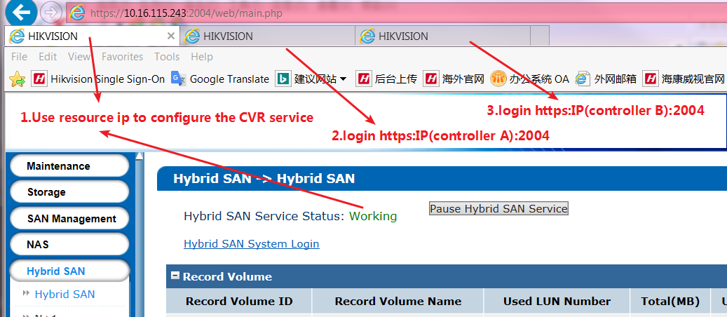
235-2 Firmware Package:
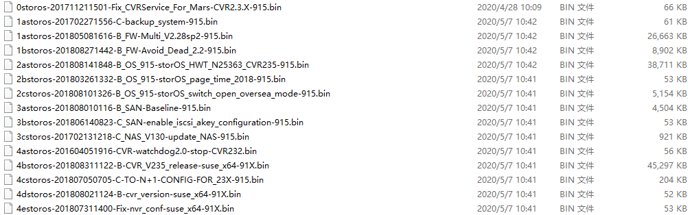

Steps:
Step1: Upgrade 0storos-201711211501-Fix_CVRService_For_Mars-CVR2.3.X-915.bin in controller A, then do same operation in controller B
Controller A:
Please wait several minutes until it shows below tips
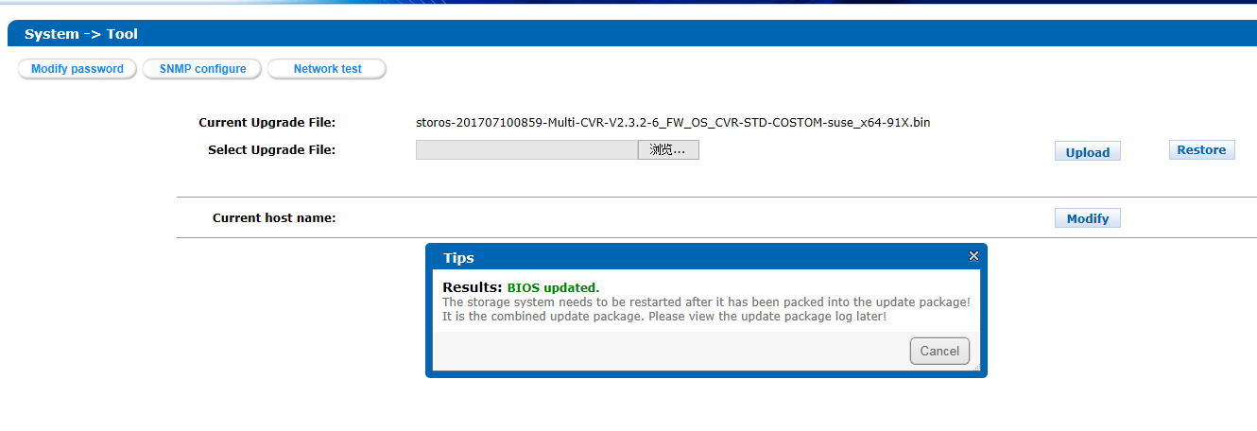
Controller B:
Please wait several minutes until it shows below tips
Step2: Upgrade following files one by one in controller A
1astoros-201702271556-C-backup_system-915.bin
1astoros-201805081616-B_FW-Multi_V2.28sp2-915.bin
1bstoros-201808271442-B_FW-Avoid_Dead_2.2-915.bin
2astoros-201808141848-B_OS_915-storOS_HWT_N25363_CVR235-915.bin
2bstoros-201803261332-B_OS_915-storOS_page_time_2018-915.bin
2cstoros-201808101326-B_OS_915-storOS_switch_open_oversea_mode-915.bin
3astoros-201808010116-B_SAN-Baseline-915.bin
3bstoros-201806140823-C_SAN-enable_iscsi_akey_configuration-915.bin
3cstoros-201702131218-C_NAS_V130-update_NAS-915.bin
4astoros-201604051916-CVR-watchdog2.0-stop-CVR232.bin
4bstoros-201808311122-B-CVR_V235_release-suse_x64-91X.bin
4cstoros-201807050705-C-TO-N+1-CONFIG-FOR_23X-915.bin
4dstoros-201808021124-B-cvr_version-suse_x64-91X.bin
4estoros-201807311400-Fix-nvr_conf-suse_x64-91X.bin
Step3: Upgrade following files one by one in controller B
1astoros-201702271556-C-backup_system-915.bin
1astoros-201805081616-B_FW-Multi_V2.28sp2-915.bin
1bstoros-201808271442-B_FW-Avoid_Dead_2.2-915.bin
2astoros-201808141848-B_OS_915-storOS_HWT_N25363_CVR235-915.bin
2bstoros-201803261332-B_OS_915-storOS_page_time_2018-915.bin
2cstoros-201808101326-B_OS_915-storOS_switch_open_oversea_mode-915.bin
3astoros-201808010116-B_SAN-Baseline-915.bin
3bstoros-201806140823-C_SAN-enable_iscsi_akey_configuration-915.bin
3cstoros-201702131218-C_NAS_V130-update_NAS-915.bin
4astoros-201604051916-CVR-watchdog2.0-stop-CVR232.bin
4bstoros-201808311122-B-CVR_V235_release-suse_x64-91X.bin
4cstoros-201807050705-C-TO-N+1-CONFIG-FOR_23X-915.bin
4dstoros-201808021124-B-cvr_version-suse_x64-91X.bin
4estoros-201807311400-Fix-nvr_conf-suse_x64-91X.bin

Step4:Reboot both of controller A and controller B
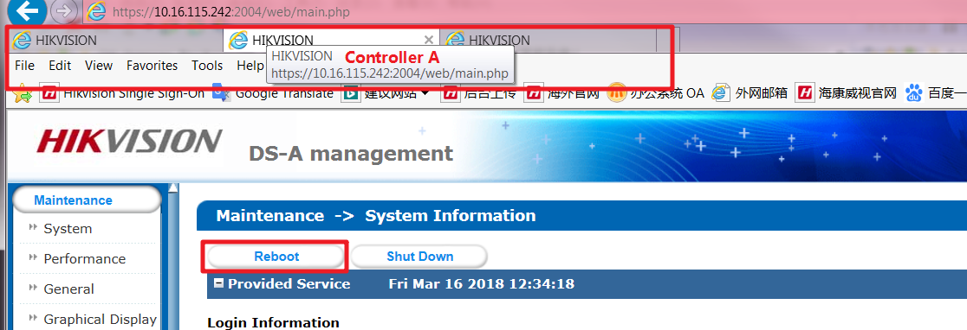

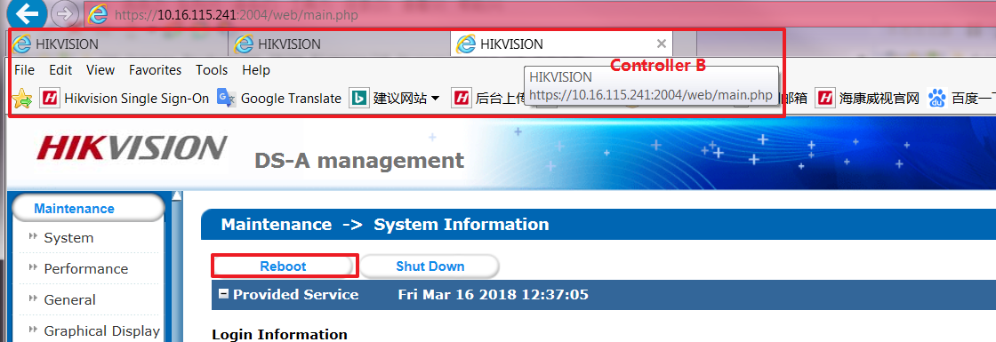

Upgrade done

First Choice for Security Professionals
HIKVISION Technical Support

