How to Configure Dual Controller Device based on IVMS-4200
Note: This document will show you how to configure dual controller device, and make recording
schedule based on IVM-4200.
Steps
- For dual controller device, you need to connect two network cable for each controller. So you can find these two controller IP address in SADP tool
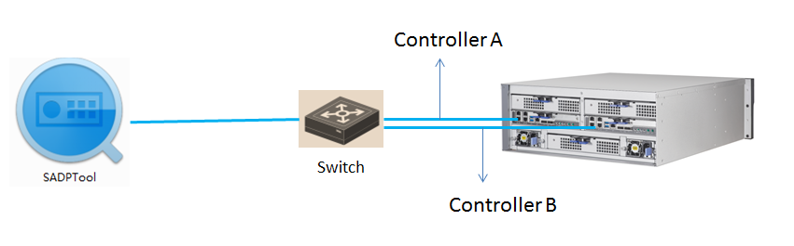
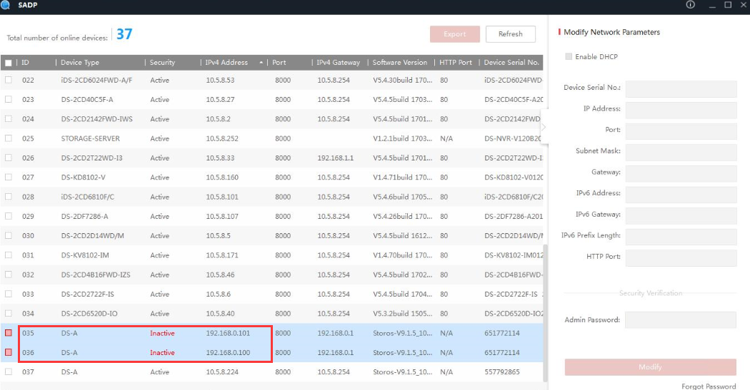
- Activate the two controller device SADP tool. And then you need to configure the IP parameter for each controller. Note: each controller need to be activated and allocate different IP address.
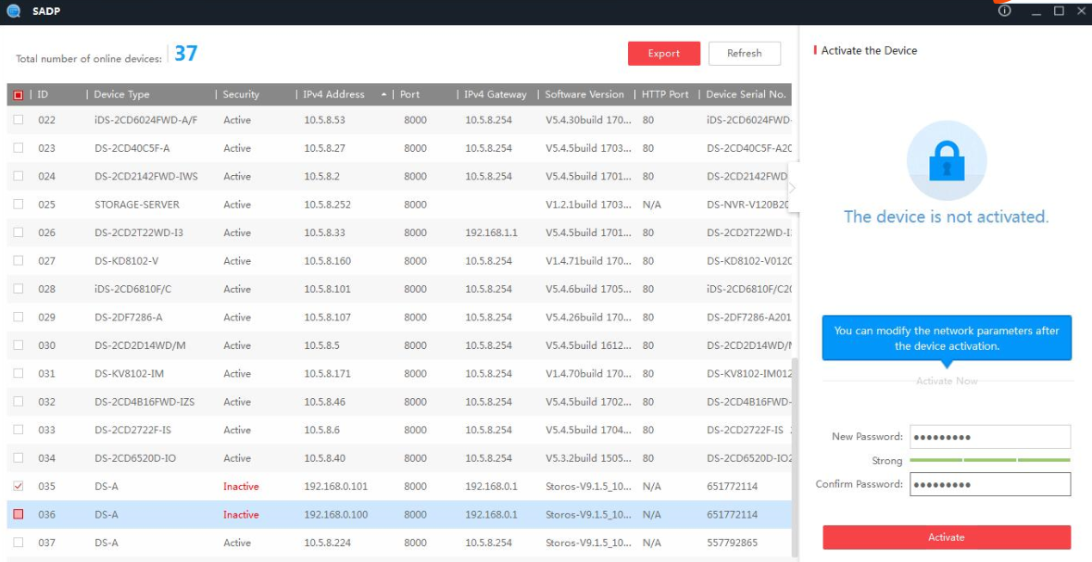
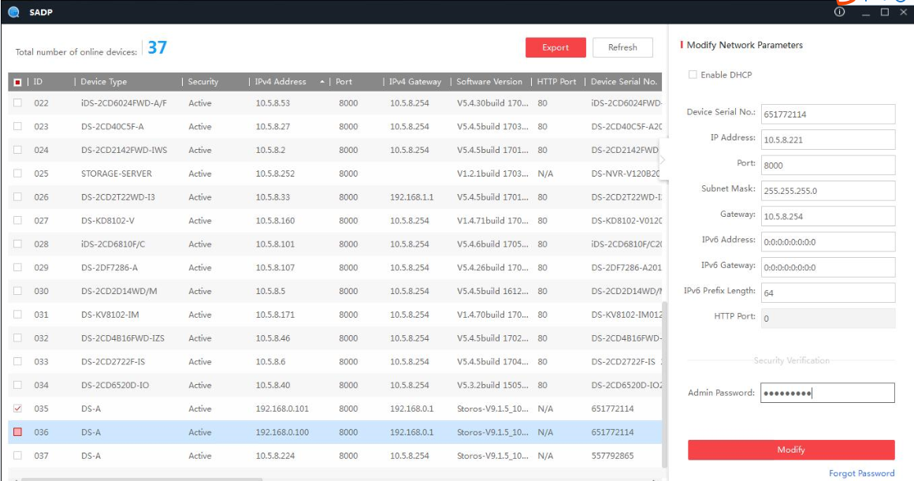
- Login the web of storage device by controller IP address. The ip address format is https:IP:2004,
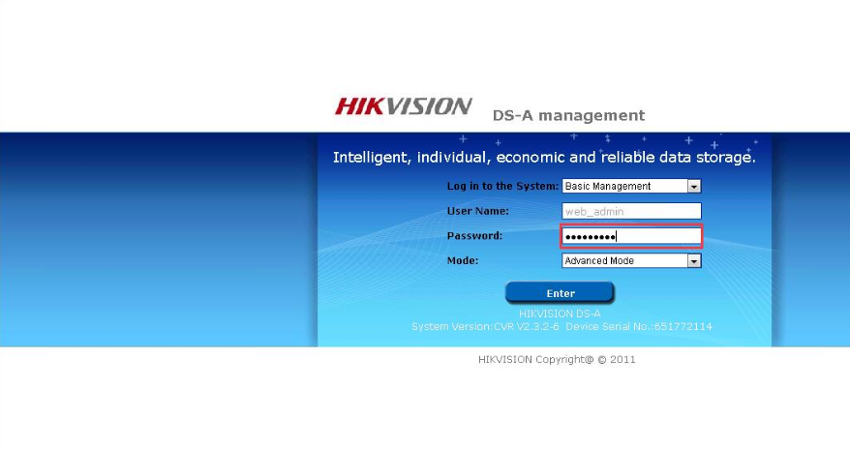

- Click the cluster button after you login web, and click Modify resource IP button and then access into Modify resource IP interface. And set resource IP for this dual controller device.
Note: the dual controller device has three different IP address. Each controller devicedifferent IP， and it also need to configure resource IP, configure recording service or add storage device into VMS based on resource IP address.
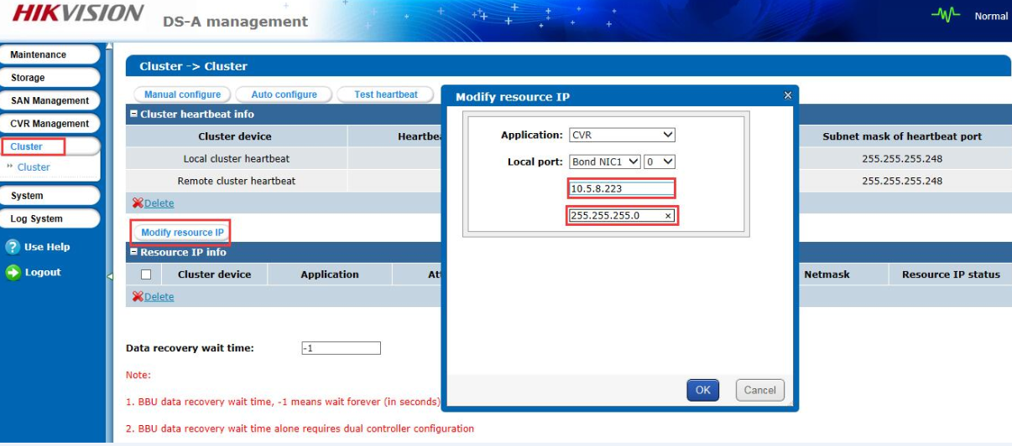
- Add resource IP address into IVMS-4200 in device management interface. The device type belongs to storage server. You need to input IP address, user name and password.
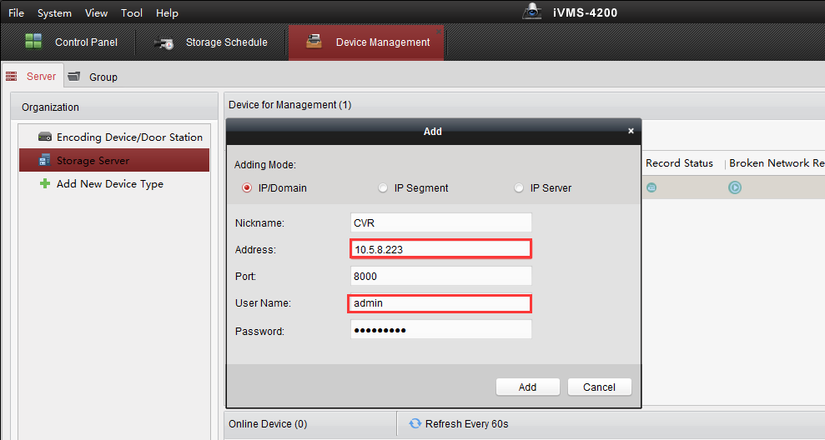
- Click Remote Configuration, And you will enter configuration interface. In the storage interface, Click General, and just click One-touch Config which will start to automatically configure CVR service.
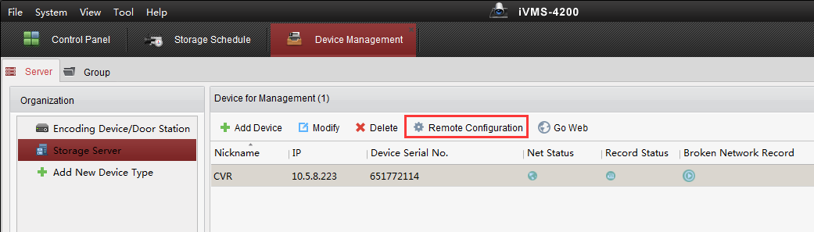
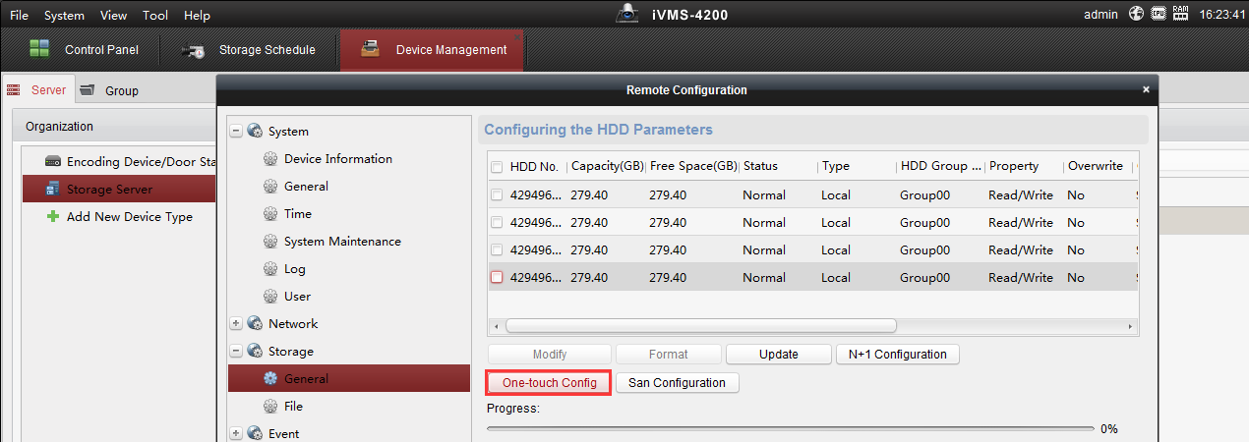
- After one-touch configuration, you can start to make recording schedule in storage schedule interface.
Choose the camera in left bar which you want to make recording schedule. And then choose storage server and related HDD. Finally, make a recording schedule for this camera.
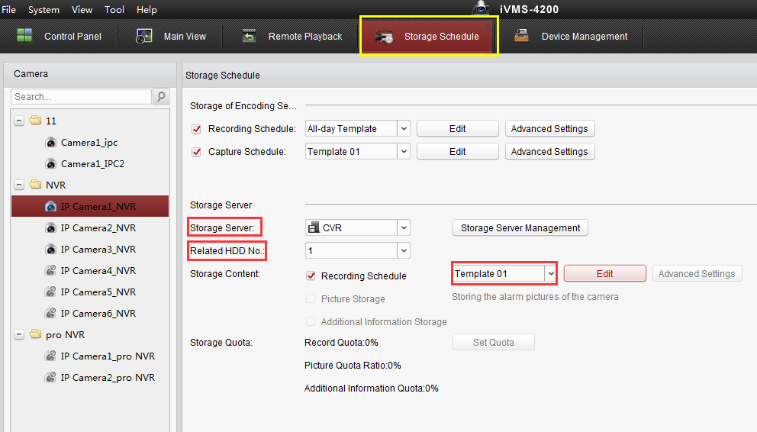
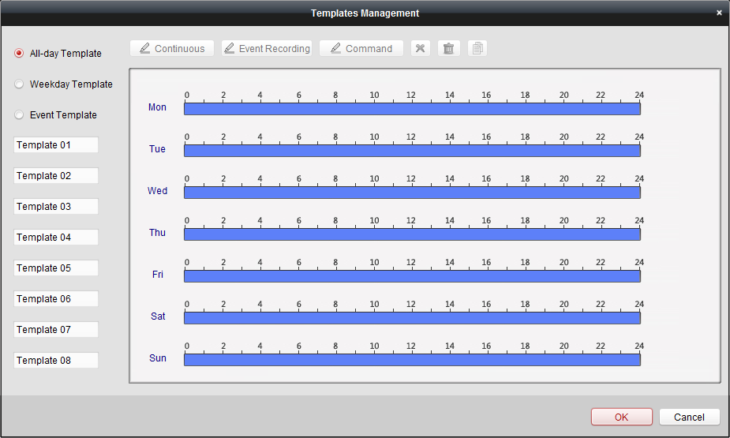

First Choice for Security Professionals
HIKVISION Technical Support

