How to Make Video LUN and Picture Record LUN
Note:
We should manually make video record LUN and picture record LUN if our customers want to storage video and ANPR picture at the same time. one-key configuration doesn’t support to make picture storage schedule.

Step1: Click Array button in the storage interface and then click create button to create RAID, select available disks and click ok to finish it.
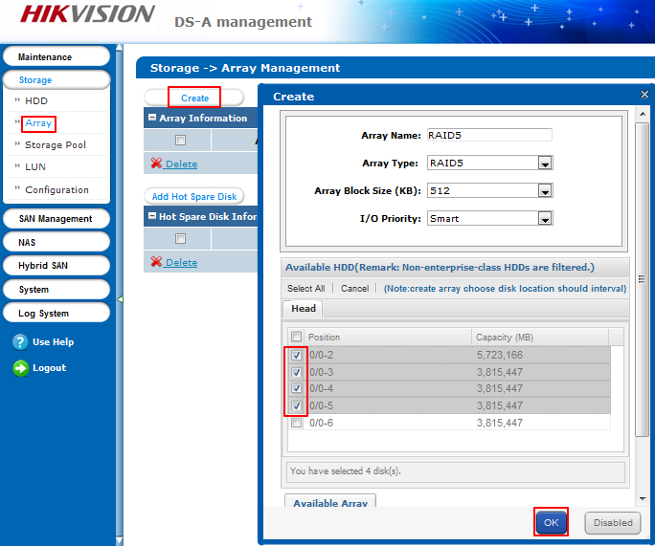
Step2: Click Add Hot Spare Disk in the array interface, choose hot spare type and available disk, finally, click ok button.
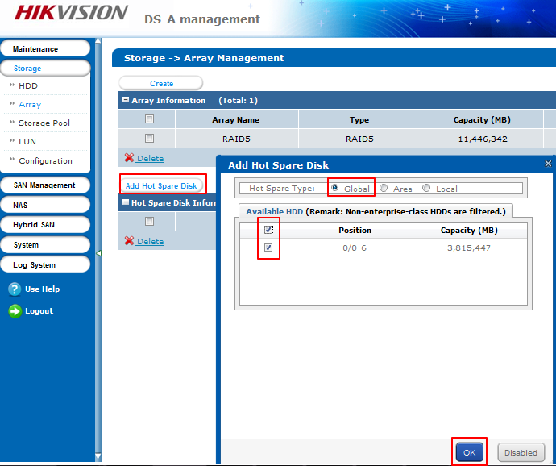

Step3: click storage pool and click add button in this interface, choose available RAID or HDD. And Click ok button to finish it.
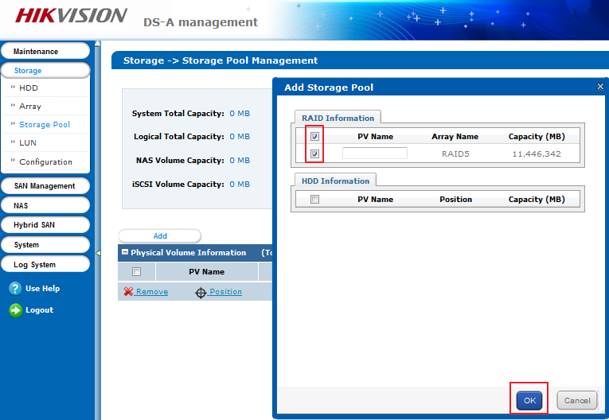
Step 4: Click LUN and create LUN in this interface. Firstly, we need to create 4 LUNs which are used to store video data index and encoding device information. And then we can create video storage and picture storage LUN, how much storage capacity it should be depends on your demand.
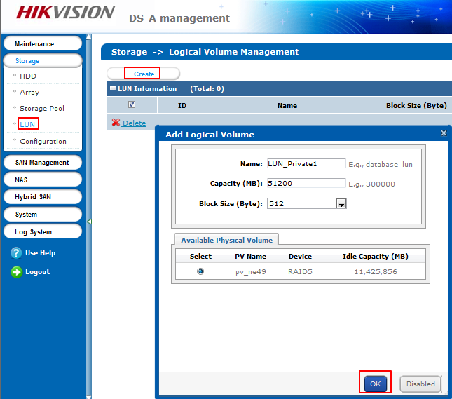
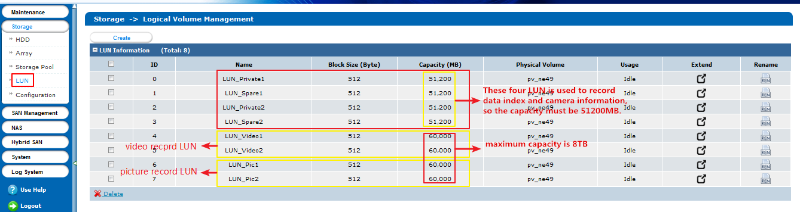
Step 5: Click Hybird SAN and click Configure Hybird SAN on the right top. We need to configure LUN_Private1, LUN_Spare1 and LUN_Private2, LUN_Spare2 here. Click Private Volume 1 and Private Volume 2, LUN_Spare is used to backup LUN_Private.
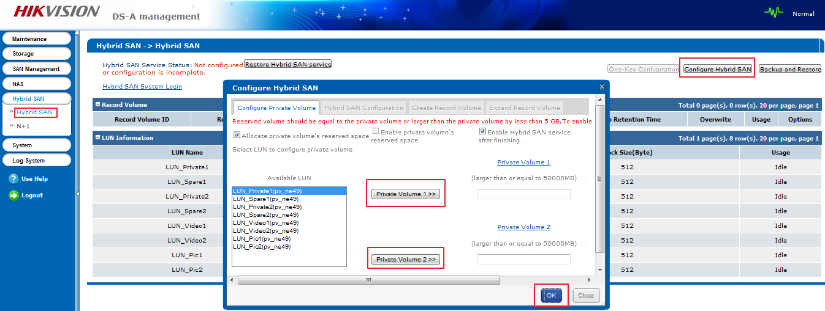
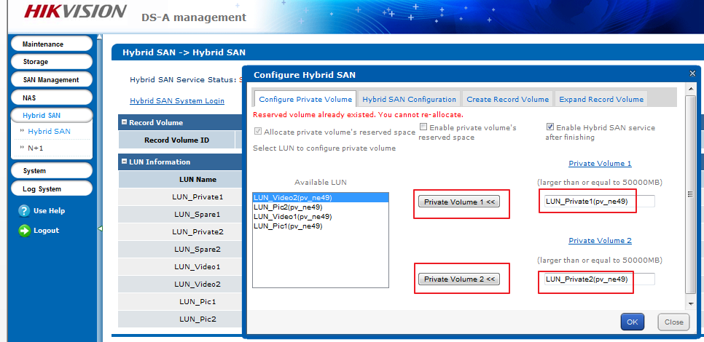
Step 6: we can configure video storage LUN in the Configure Hybird SAN interface, input record volume name and select video record LUN, the usage should be Video Storage here.
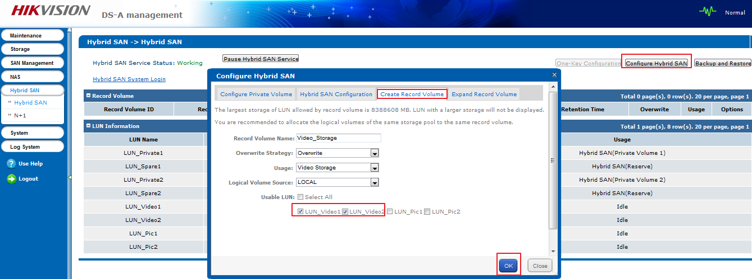
Step 7: Finally, we can configure picture storage LUN, input record volume name and set usage type as Video Storage. And then we should select LUN_Pic which is used to store picture.
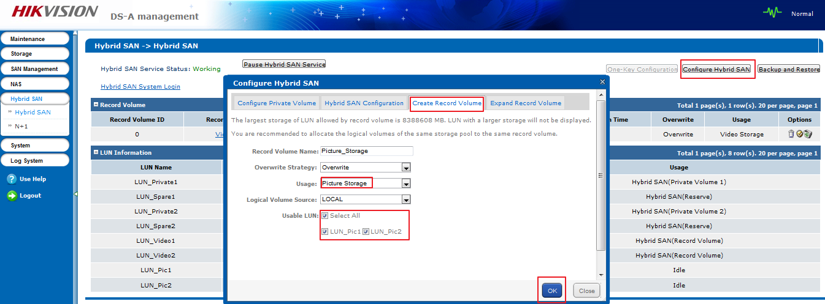
Step 7: you can check information and configuration in this interface.
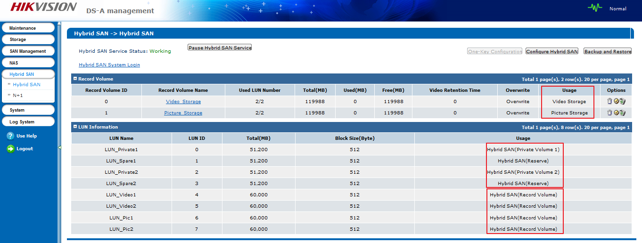

First Choice for Security Professionals
HIKVISION Technical Support

