How to Manually Configure Hybird SAN Service
Note: As we all know, Hybird SAN support to one-key configuration via web or VMS client. However, some case you need to know how to manually configure Hybird SAN service. So this file will show you how to configure it.
Steps
- Click Array button in the storage interface. Click Create button and you will see create RAID interface. Set uo RAID name and choose RAID type. Finally, Click disk list which you want to build RAID.
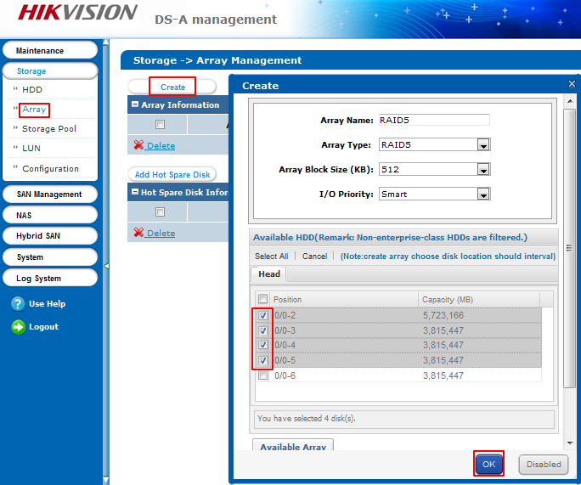
- You should set up hot spare disk after you create RAID. Click Add Hot Spare Disk and set idle disk as hot spare disk. The hot spare type just choose global one.
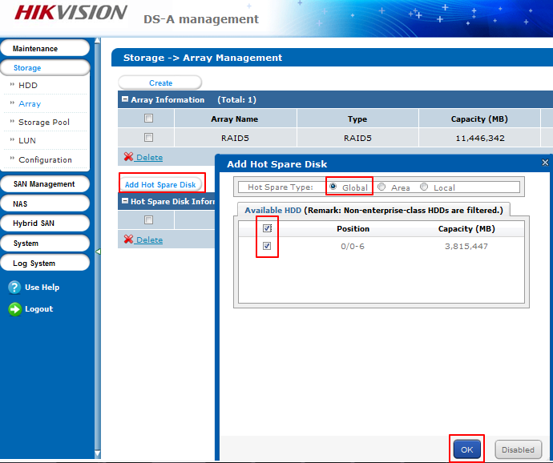
- Click Storage Pool in storage interface. And click Add button, you will see add storage pool interface. Add the available RAID or HDD into storage pool.
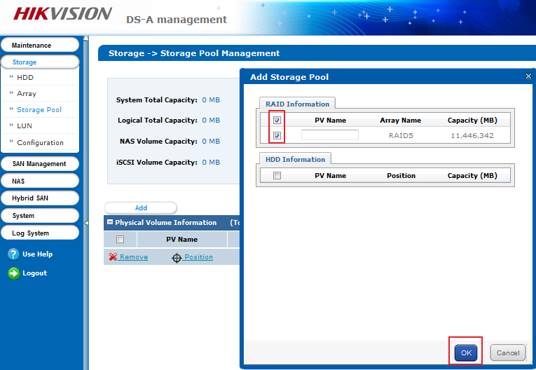
- Click LUN button, you will go into Logical Volume Management interface. You need to create 3 LUNs. Two of them are Private LUN, LUN_Private1 and LUN_Private2, respectively. It must be 51200MB for these 2 LUNs. And then you can create recording LUN which maximum is 8TB
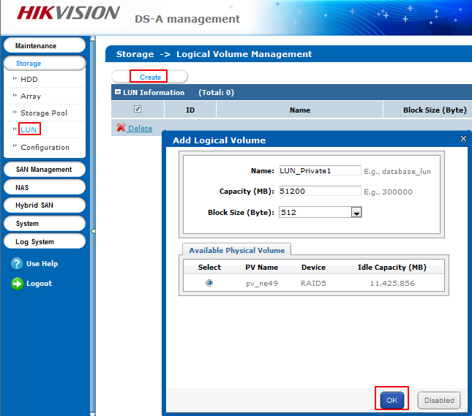

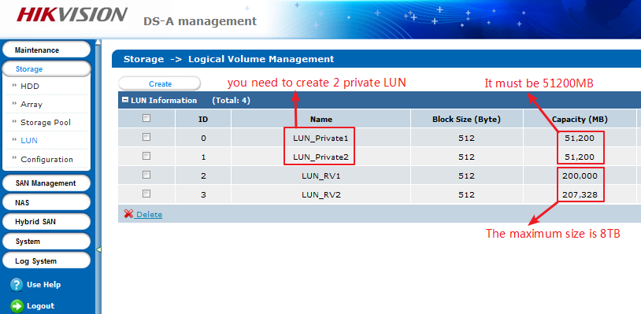
- After creating private volume and recording volume, you can start to configure Hybird SAN. Click Hybird SAN management, click Configure Hybird SAN on the right top and then enter into Configure Hybird SAN interface. DO not tick Allocate private volume’s reserved space. And then click private volume 1 and private volume 2. Finally, click ok.
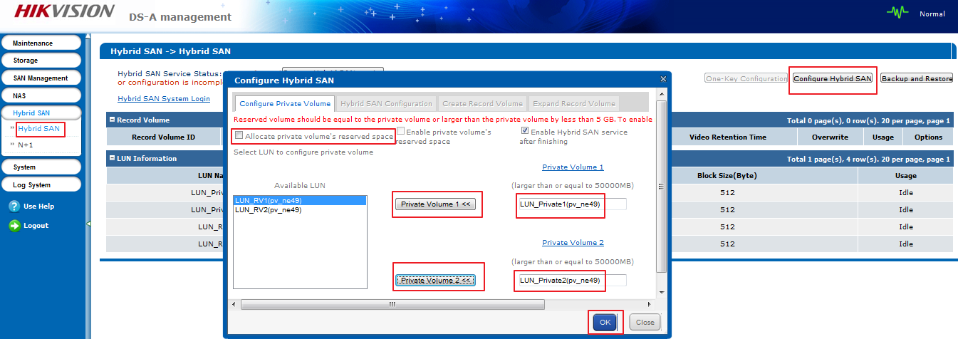
- In the same interface, and click Create Record Volume. Set record volume name and relate to usable LUN .
And click ok finally.
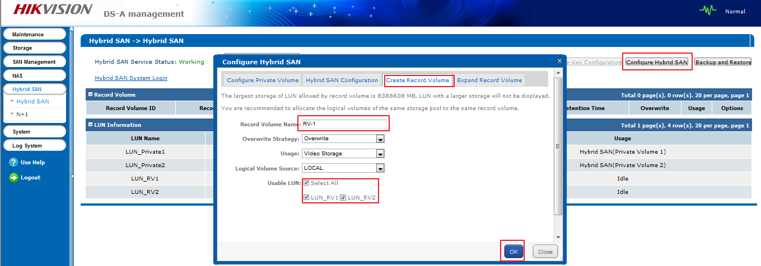
- You can check the configuration in this interface. The Hybird SAN service status is running, the four LUN are used to private volume and recording volume.
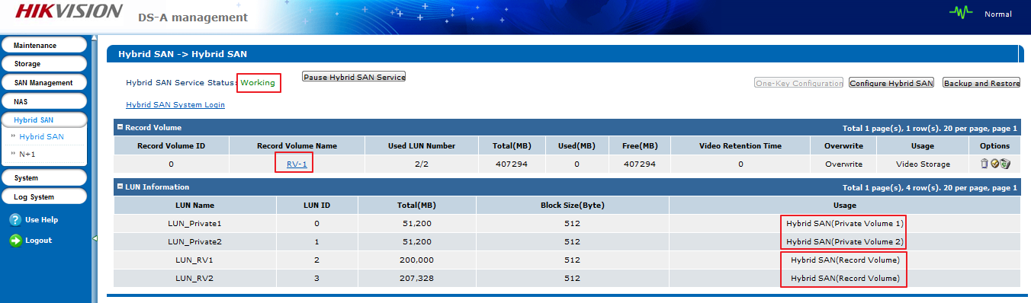

First Choice for Security Professionals
HIKVISION Technical Support

