How to set up email alarm function
Note: This document will show you how to configure email alarm when storage device has abnormal issues. Please make sure that conditions can meet the following requirements.
- The sending email should open SMTP server.
- The SMTP port is 25 or 587
- The user name should adopt email authorization code
- The email should support SSL encryption or TLS encryption.
Steps:
- Please check the DNS server address in your server side.
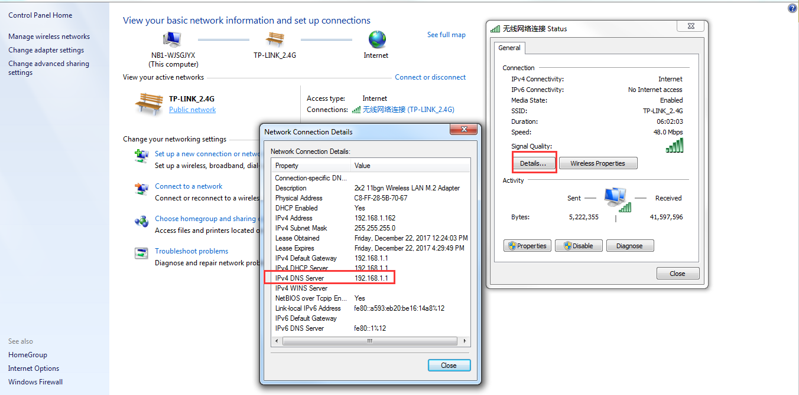
- Login storage’s web and click network in system interface. Input the DNS server address which you get in last step.
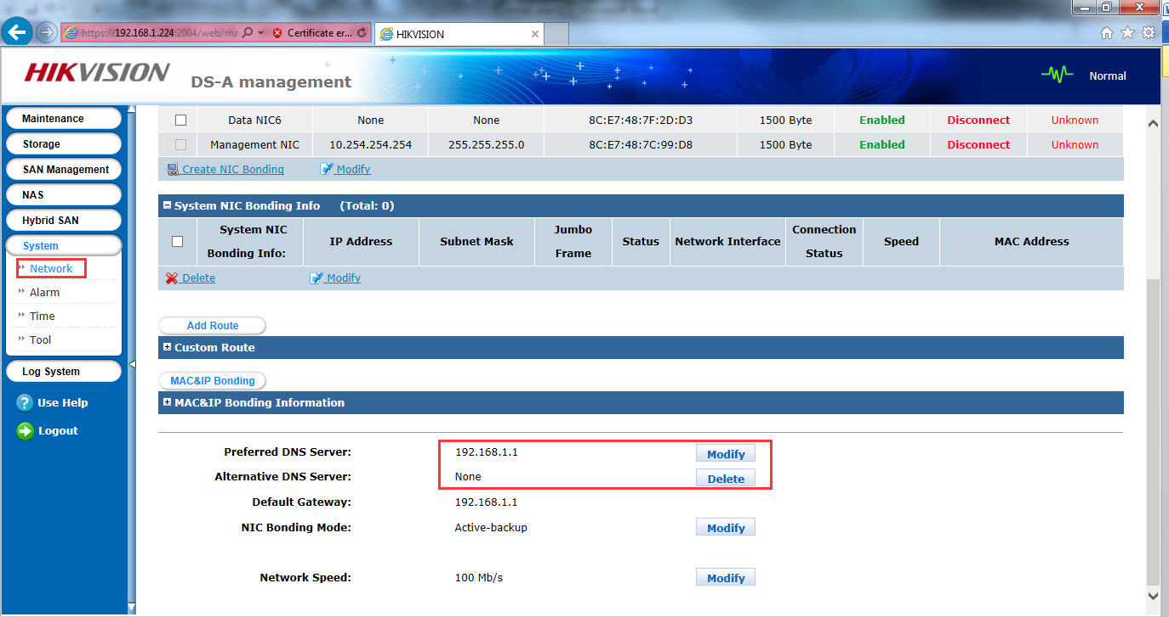
- Click Use help and click Comand line tools, you need to download this tool.
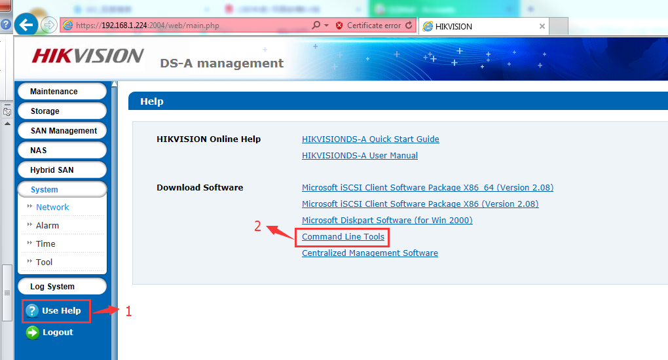
- Input the IP address of storage device and port number. The port number is 55555.
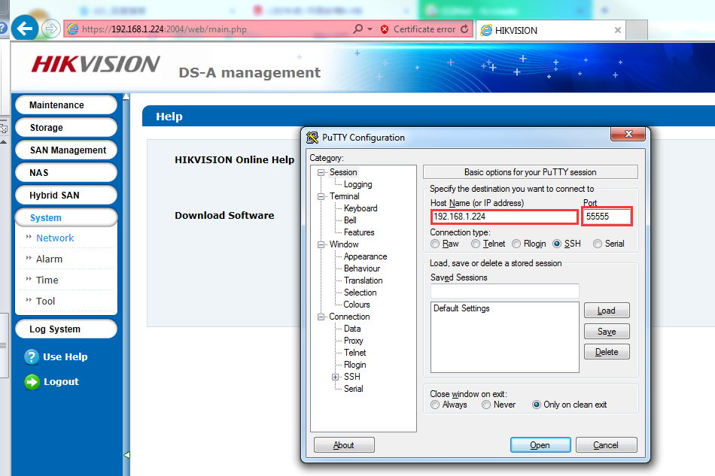

- Login as web_admin and input the password the device. Then try to ping www.google.com after you successfully login device in this command tool.
Note: this process can prove that device is in WAN, and you can change www.google.com into any other web site.
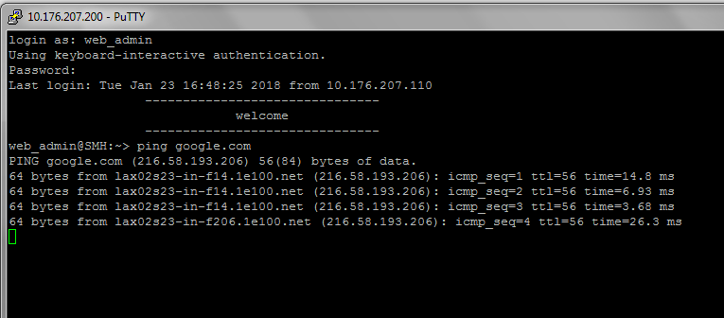

- Login email account and then click settings which can open POP3/SMTP service.
Note: please try to find the configuration interface according to different email account.
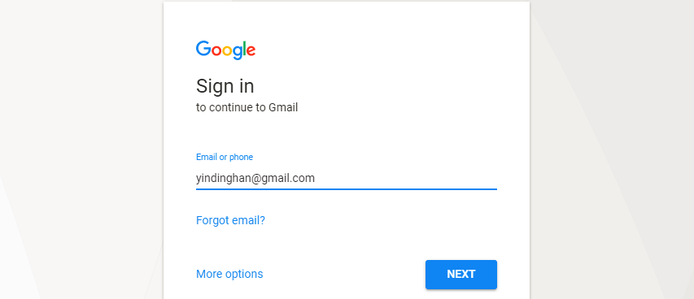
- Go to mail settings(use Gmail for example)
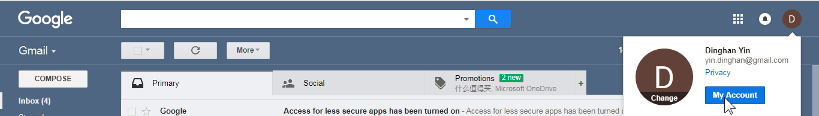
- Go to “Signing in to Google”
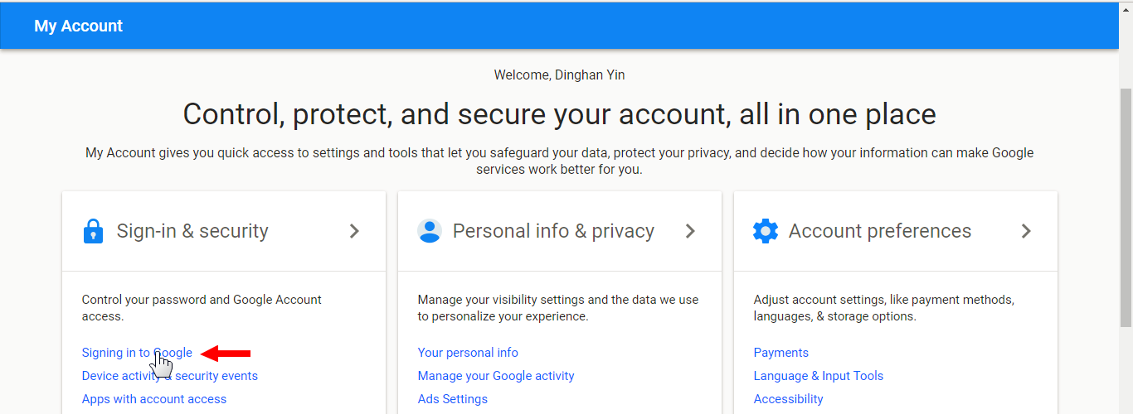
- Enable “2-Step Verification”
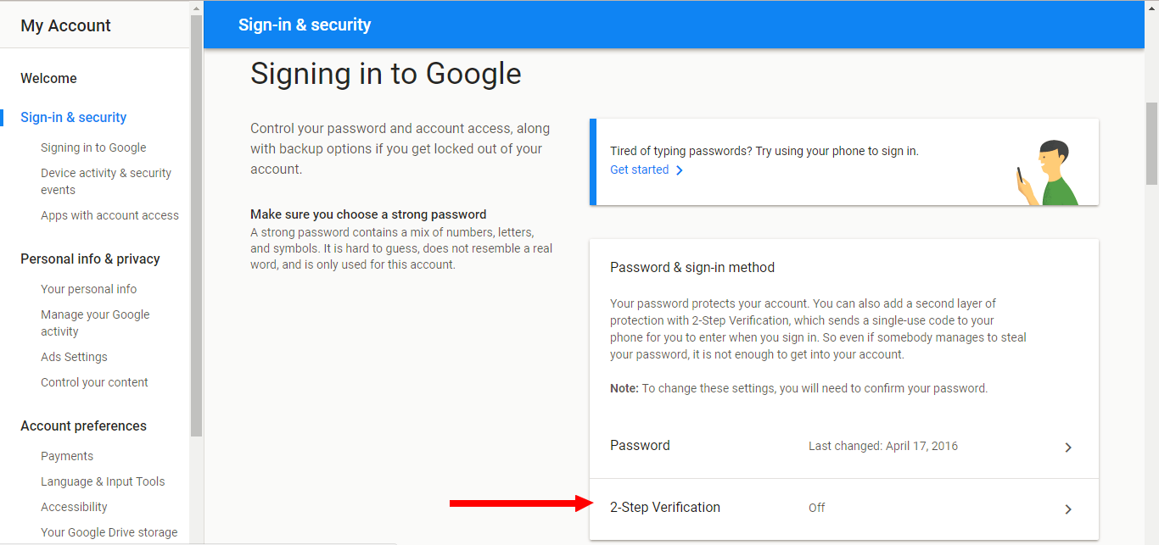
- After 2-step Verification enabled, there’s “App passwords” option available.
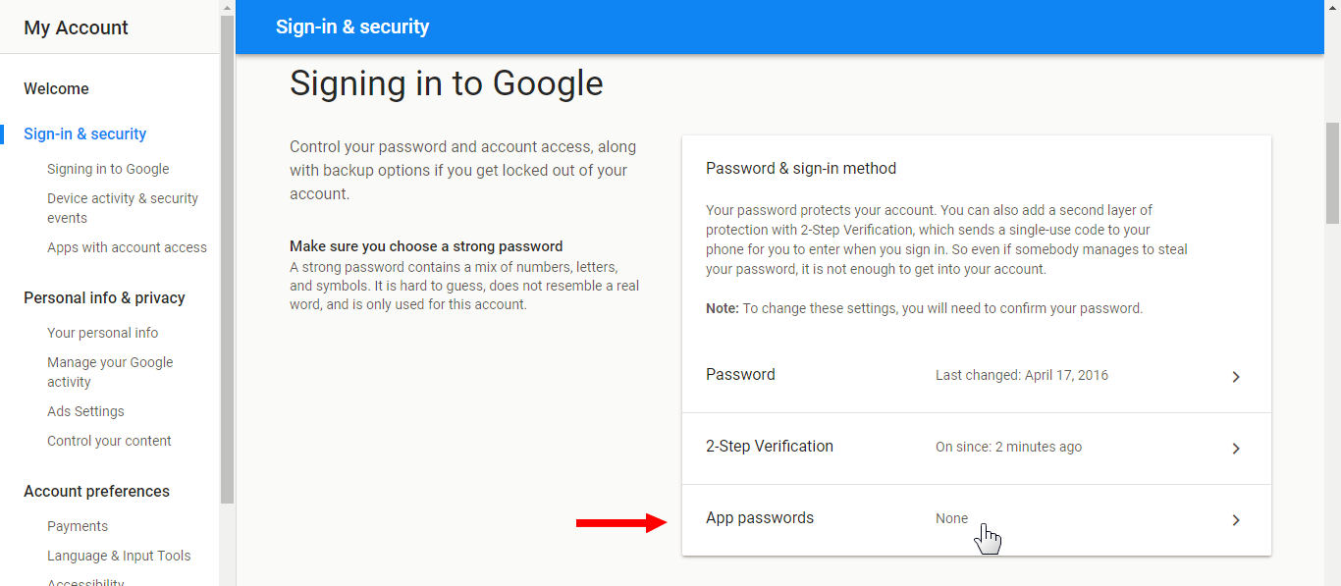
- Click Select app Button, then Click Other.
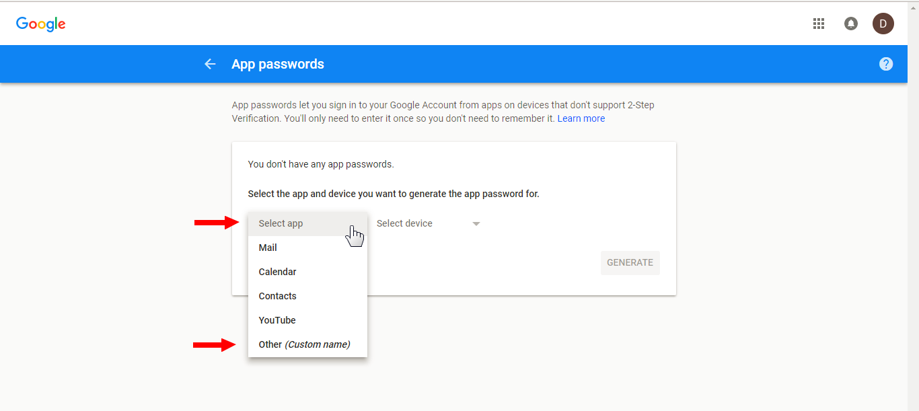
- Input the custom name, then click GENERATE.
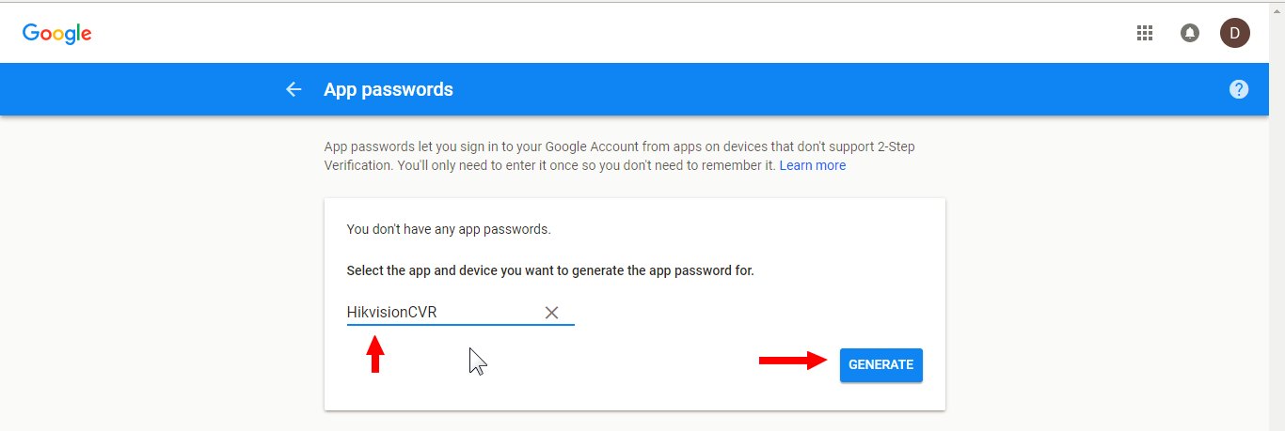
- You will get a specific app password.
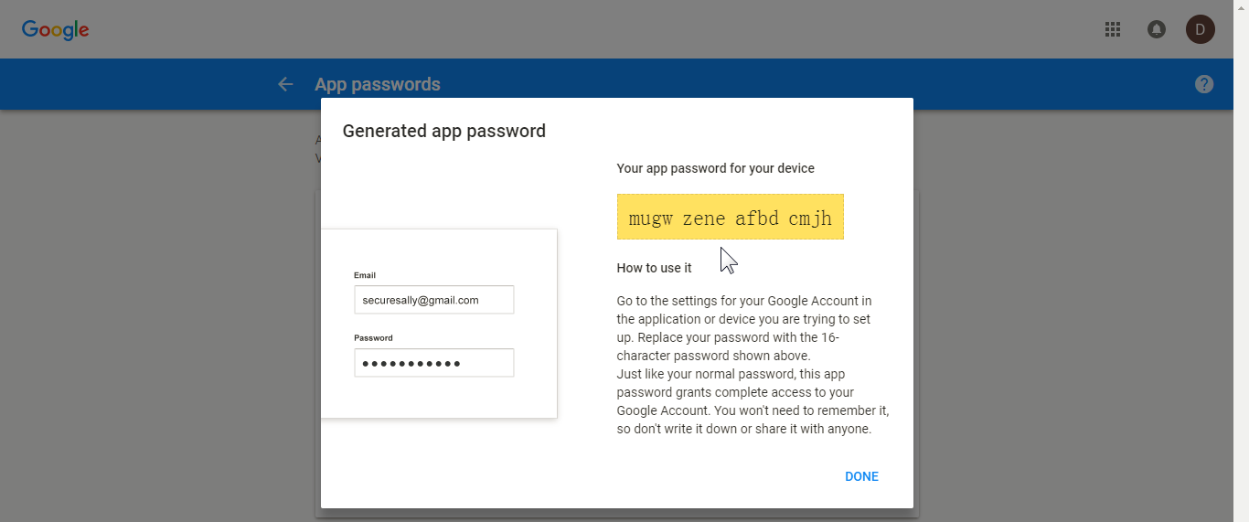
- Click Alarm button in storage device’s web. And click configure SMPT and go into configure sending email address interface. Input user name, password, SMTP and SMTP port No.
Note: the password is app password which you get in last step.
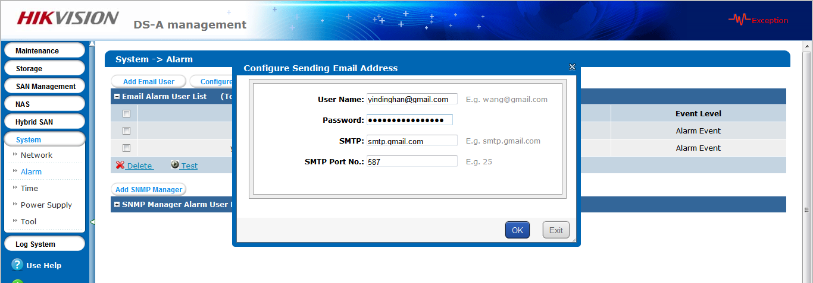
- Click Add email User. Input email account which you want to be alarmed and input user name. Please select serious event level.
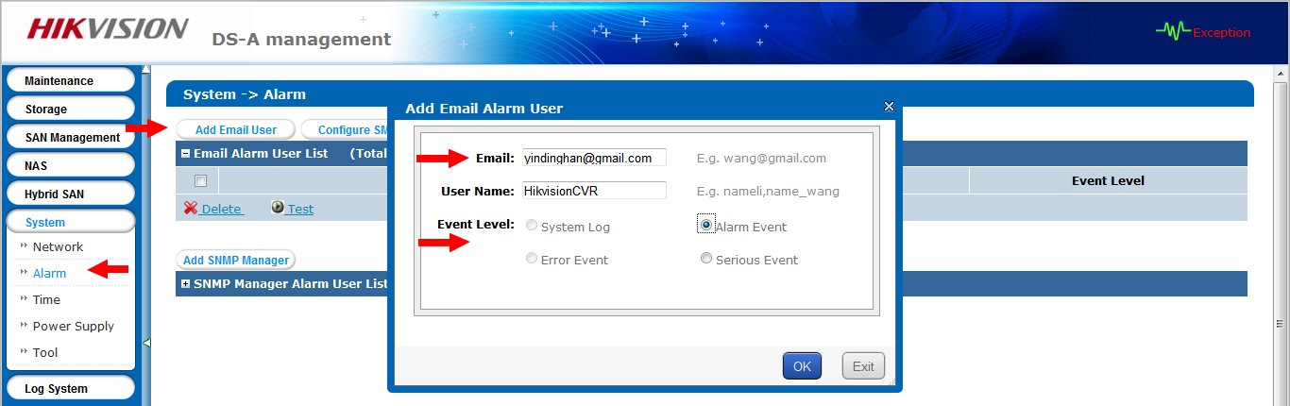
- You can test the email alarm function after finishing configuration.
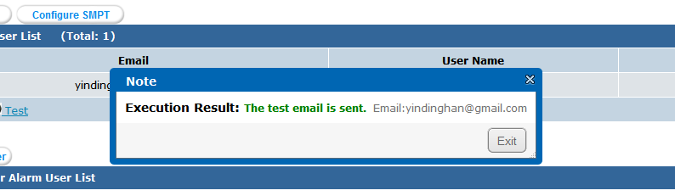
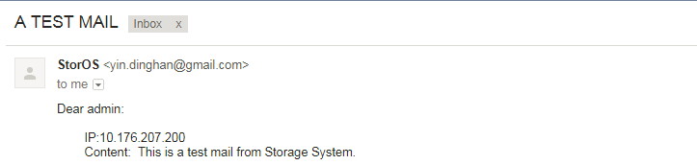

First Choice for Security Professionals
HIKVISION Technical Support

