How to Make Schedule Backup History Video in IVMS-4200
Note: As we all know, we can add Hybird SAN into IVMS-4200 and configure recording schedule for each camera. This manual will show you how to do it and points for attention. The version of IVMS-4200 is v2.7.2.4 which supports to make schedule backup history video template.
IVMS-4200 download Link: https://www.hikvision.com/en/Support/Downloads/Client-Software

Steps
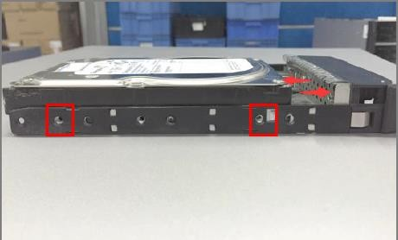
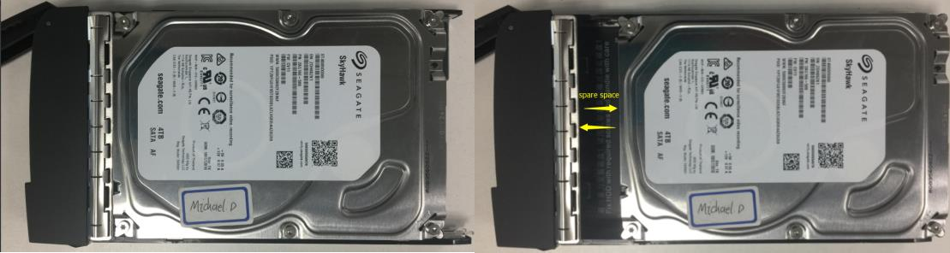
- You need to insert the hard driver before configuring device. And the disk should be installed in right position as follow pictures.

Wrong Installation Correct Installation
- The status of disk is unauthorized when you insert new disk into device.so you need to check or detect it. The status of disk will be Normal after checking or detectin
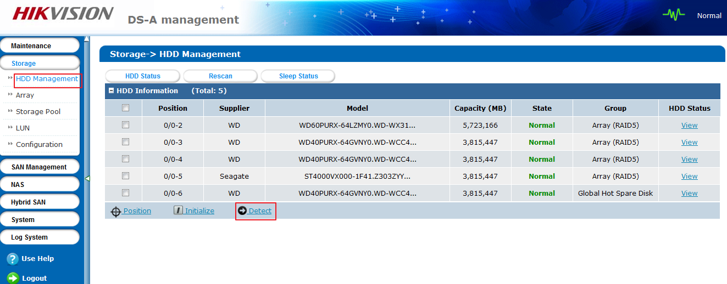
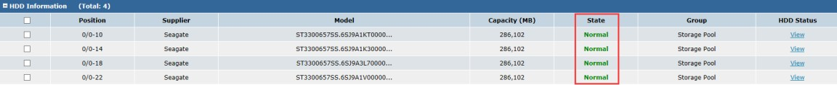
- Add Hybird SAN device into IVMS-4200 in device management interface. You need to input IP address, user name and password.
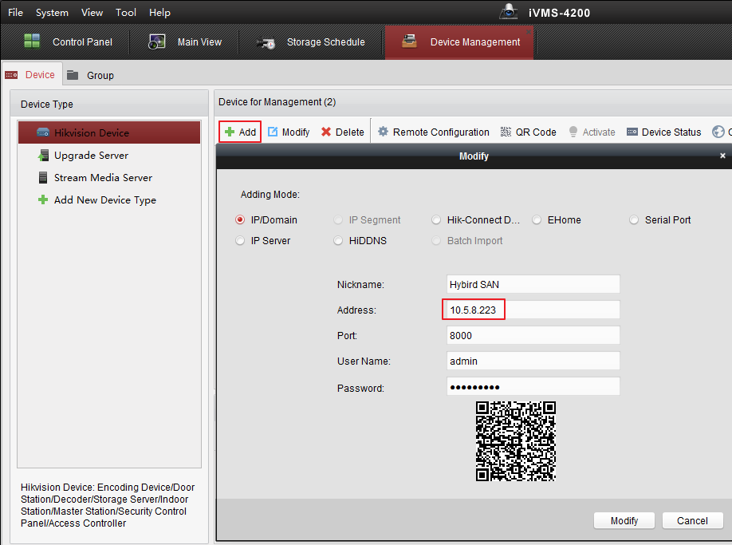
- Click Remote Configuration, And you will enter configuration interface. In the storage interface, Click
General, and just click One-touch Config which will start to automatically configure Hybird SAN service. When the one-touch config finish, the status of hybrid san will be Working .
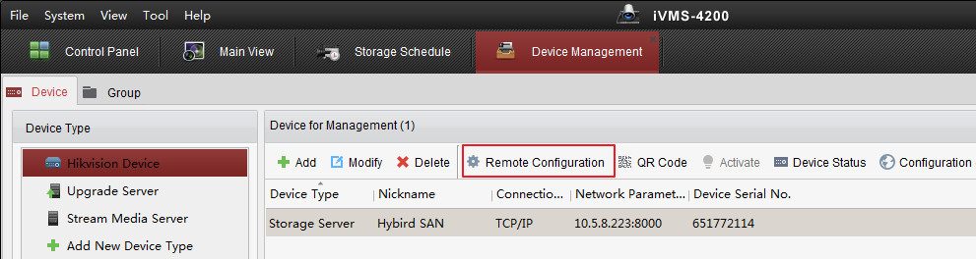

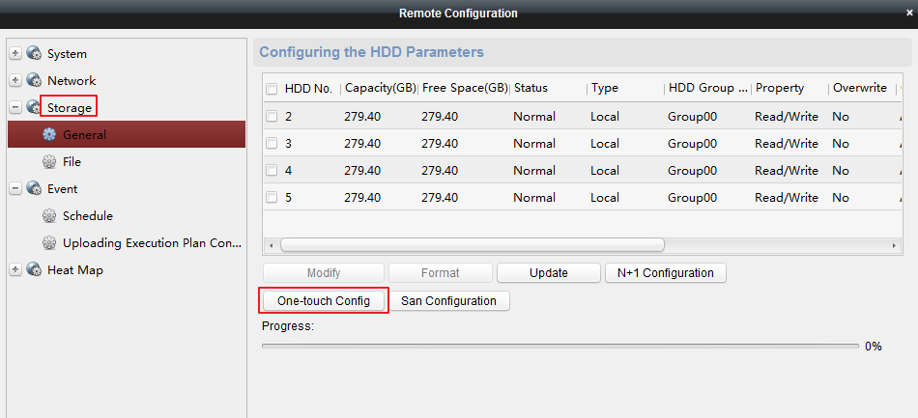
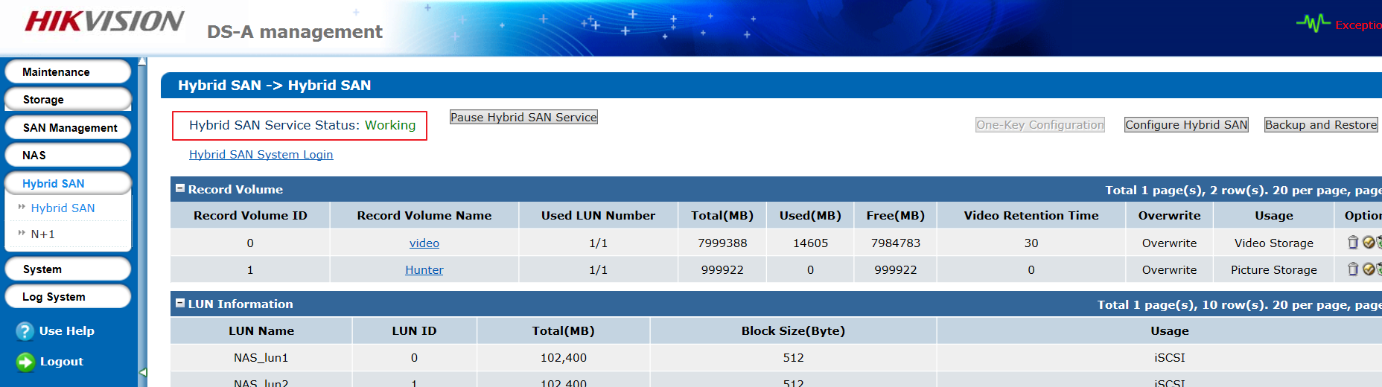

- After one-touch configuration, you can start to make recording schedule in storage schedule interface.

Choose the camera in left bar which you want to make recording schedule. And then choose storage server
and related HDD. Finally, The recording schedule should be empty template.
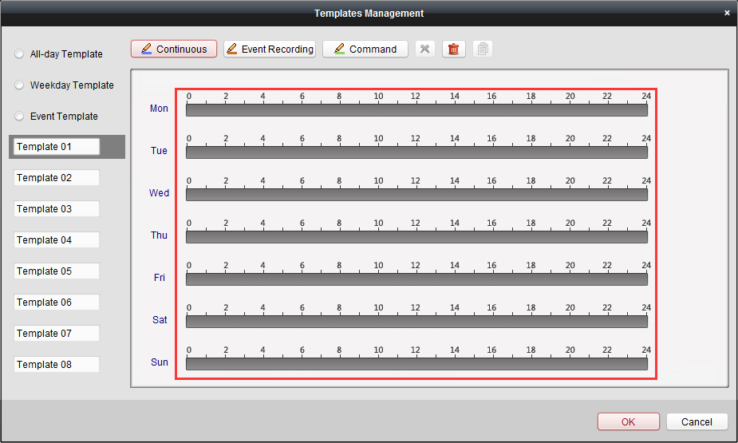
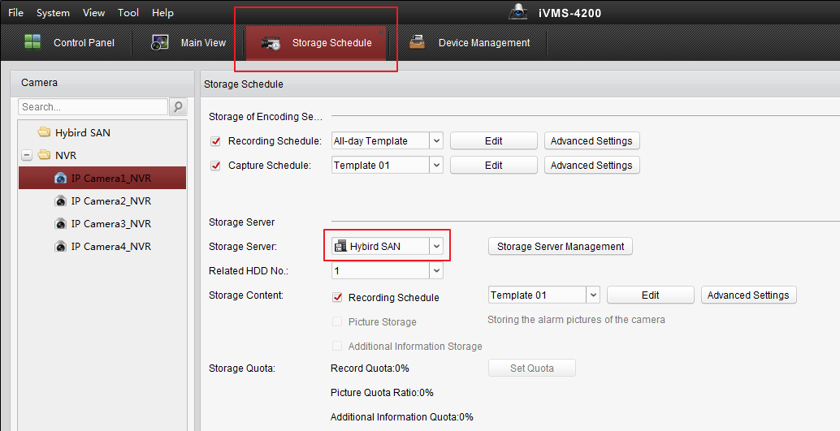
- After configuring empty template schedule. Click Remote configuration in the device management. 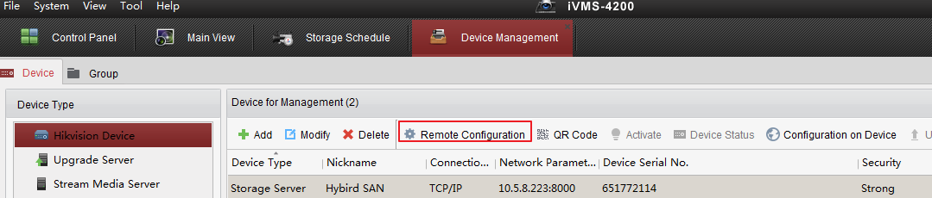

- And Click Uploading Historical Record in Event option, you can set which certain period of video you want to backup. In this case, make a backup schedule for this camera is that from 8 am to 6 pm. But you also can make an all-day template for it. So it depends on project requirements.
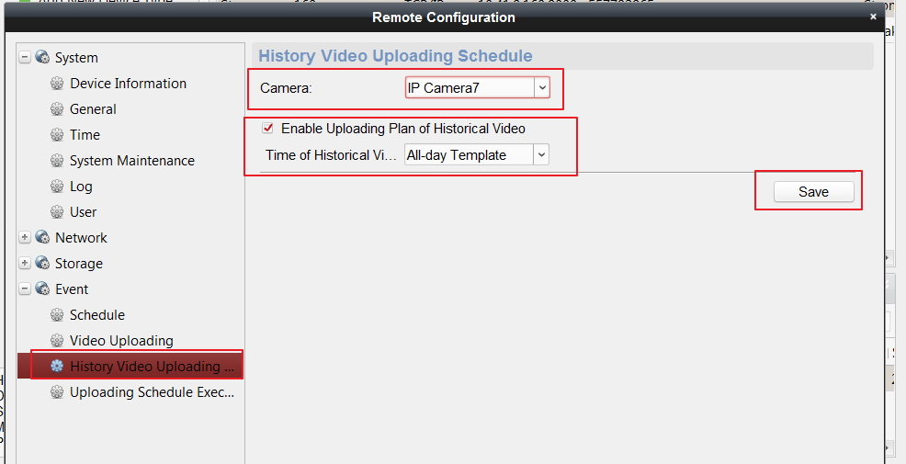
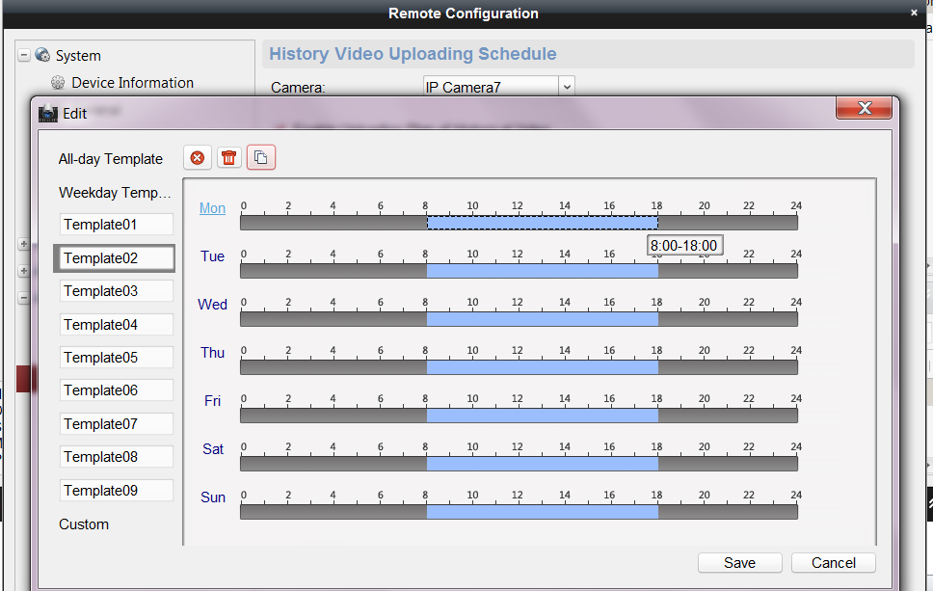

- Click Uploading Execution Plan Configuration, you can set when you want to start to backup video from NVR/DVR/IPC. In this case, make execution plan from 0 am to 8 am and from 6 pm from to 24 pm. You can set all-day template for it as well if necessary.
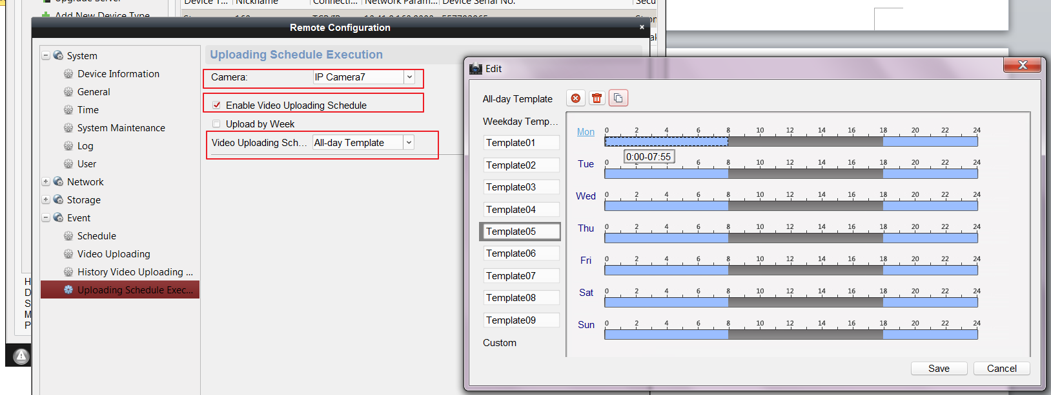

- Then login hybrid san system to check the status of upload.

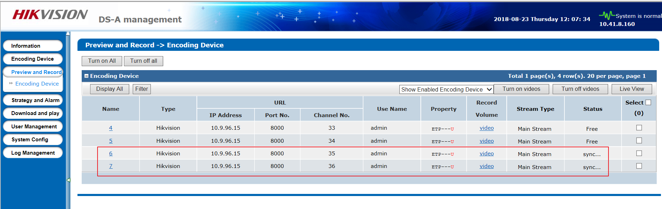

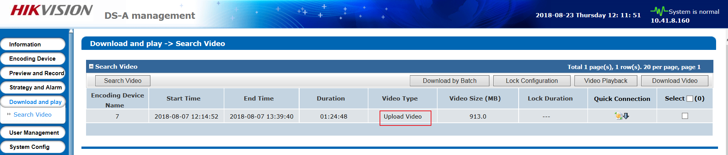

First Choice for Security Professionals
HIKVISION Technical Support

