How to Make Recording Schedule in HikCentral
Note: As we all know, we can add Hybird SAN into HikCentral and configure recording schedule for each camera. This manual will show you how to do it and points for attention.

Steps
- You need to insert the hard driver before configuring device. And the disk should be installed in right position as follow pictures.
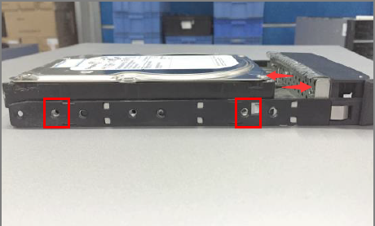
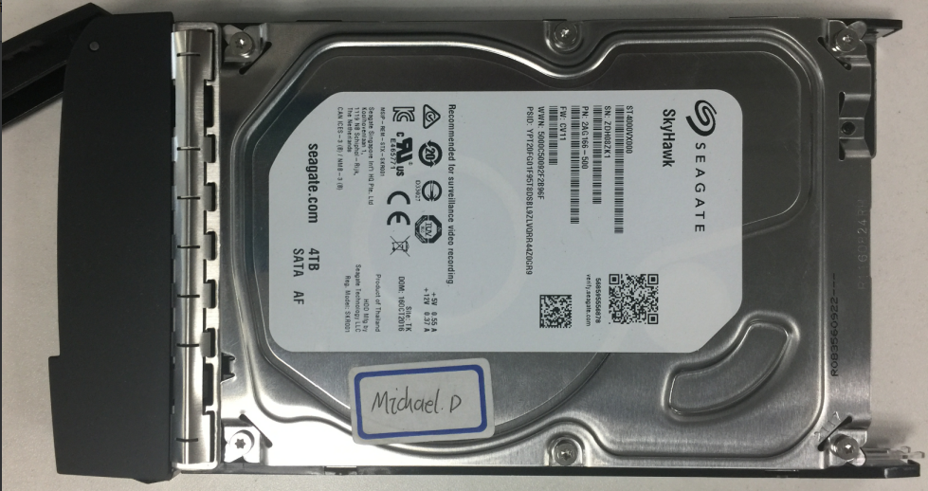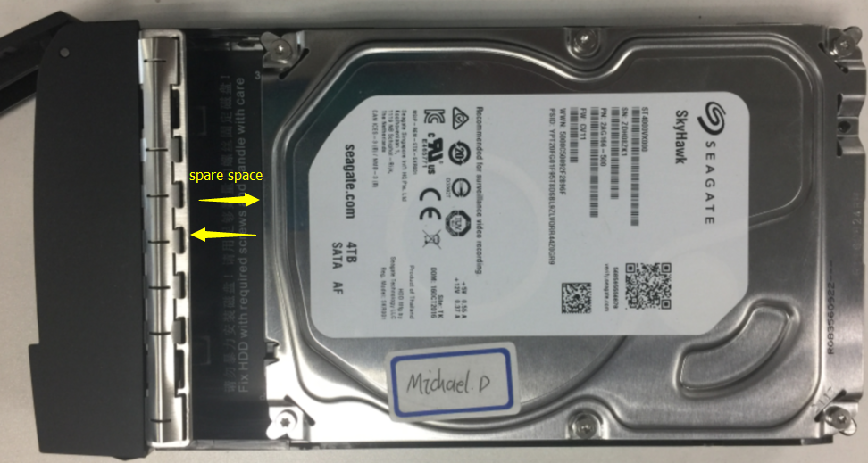
Wrong Installation Correct Installation
- The status of disk is unauthorized when you insert new disk into device.so you need to check or detect it.
The status of disk will be Normal after checking or detecting.
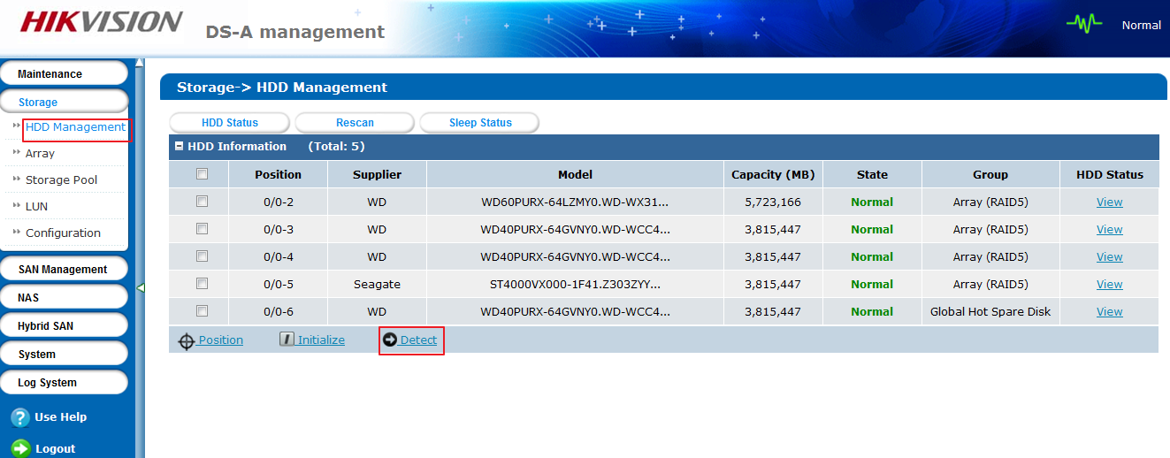
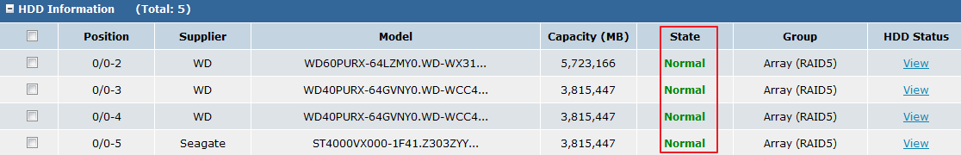
- Add Hybird SAN device into HikCentral in device management interface. The device type belongs to Recording server. You need to input IP address, user name and password. Then click Add.
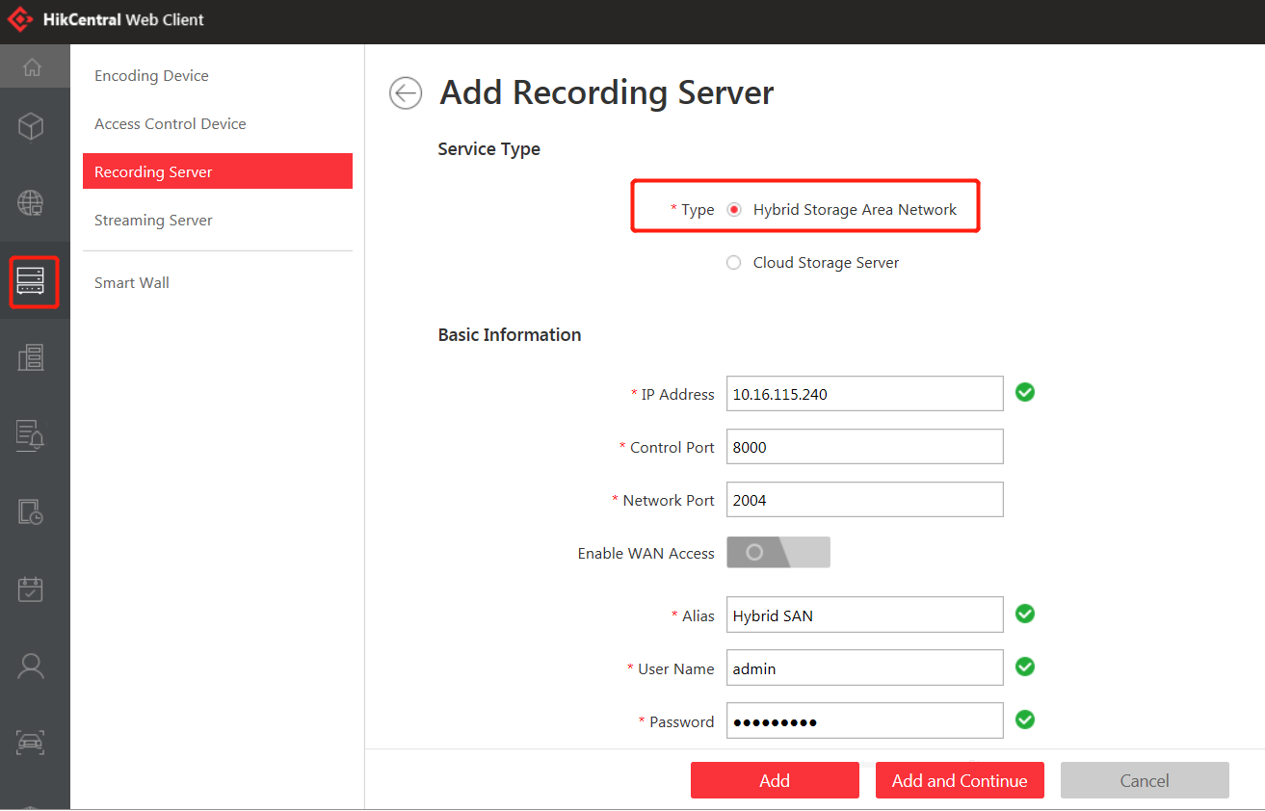
- Click One-touch Config ,there is a pop-up window to select the type of RAID, normally is RAID 5, then click OK, which will start to automatically configure Hybird SAN service,
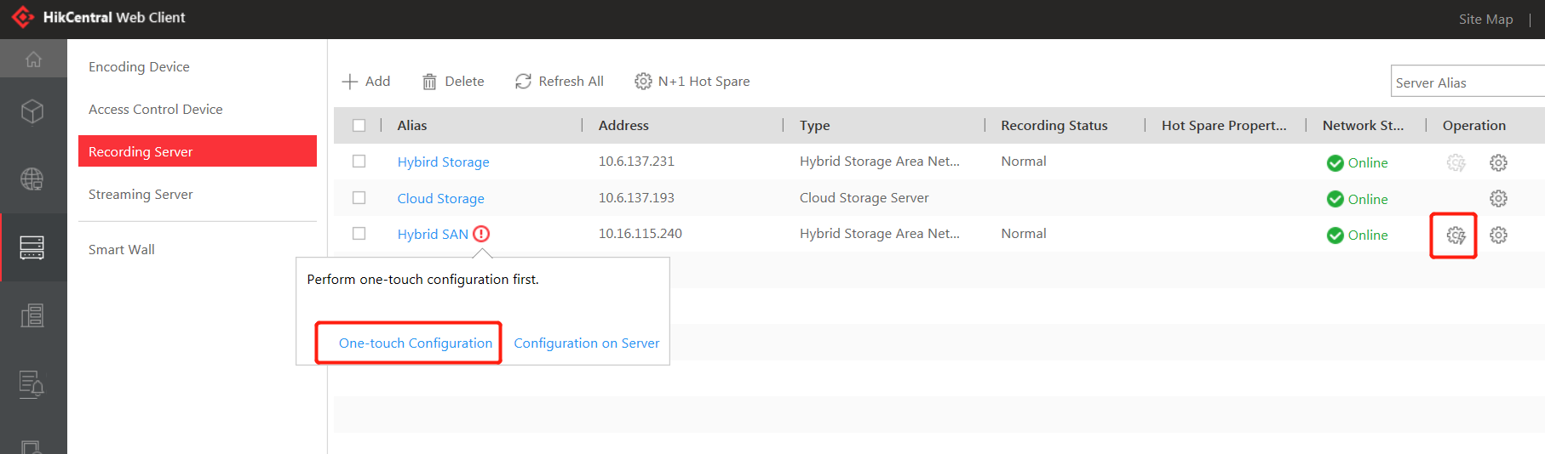
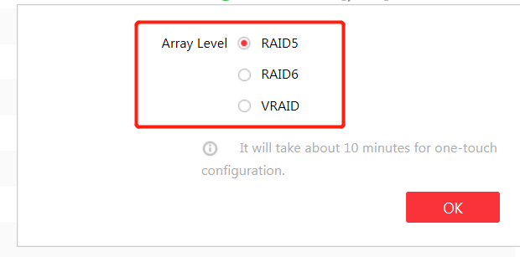
- After one-touch configuration, you can start to make recording schedule in Logical view interface.
Choose the group in left bar which you want to make recording schedule. And then click the camera. choose storage server and related volume. Finally, Configure record schedule template for camera and click save button .
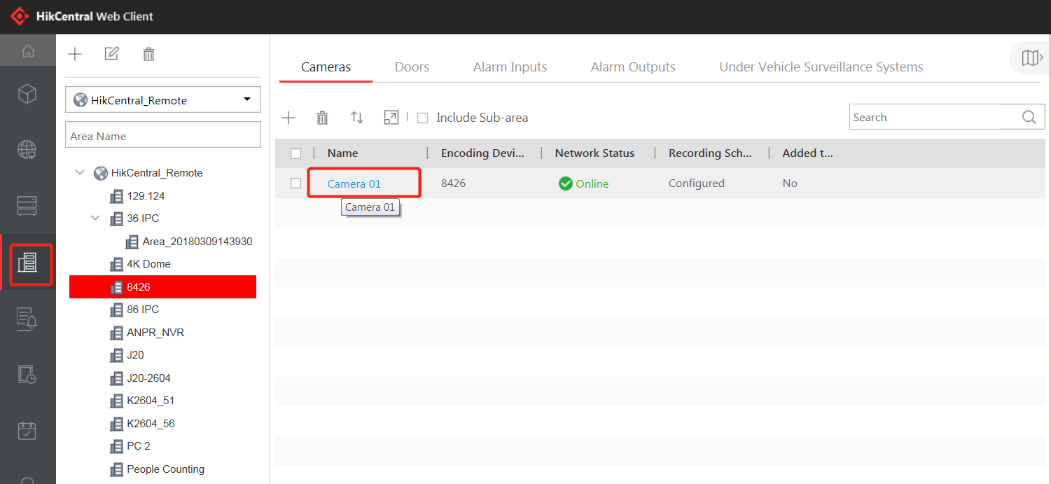
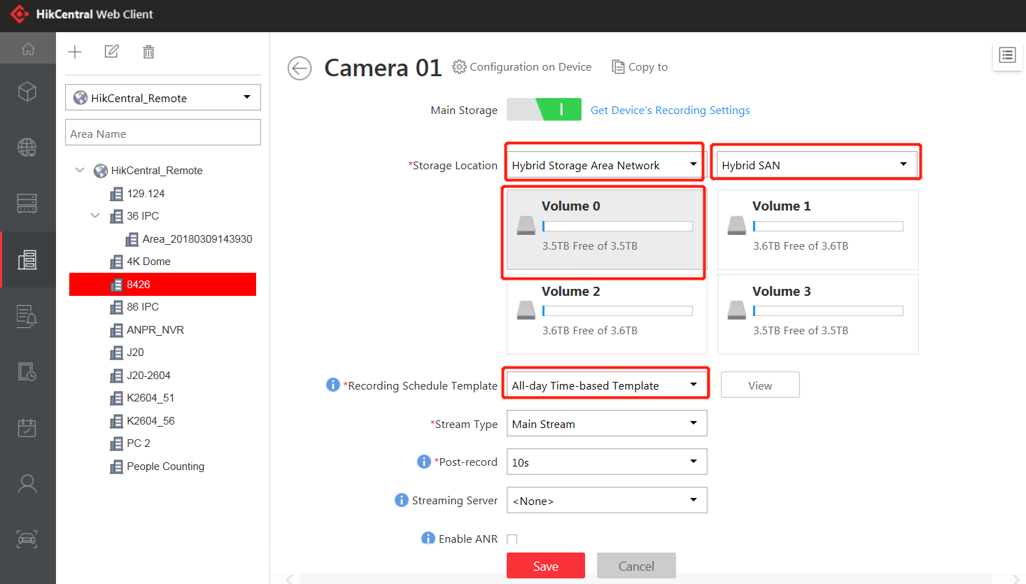

First Choice for Security Professionals
HIKVISION Technical Support

