How to Make Recording Schedule in IVMS-4200
Note: As we all know, we can add Hybird SAN into IVMS-4200 and configure recording schedule for each camera. This manual will show you how to do it and points for attention. The version of IVMS-4200 is v2.7.0.10 which supports to make schedule backup history video template.
IVMS-4200 download Link: http://www.hikvision.com/en/Tools_84.html
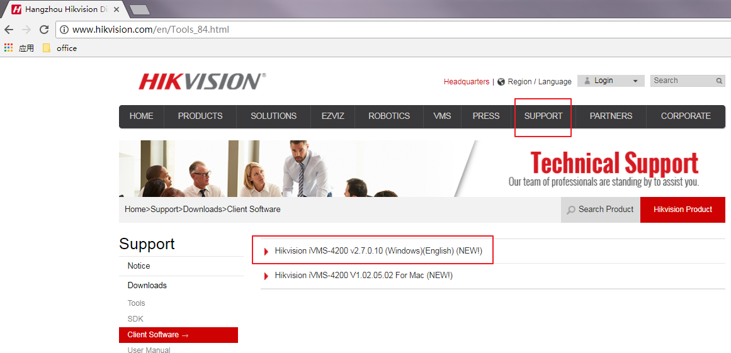
Steps
- You need to insert the hard driver before configuring device. And the disk should be installed in right position as follow pictures.
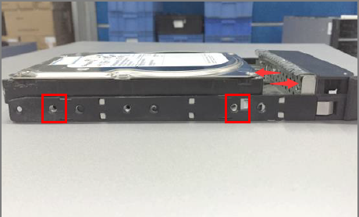
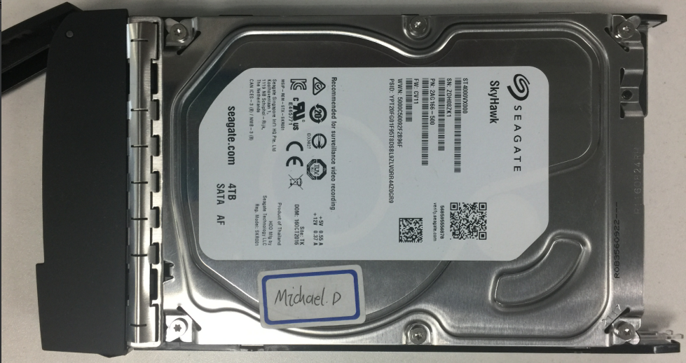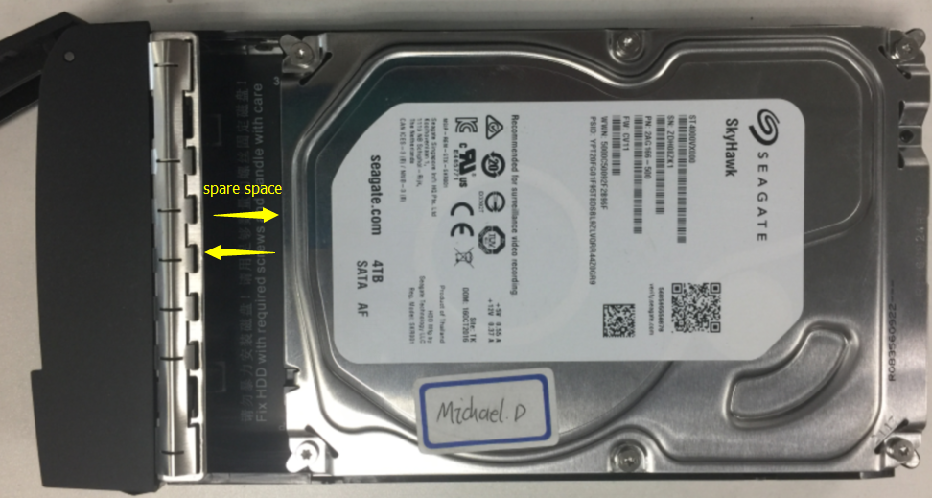
Wrong Installation Correct Installation
- The status of disk is unauthorized when you insert new disk into device.so you need to check or detect it.
The status of disk will be Normal after checking or detecting.
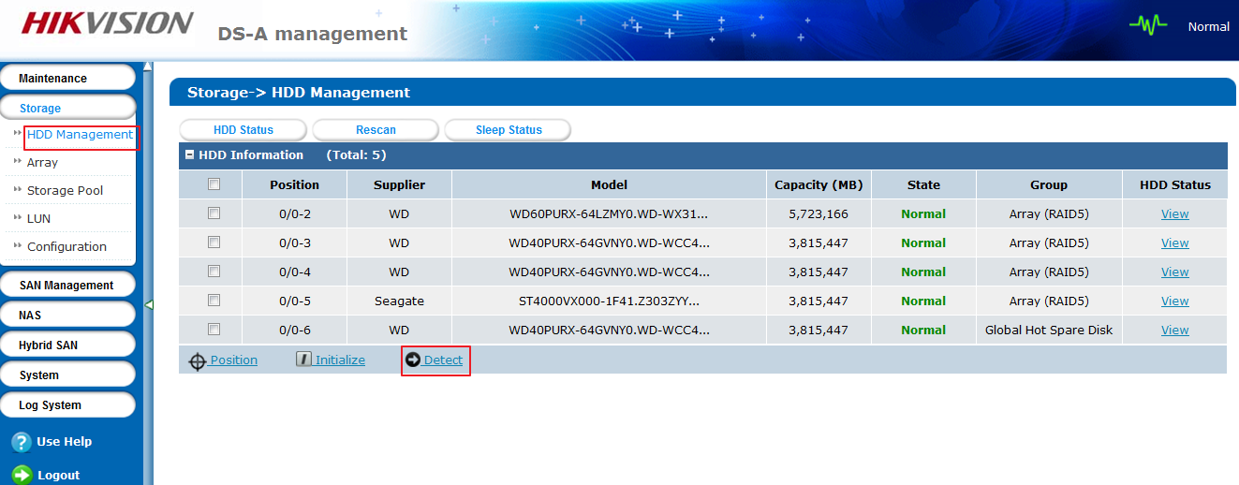
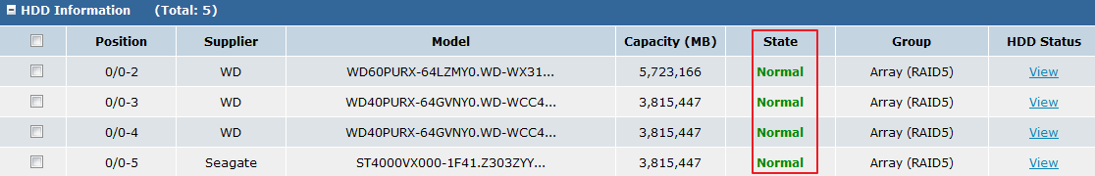
- Add Hybird SAN device into IVMS-4200 in device management interface. The device type belongs to storage server. You need to input IP address, user name and password.
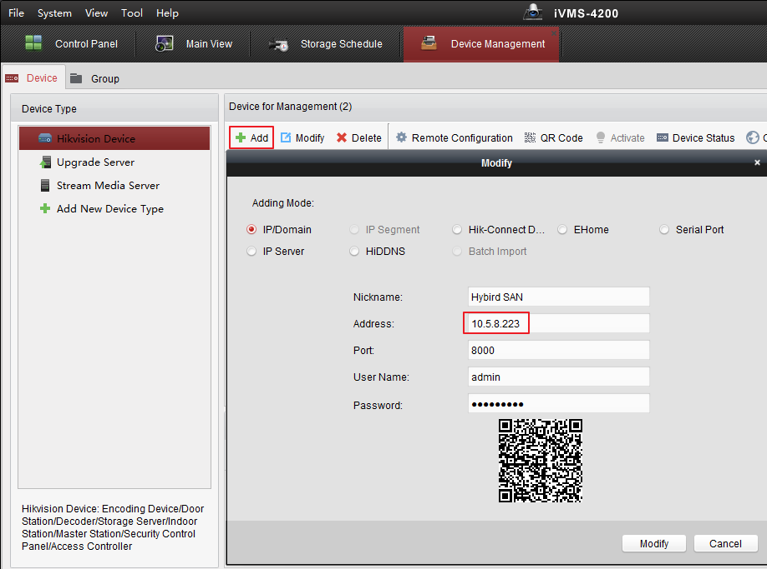
- Click Remote Configuration, And you will enter configuration interface. In the storage interface, Click General, and just click One-touch Config which will start to automatically configure Hybird SAN service.
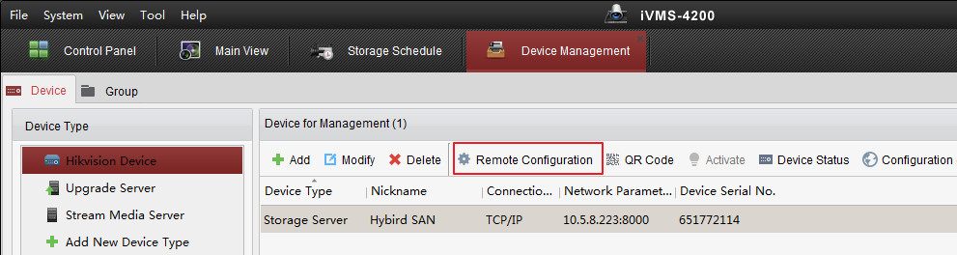
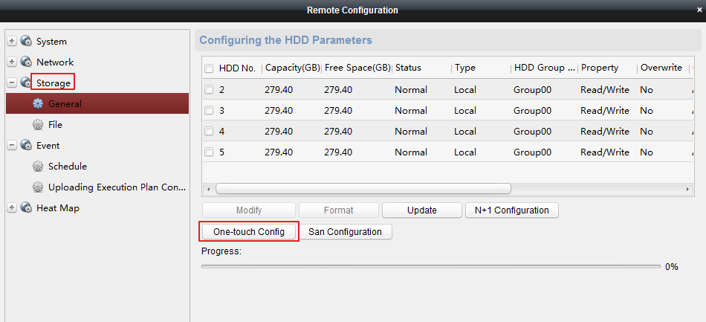
- After one-touch configuration, you can start to make recording schedule in storage schedule interface.
Choose the camera in left bar which you want to make recording schedule. And then choose storage server and related HDD. Finally, Configure record schedule template for camera and click save button on right top.
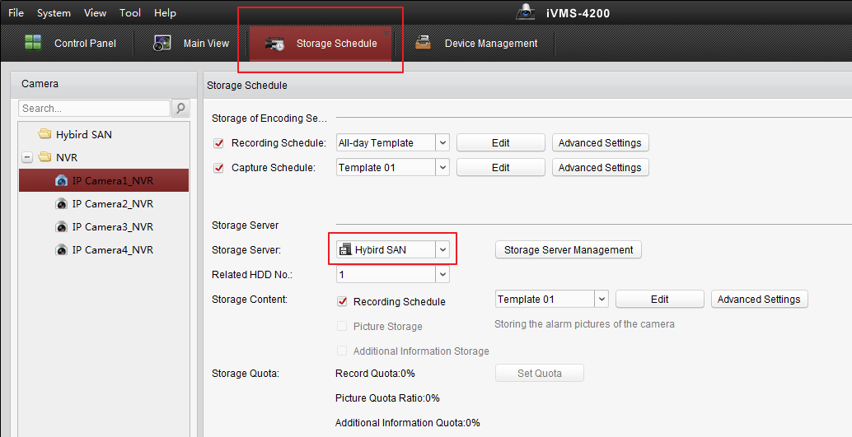

First Choice for Security Professionals
HIKVISION Technical Support

