How to Add IP SAN to DVR/NVR
Note: Hikvision’ s network storage supports two working modes, Hybird SAN &IPSAN, this file is to instruct how to configure IP SAN

Steps:
- Before we create the IP SAN, we need reset system.(note: system reset operation will delete all data.) Click General>Reset system to enter Reset system interface. Fill in Yes in the blank form.
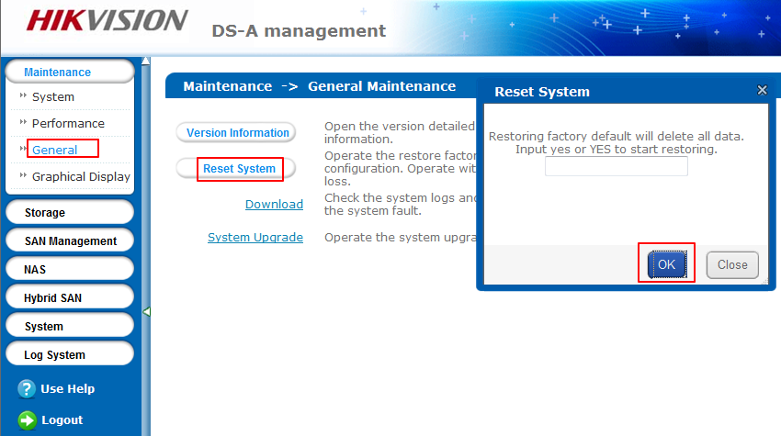
- Click Storage > Array to enter Array interface. Please manually delete the RAID which you created before.
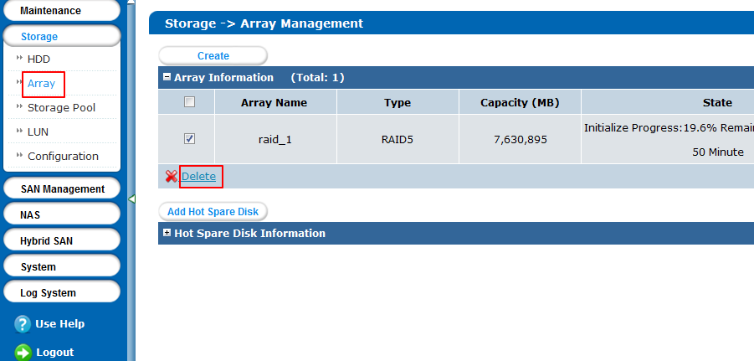
- Please create RAID .Here we are recommended to build RAID5.And add hot spare HDD for these RAID.
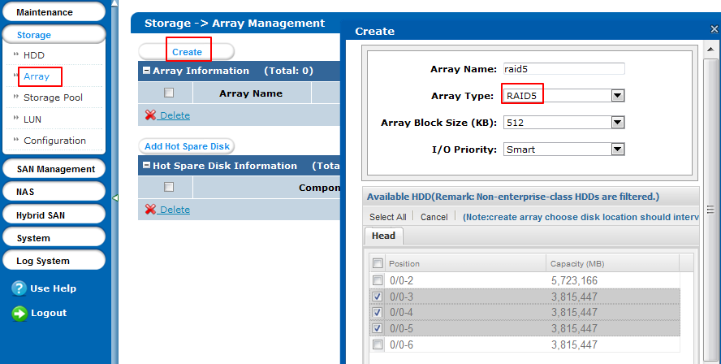
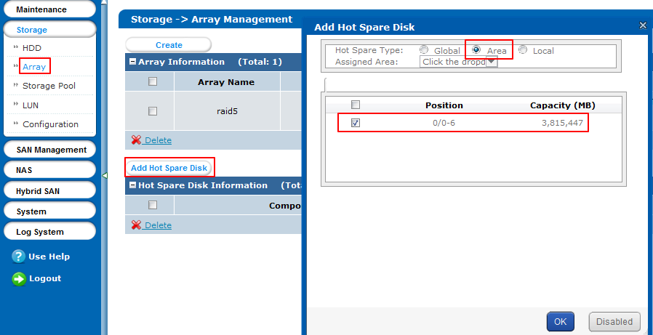
- Click Storage > Storage Pool to enter storage pool management interface. Click the Add button to enter add storage pool interface. Click OK to add the storage pool. And the added storage pool will be listed in the physical volume information list.
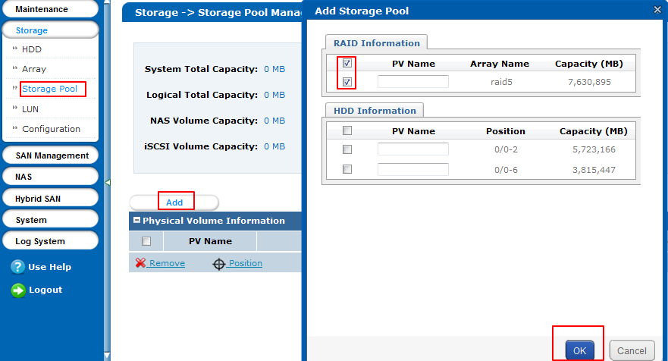
- Click Storage > LUN to enter LUN interface. Create LUN volume, The space of a single LUN volume forming the record volume is recommended to be less than 8T.Click OK to build LUN.
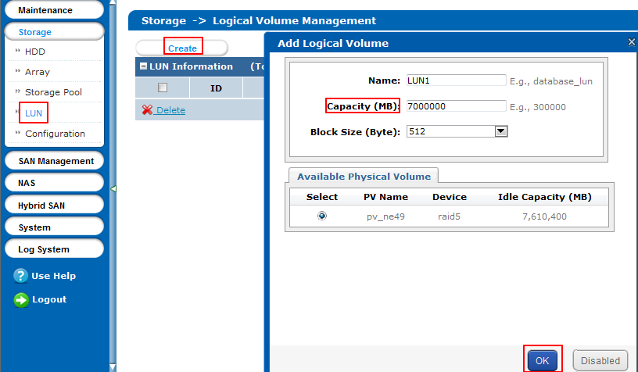
- Click SAN Management > iSCSI to enter iSCSI interface. Click the Enable iSCSI button to enter iSCSI interface. Input the Client IP, iSCSI ID and check the checkbox of Available LUN. Click Ok to save the settings.
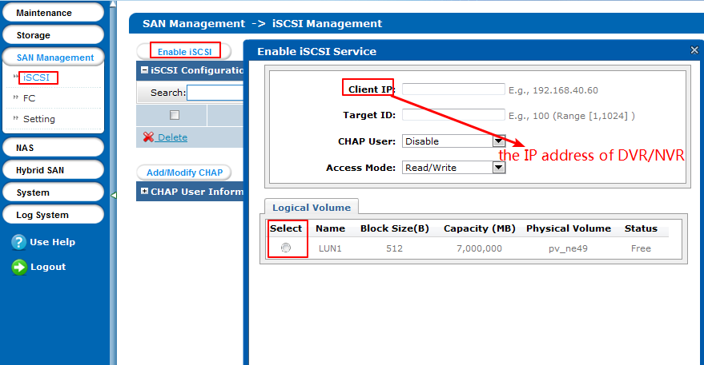
- Configure the IP SAN on the GUI of NVR. Click HDD enter HDD interface and click the Add button.
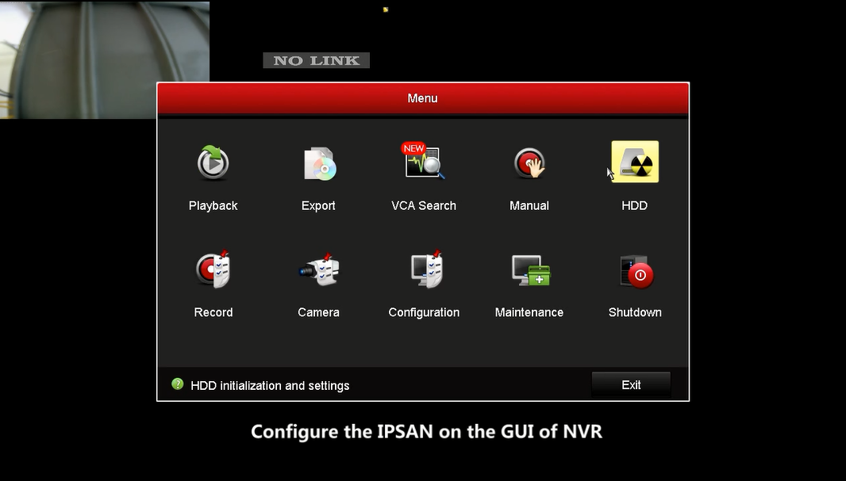
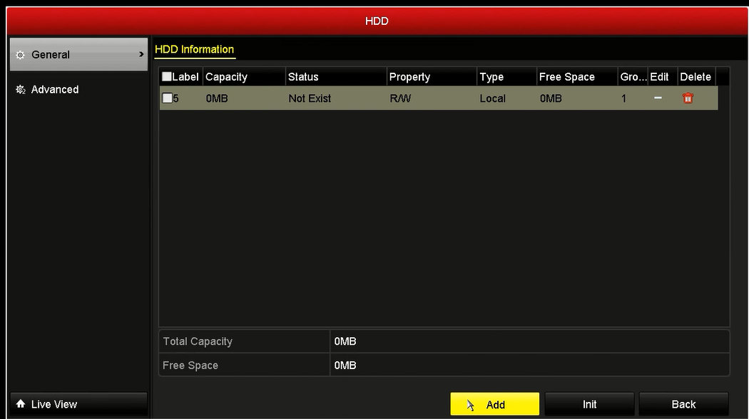
- Choose the type of NetHDD is IP SAN. And input the Net IP Address which is the address of network device (e.g.: DS-A81016S or DS-A82024D ). Click Search button. Wait until appear the NetHDD Directory. Click OK to finish the configuration.
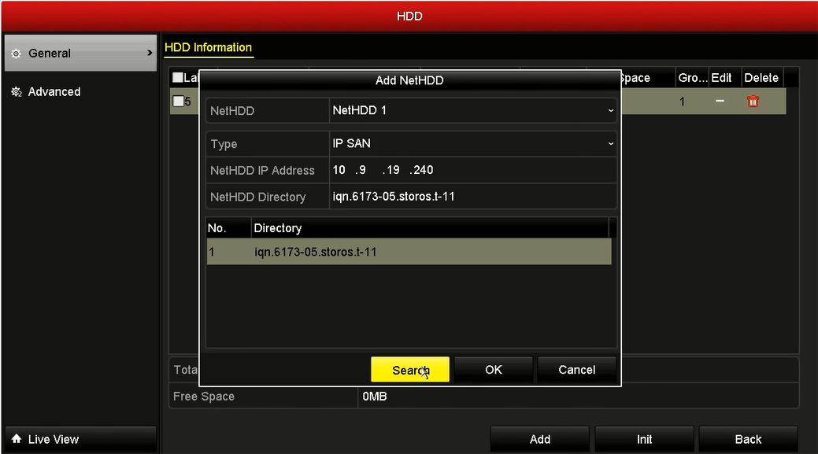
- You can see the IP SAN HDD in the HDD information interface. Tick IP SAN HDD and click Init when the status of IPSAN is offline. And you will see the status of IP SAN change to Normal.
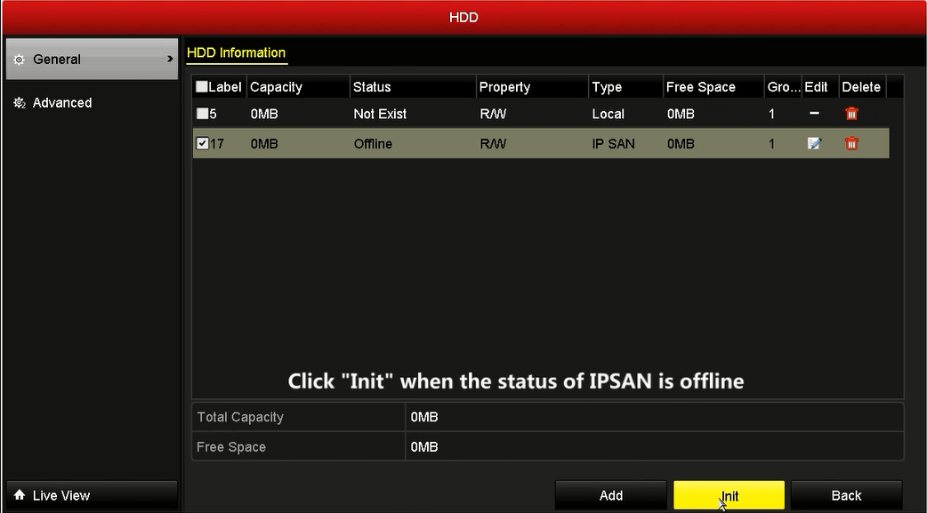
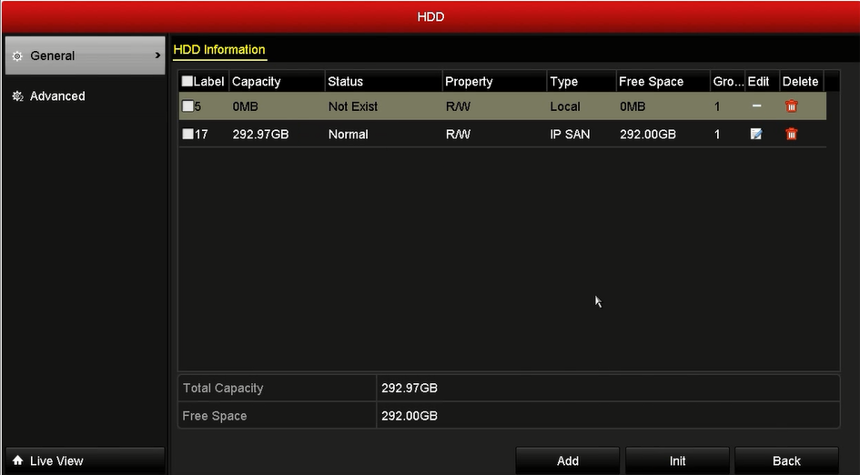

First Choice for Security Professionals
HIKVISION Technical Support

