How to add IP SAN storage in windows storage server
Note: This file will tell you how to add IP SAN storage in storage server.
Steps
- Click LUN in left bar and enter the LUN interface. Click Create button, input LUN name and LUN size.
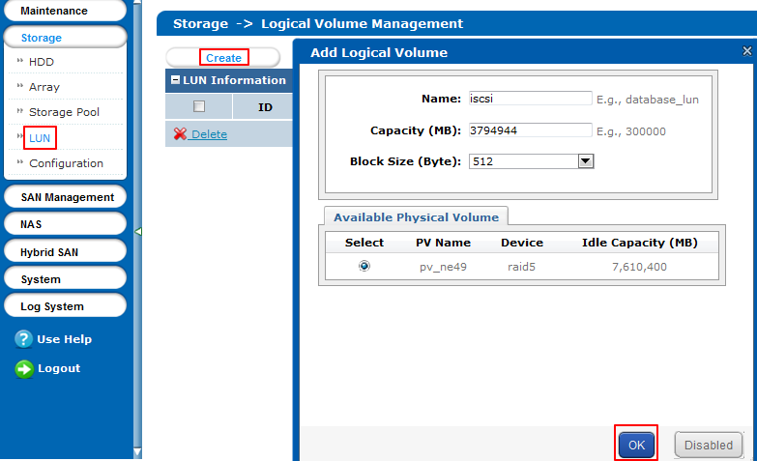
- Right click the SAN Management in the left bar. Click iSCSI and enter the iSCSI interface. And then click Enable iSCSI, input the Client IP which is the IP address of storage server.
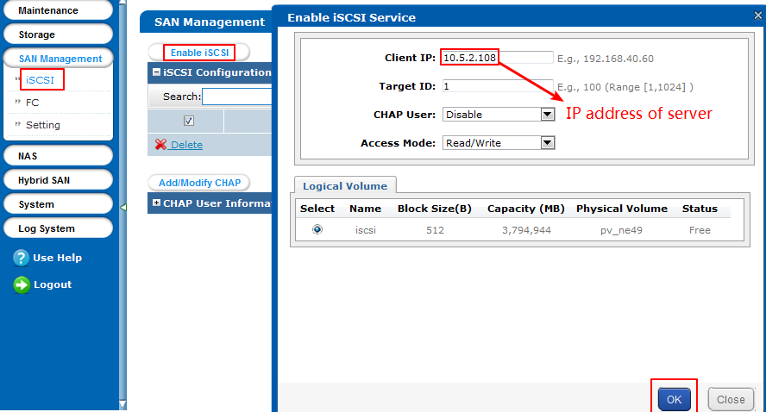
- Input iSCSI in the windows and click the iSCSI initiator.
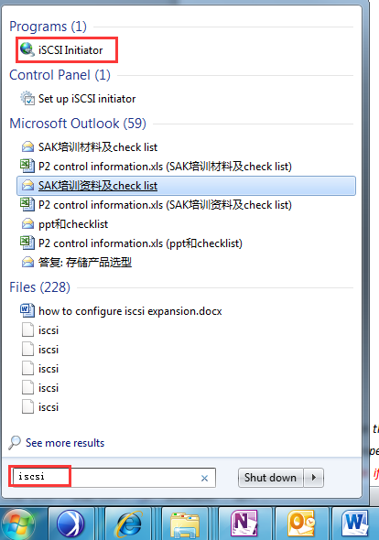
- Click the Discover portal button in the iscsi initiator Properties, and input the IP address of IP SAN, Click OK.
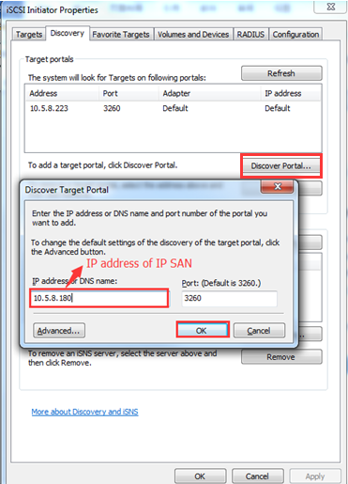
- You can see the targets of IP SAN in the target portals list.
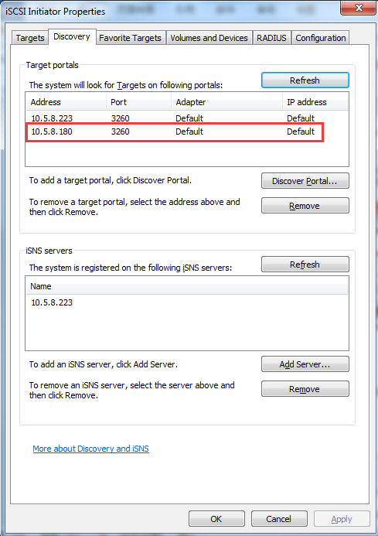

- Click the Targets in the top bar. You can see the Discovered targets and click the connect , check the connected status.
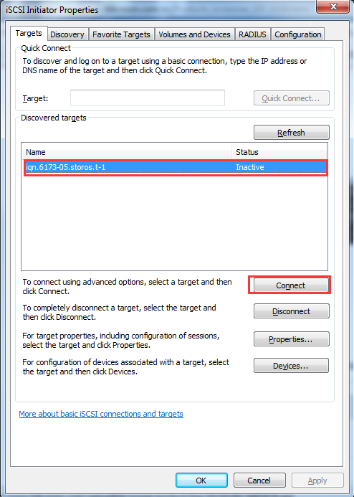 a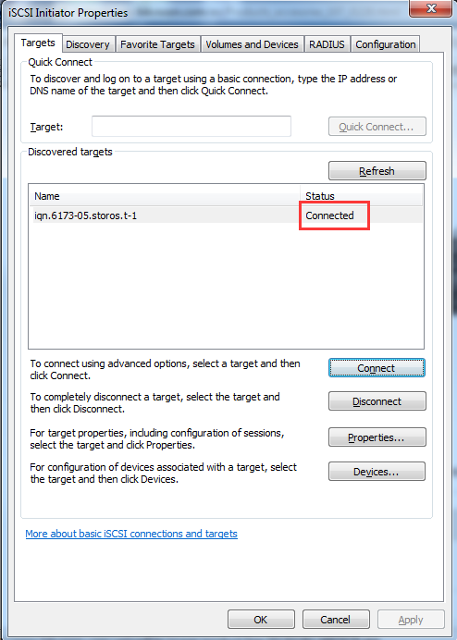

- Click the Disk management in the Storage and you will find a new disk, and click OK.
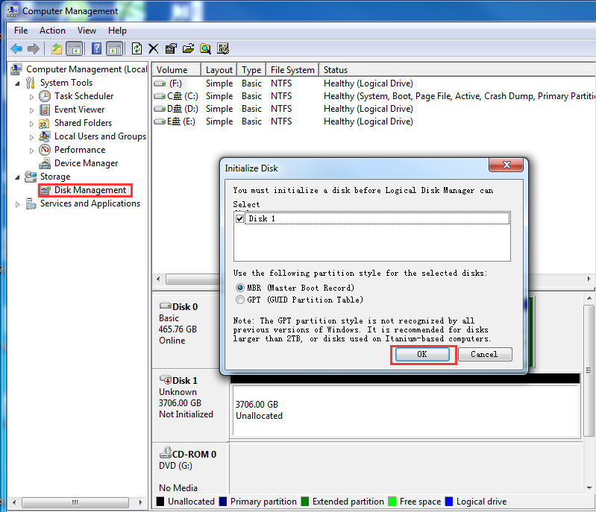
- You will see the unallocated disk in the Disk bar, Right click the unallocated
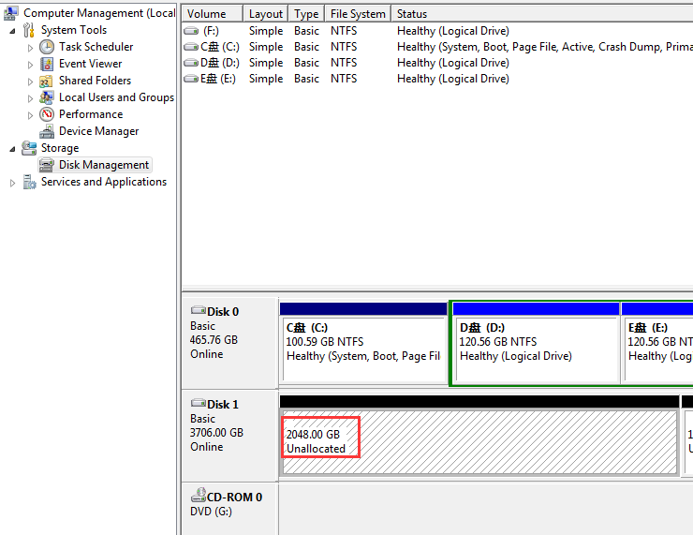
- Click the Next button in the new simple volume wizard until final step.
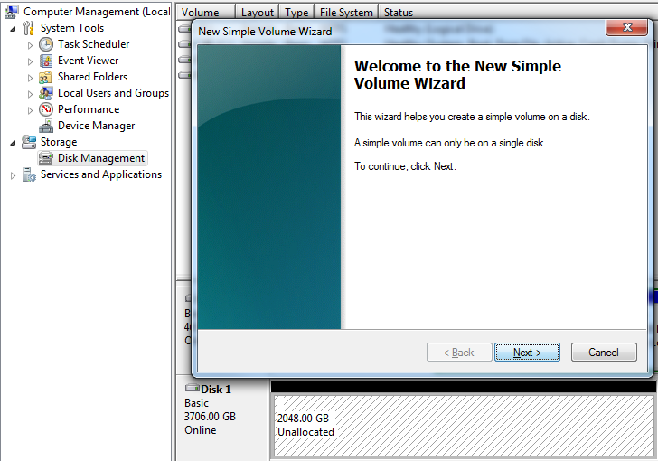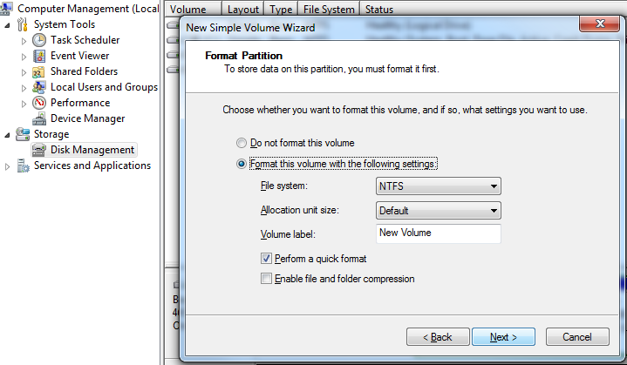
- You can see the status of disk is formatting, you can check the disk in the hard disk drivers after formatting finished.
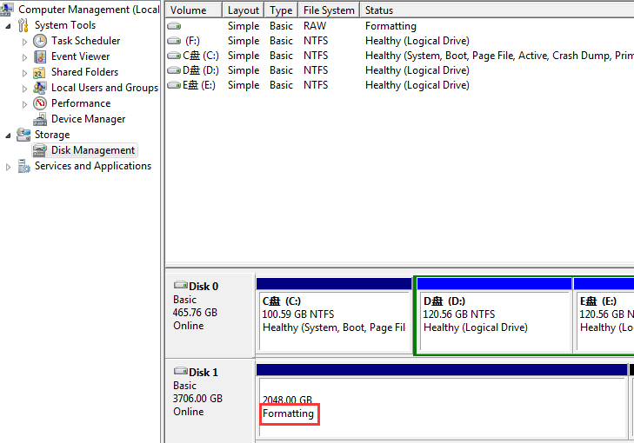

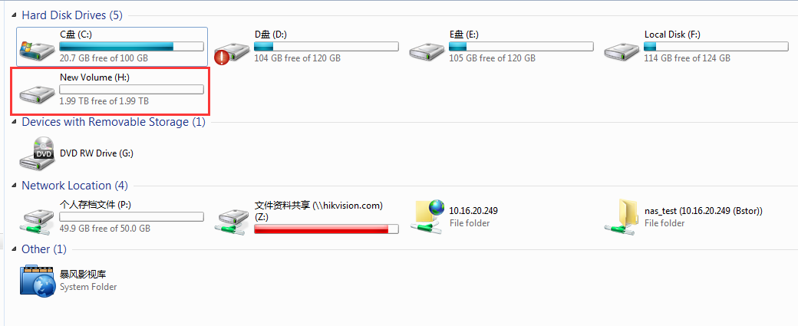

First Choice for Security Professionals
HIKVISION Technical Support

