Temperature Screening Thermographic Camera Version:V5.5.26 build200708

Release Note

(2020-7-15)

Firmware Version | V5.5.26 build 200708

Product Support List
DS-2TD1217B-3/PA
DS-2TD1217B-6/PA
DS-2TD2617B-3/PA
DS-2TD2617B-6/PA
DS-2TD2636B-10/P
DS-2TD2636B-13/P
DS-2TD2636B-15/P
DS-2TD2637B-10/P

Reason of Upgrade
Add new functions, fix some known bugs.

New Features
- Added prompt for face capture attributes on web page (age, gender, whether to wear a mask, glasses, facial expression information)
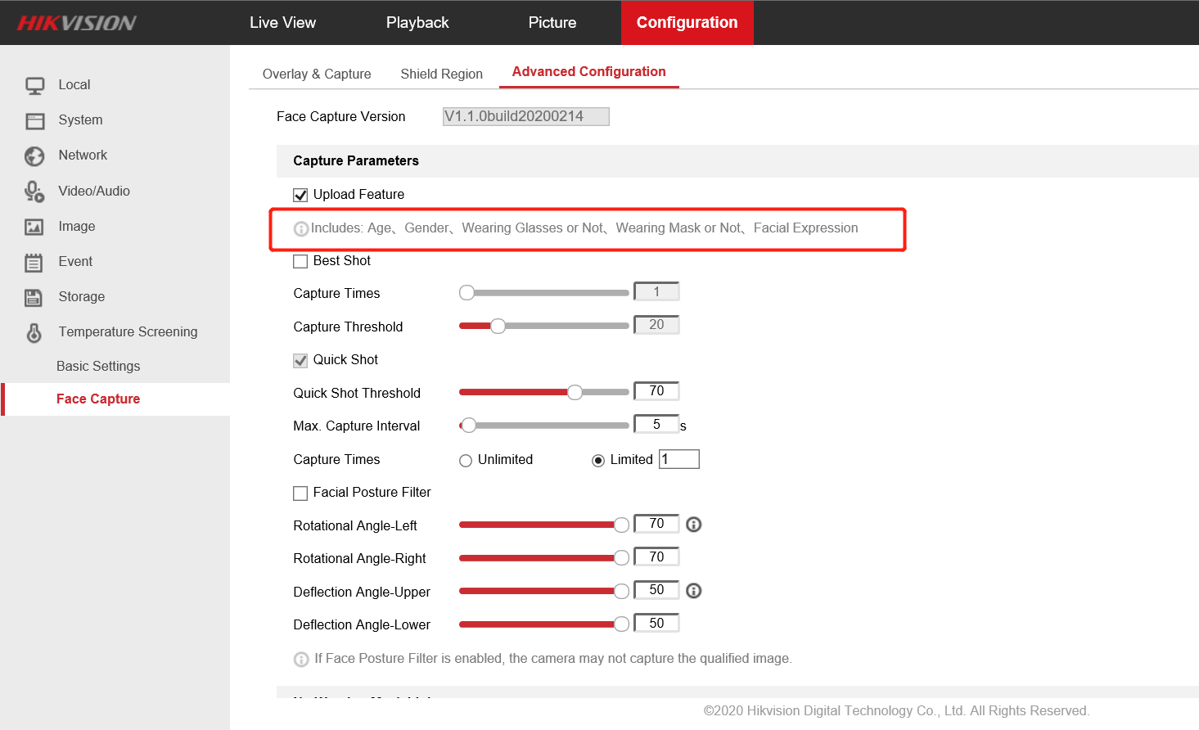
Web page prompts face capture attribute

Optimization
- Fix the issues that the temperature information and face frame are not displayed when restarting the device, after turning off the function of displaying temperature information in the stream information of the human body temperature measurement mode.
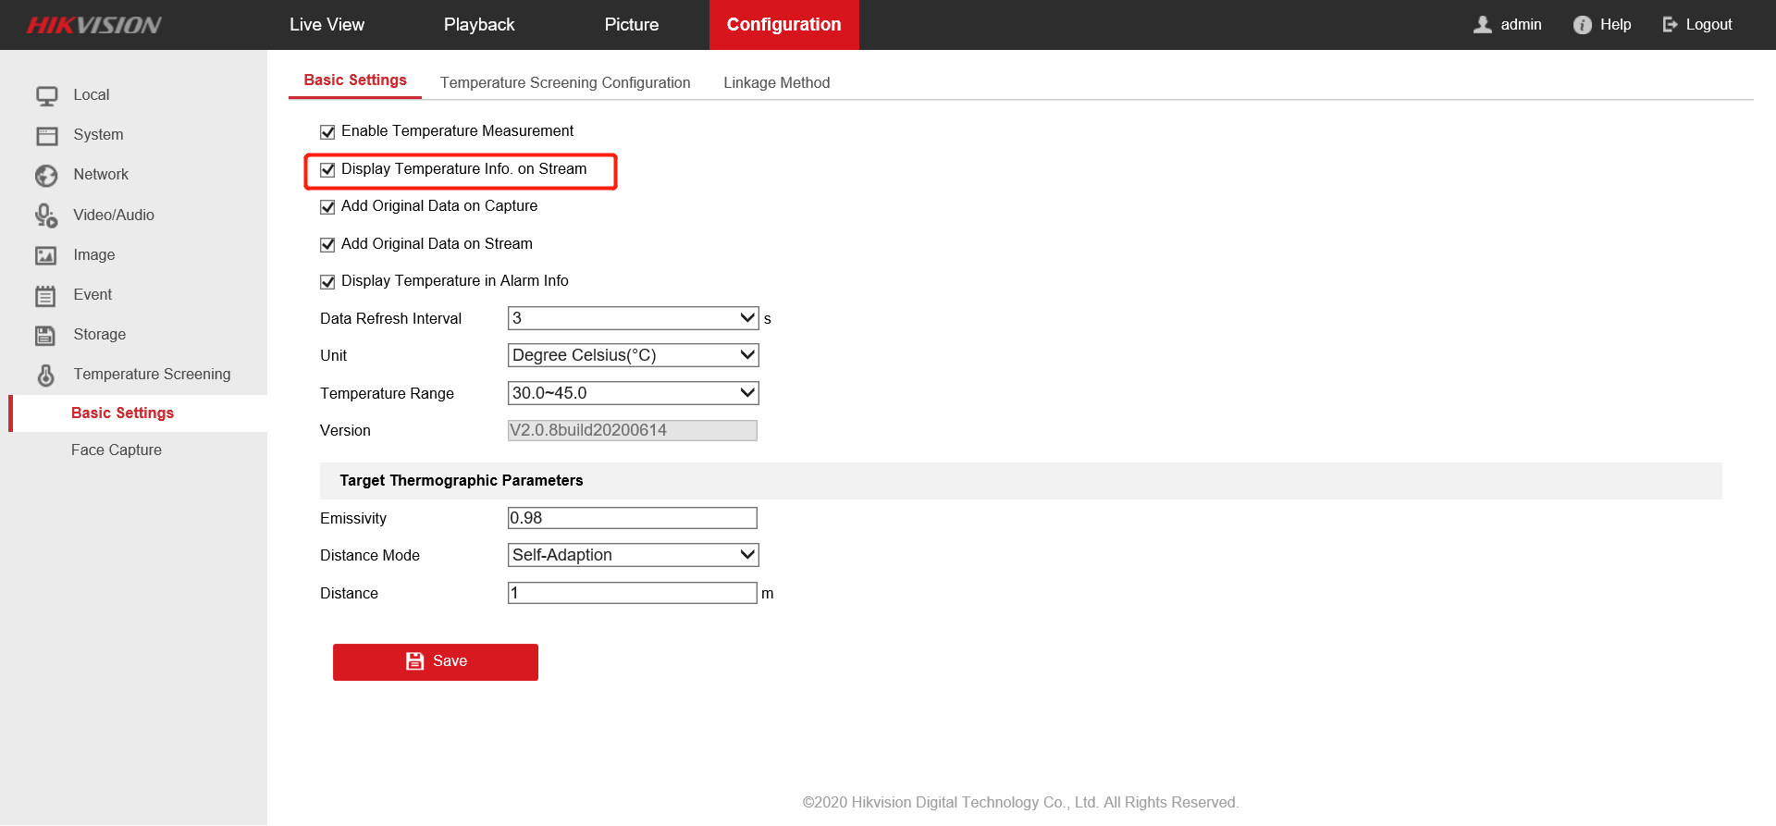
Stream information switch
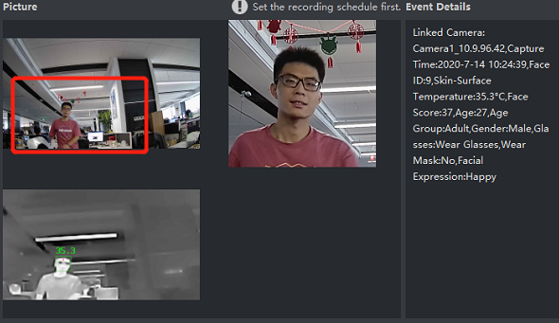
Problem occurrence
2. Fix the problem that Device Error is prompted when the temperature measurement configuration is saved due to code logic defects.
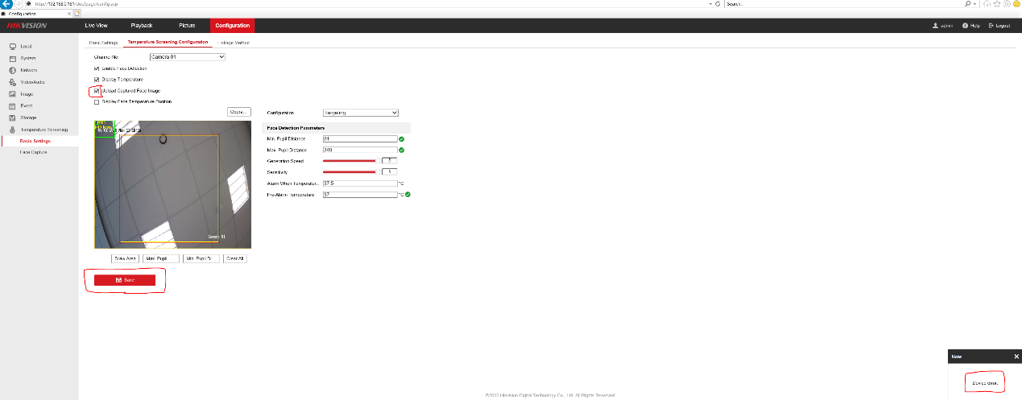
3. Fix issues that 10mm Bullet camera (DS-2TD2636B-10/P DS-2TD2637B-10/P) background compensation temperature is low, resulting in low temperature measurement.
4. Fix the problem of low temperature when black body correction and background compensation are turned on at the same time.
5. Fix the problem that the custom audio package fails to import if larger than 300KB and smaller than 512KB.

Remarks:
- Hikvision reserves the right to change, alter or withdraw the above notification without prior notice.
- Product design and specifications are subject to change without prior notice.
- The Hikvision firmware may contain errors known as errata which may cause the product to deviate from published specifications. Current characterized errata are available on request.
- Hikvision is not liable for any typing or printing errors.
Hikvision Digital Technology CO., Ltd.
No. 555 Qianmo Road, Binjiang District, Hangzhou 310051, China
Tel: +86-571-8807-5998
FAX: +86-571-8993-5635
Email: overseabusiness@hikvision.com

