How to use DS-KC001
Step 1.
Active the device
(the password must same as Temperature MinMoe Terminal)
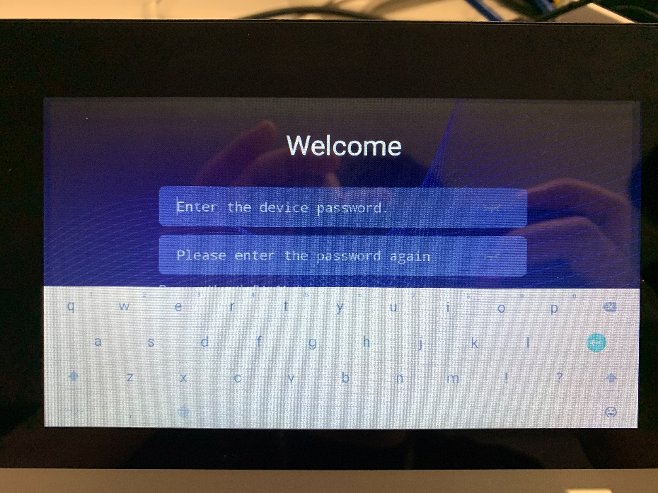
Step 2.
If you don’t connect the network cable, the Wi-Fi configuration interface will pop up automatically.
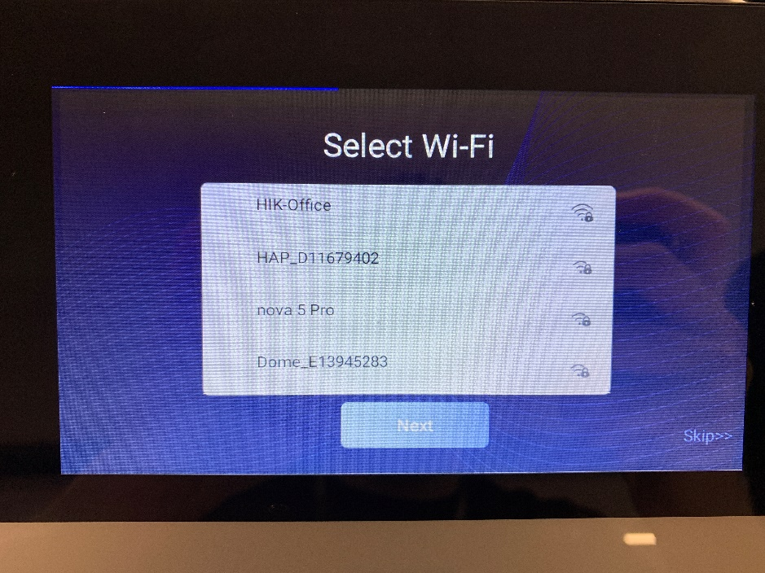
Step 3.
If you are using a wired network, you can obtain an available IP address by turning on DHCP\
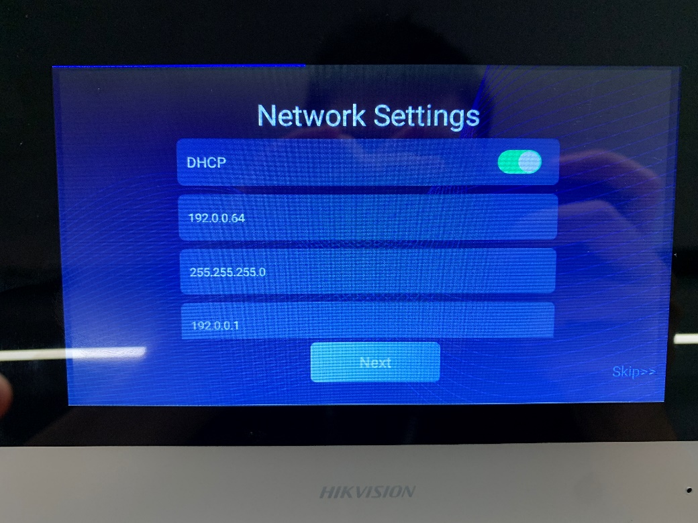
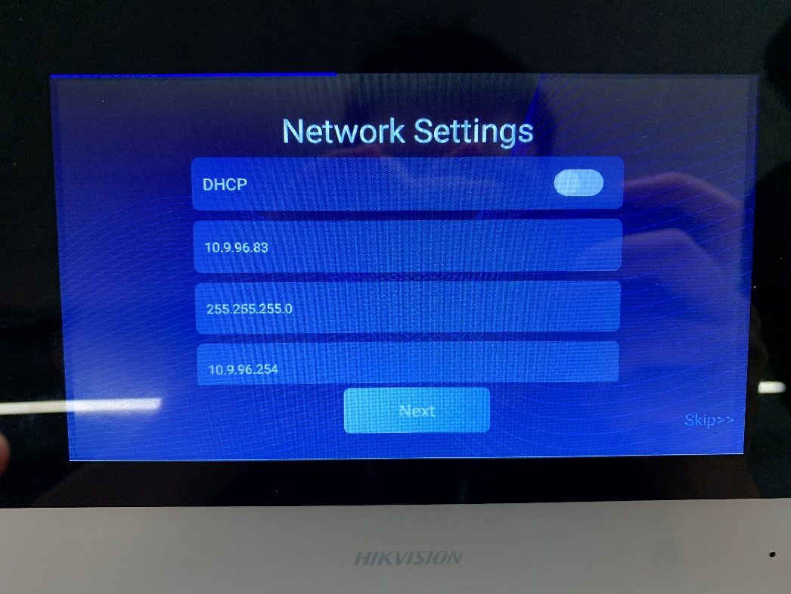

Step 4.
Select the Temperature MinMoe Terminal to be bound
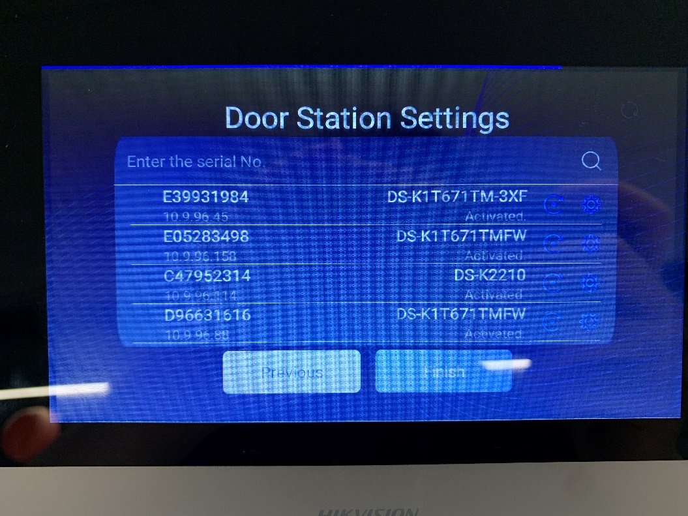

Note.
The ‘temperature measurement only’ mode is a thermal imaging picture; the visible light pictures will be taken after authentication.
(It depends on the version of MinMoe Terminal)

See Far Go Farther
HIKVISION Technical Support

